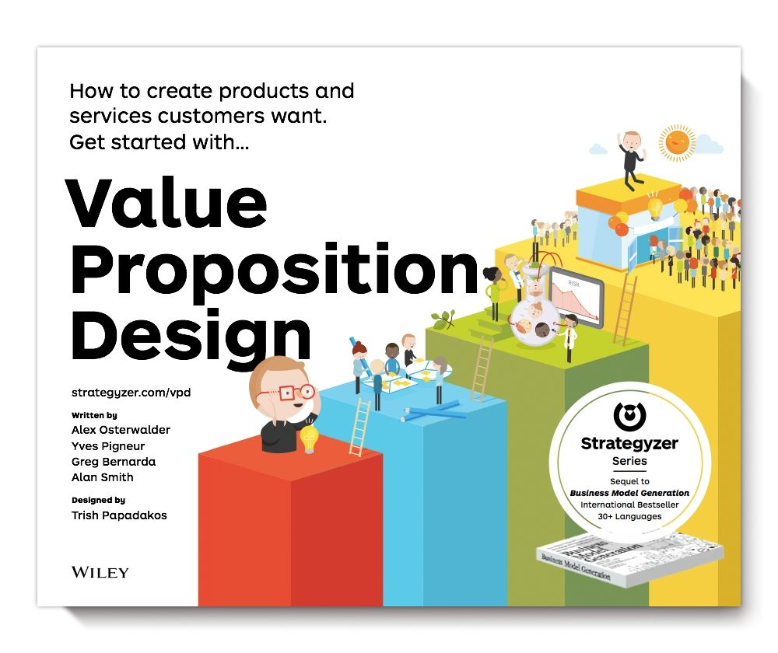

# Table of Contents

Cover Page

Title Page

Copyright

1. Canvas

1.1 Customer Profile

1.2 Value Map

1.3 Fit

2. Design

2.1 Prototyping Possibilities

2.2 Starting Points

2.3 understanding Customers

2.4 Making Choices

2.5 Finding the Right Business Model

2.6 Designing in Established organizations

3. Test

3.1 What to Test

3.2 Testing Step-by-Step

3.3 Experiment Library

3.4 Bringing it All Together

4. Evolve

Create Alignment

Measure & Monitor

improve Relentlessly

Reinvent Yourself Constantly

Taobao: Reinventing (E-)Commerce

Glossary

Core Team

Prereaders

Bios

Index



How to create products and services customers want.  
 Get started with . . .

Value Proposition Design

[strategyzer.com/vpd](http://strategyzer.com/vpd)

Written by

Alex Osterwalder

Yves Pigneur

Greg Bernarda

Alan Smith

Designed by

Trish Papadakos

WILEY

Cover image: Pilot Interactive

Cover design: Alan Smith and Trish Papadakos

Copyright © 2014 by Alexander Osterwalder, Yves Pigneur, Alan Smith, Greg Bernarda, and Patricia Papadakos. All rights reserved.

Published by John Wiley & Sons, Inc., Hoboken, New Jersey.

Published simultaneously in Canada.

No part of this publication may be reproduced, stored in a retrieval system, or transmitted in any form or by any means, electronic, mechanical, photocopying, recording, scanning, or otherwise, except as permitted under Section 107 or 108 of the 1976 United States Copyright Act, without either the prior written permission of the Publisher, or authorization through payment of the appropriate per-copy fee to the Copyright Clearance Center, 222 Rosewood Drive, Danvers, MA 01923, (978) 750-8400, fax (978) 646-8600, or on the web at www.copyright.com. Requests to the Publisher for permission should be addressed to the Permissions Department, John Wiley & Sons, Inc., 111 River Street, Hoboken, NJ 07030, (201) 748-6011, fax (201) 748-6008, or online at [www.wiley.com/go/permissions](http://www.wiley.com/go/permissions).

Limit of Liability/Disclaimer of Warranty: While the publisher and author have used their best efforts in preparing this book, they make no representations or warranties with the respect to the accuracy or completeness of the contents of this book and specifically disclaim any implied warranties of merchantability or fitness for a particular purpose. No warranty may be created or extended by sales representatives or written sales materials. The advice and strategies contained herein may not be suitable for your situation. You should consult with a professional where appropriate. Neither the publisher nor the author shall be liable for damages arising herefrom.

For general information about our other products and services, please contact our Customer Care Department within the United States at (800) 762-2974, outside the United States at (317) 572-3993 or fax (317) 572-4002.

Wiley publishes in a variety of print and electronic formats and by print-on-demand. Some material included with standard print versions of this book may not be included in e-books or in print-on-demand. If this book refers to media such as a CD or DVD that is not included in the version you purchased, you may download this material at <http://booksupport.wiley.com>. For more information about Wiley products, visit [www.wiley.com.](http://www.wiley.com)

ISBN 978-1-118-97310-3

CONTENTS

1. Canvas

1.1 Customer Profile

1.2 Value Map

1.3 Fit

2. Design

2.1 Prototyping Possibilities

2.2 Starting Points

2.3 Understanding Customers

2.4 Making Choices

2.5 Finding the Right Business Model

2.6 Designing in Established organizations

3. Test

3.1 What to Test

3.2 Testing Step-by-Step

3.3 Experiment Library

3.4 Bringing it All Together

4. Evolve

Create Alignment

Measure & Monitor

improve Relentlessly

Reinvent Yourself Constantly

Taobao: Reinventing (E-)Commerce

Glossary

Prereaders

Bios

Index

Core Team

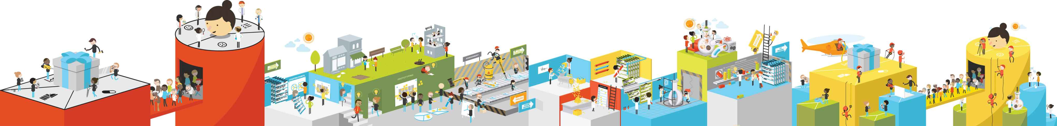

Note to the Reader:

The print edition of this book is designed around large, four-color two-page spreads.

This digital version has been reformatted for smaller ebook readers and mobile devices.

You’ll love Value Proposition Design if you’ve been…

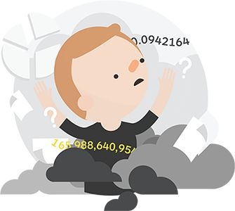

Overwhelmed by the task of true value creation

Sometimes you feel like…

* There should be better tools available to help you create value for your customers and your business.
* You might be pursuing the wrong tasks and you feel insecure about the next steps.
* It’s difficult to learn what customers really want.
* The information and data you get from (potential) customers is overwhelming and you don’t know how to best organize it.
* It’s challenging to go beyond products and features toward a deep understanding of customer value creation.
* You lack the big picture of how all the puzzle pieces fit together.

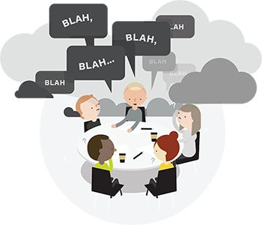

Frustrated by unproductive meetings and misaligned teams

You have experienced teams that…

* Lacked a shared language and a shared understanding of customer value creation.
* Got bogged down by unproductive meetings with tons of unstructured “blah blah blah” conversations.
* Worked without clear processes and tools.
* Were focused mainly on technologies, products, and features rather than customers.
* Conducted meetings that drained energy and ended without a clear outcome.
* Were misaligned.

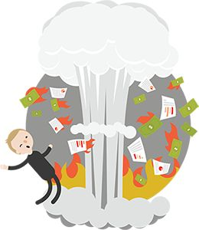

Involved in bold shiny projects that blew up

You have seen projects that…

* Were big bold bets that failed and wasted a lot money.
* Put energy into polishing and refining a business plan until it perpetuated the illusion that it could actually work.
* Spent a lot of time building detailed spreadsheets that were completely made up and turned out to be wrong.
* Spent more time developing and debating ideas rather than testing them with customers and stakeholders.
* Let opinions dominate over facts from the field.
* Lacked clear processes and tools to minimize risk.
* Used processes suited for running a business rather than ones for developing new ideas.

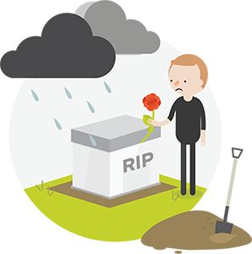

Disappointed by the failure of a good idea.

 [Get “From Failure to Success” poster](http://strategyzer.com/vpd/intro)

Value Proposition Design will help you successfully…



Understand the patterns of value creation

Organize information about what customers want in a simple way that make the patterns of value creation easily visible. As a result, you will more effectively design value propositions and profitable business models that directly target your customers’ most pressing and important jobs, pains, and gains.

Gain clarity.

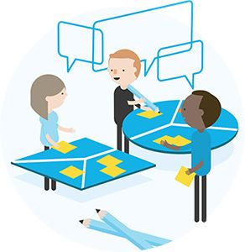

Leverage the experience and skills of your team

Equip your team with a shared language to overcome “blah blah blah,” conduct more strategic conversations, run creative exer- cises, and get aligned. This will lead to more enjoyable meetings that are full of energy and produce actionable outcomes beyond a focus on technology, products, and features toward creating value for your customers and your business.

Get your team aligned.

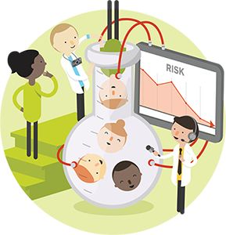

Avoid wasting time with ideas that won’t work

Relentlessly test the most important hypotheses underlying your business ideas in order to reduce the risk of failure. This will allow you to pursue big bold ideas without having to break the bank. Your processes to shape new ideas will be fit for the task and complement your existing processes that help you run your business.

Minimize the risk of a flop.

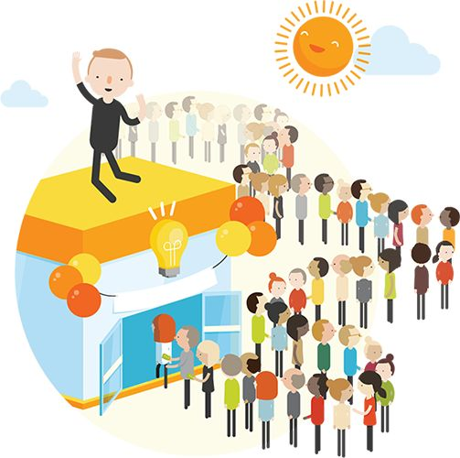

Design, test, and deliver what customers want.

  [Get “From Failure to Success” poster](http://strategyzer.com/vpd/intro)

Our value proposition to you

Watch for the Strategyzer logo and follow the link to  online exercises,  tools/templates,  posters and more.

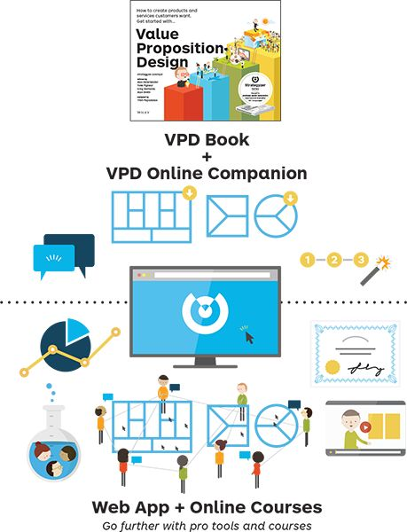

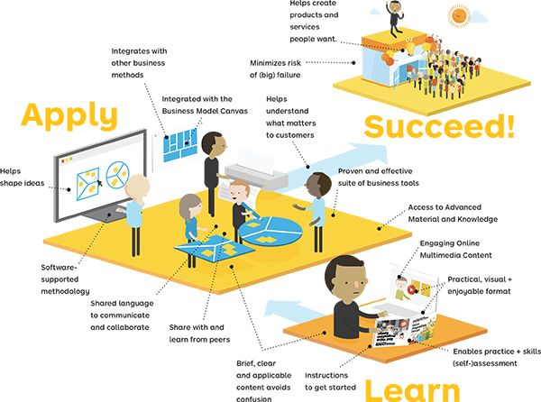

The Tools and Process of Value Proposition Design

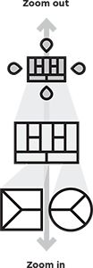

Canvas

Tools

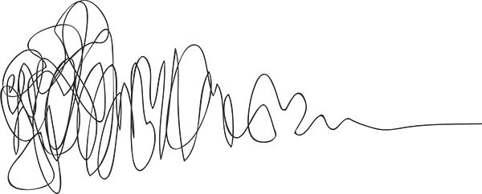

Design / Test

Search

The heart of Value Proposition Design is about applying Tools to the messy Search for value propositions that customers want and then keeping them aligned with what customers want in Evolve.

Value Proposition Design shows you how to use the Value Proposition Canvas to Design and Test great value propositions in an iterative search for what customers want. Value proposition design is a never-ending process in which you need to Evolve your value proposition(s) constantly to keep it relevant to customers.

Progress

Manage the messy and nonlinear process of value proposition design and reduce risk by systematically applying adequate tools and processes.

Evolve

Postsearch

An integrated Suite of Tools

The value propositions visible and tangible and thus easier to discuss and manage. It perfectly integrates with the Business Model Canvas and the Environment Map, two tools that are discussed in detail in Business Model Generation,* the sister book to this one. Together, they shape the foundation of a suite of business tools.

The Value Proposition Canvas zooms into the details of two of the building blocks of the Business Model Canvas.

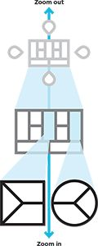

* Business Model Generation, Osterwalder and Pigneur, 2010.

The  
 Environment Map  
helps you understand the context in which you create.

The  
 Business Model Canvas helps you create value for your business.

The  
 Value Proposition Canvas  
 helps you create value for your customer.

Refresher: The Business Model Canvas

Embed your value proposition in a viable business model to capture value for your organization. To do so, you can use the Business Model Canvas, a tool to describe how your organization creates, delivers, and captures value. The Business Model, and Value Proposition Canvas perfectly integrate, with the latter being like a plug-in to the former that allows you to zoom into the details of how you are creating value for customers.

The refresher of the Business Model Canvas on this spread is sufficient to work through this book and create great value propositions. Go to the online resources if you are interested in more or get Business Model Generation,* the sister publication to this book.

Customer Segments

are the groups of people and/or organizations a company or organization aims to reach and create value for with a dedicated Value Proposition.

Value Propositions

are based on a bundle of products and services that create value for a Customer Segment.

Channels

describe how a Value Proposition is communicated and delivered to a Customer Segment through communication, distribution, and sales Channels.

Customer Relationships

outline what type of relationship is established and maintained with each Customer Segment, and they explain how customers are acquired and retained.

Revenue Streams

result from a Value Proposition successfully offered to a Customer Segment. It is how an organization captures value with a price that customers are willing to pay.

Key Resources

are the most important assets required to offer and deliver the previously described elements.

Key Activities

are the most important activities an organization needs to perform well.

Key Partnerships

shows the network of suppliers and partners that bring in external resources and activities.

Cost Structure

describes all costs incurred to operate a business model.

Profit

is calculated by subtracting the total of all costs in the Cost Structure from the total of all Revenue Streams.

*Business Model Generation (2010), Osterwalder and Pigneur

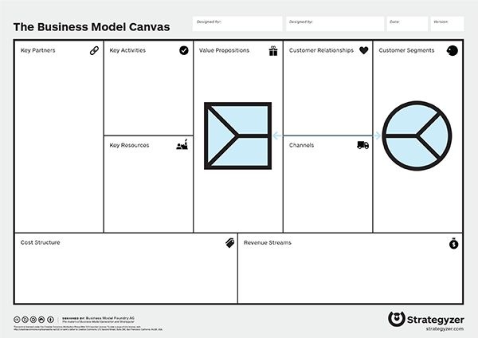

 [Download detailed Business Model Canvas Explanation and the Business Model Canvas pdf](http://strategyzer.com/vpd/intro)

Value Proposition Design works for…

Are you creating something from scratch on your own or are you part of an existing organization? Some things will be easier and some harder depending on your strategic playground.

A start-up entrepreneur deals with different constraints than a project leader for a new venture within an existing organization. The tools presented in this book apply to both contexts. Depending on your starting point you will execute them in a different way to leverage different strengths and overcome different obstacles.

New Ventures

Individuals or teams setting out to create a great value proposition and business model from scratch

Main challenges

* Produce proof that your ideas can work on a limited budget.
* Manage involvement of investors (if you scale your ideas).
* Risk running out of money before finding the right value proposition and business model.

Main opportunities

* Build on existing value propositions and business models.
* Leverage existing assets (sales, channels, brand, etc.).
* Build portfolios of business models and value propositions.

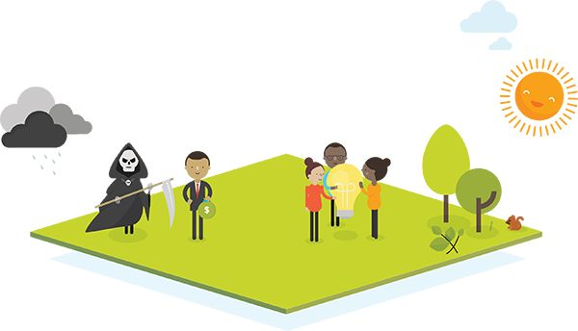

Established Organizations

Teams within existing companies setting out to improve or invent value propositions and business models

 [Get “Innovating in Established Organizations” poster](http://strategyzer.com/vpd/intro)

Main opportunities

* Build on existing value propositions and business models.
* Leverage existing assets (sales, channels, brand, etc.).
* Build portfolios of business models and value propositions.

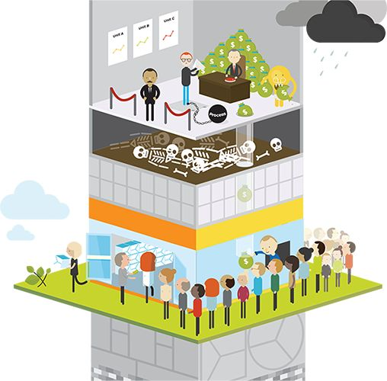

Main challenges

* Get buy-in from top management.
* Get access to existing resources.
* Manage cannibalization.
* Overcome risk aversion.
* Overcome rigid and slow processes.
* Produce big wins to move the needle.
* Manage career risk of innovators.

Use Value Proposition Design to…

Invent and improve value propositions. The tools we will study work for managing and renewing value propositions (and business models) just as much as for creating new ones. Put the Value Proposition and Business Model to work to create a shared language of value creation in your organization. Use them to continuously invent and improve value propositions that meet customer profiles, which is an undertaking that never ends.

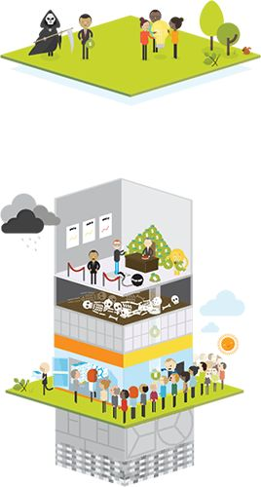

Invent

Invent new value propositions that people want with business models that work.



Improve

Manage, measure, challenge, improve, and renew existing value propositions and business models.

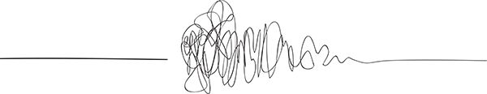

Assess Your Value Proposition Design Skills

Complete our online test and assess whether you have the attitude and skills required to systematically be successful at value proposition design. Take the test before and after working through Value Proposition Design to measure your progress.

 [Take your skills test online](http://strategyzer.com/vpd/intro)



Entrepreneurial Knowledge

You enjoy trying out new things. You don’t see the risk of failing as a threat but an opportunity to learn and progress. You easily navigate between the strategic and the tactical.

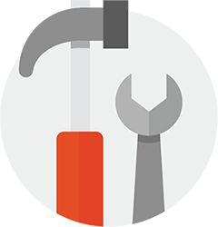

Tool Skills

You systematically use the Value Proposition Canvas, Business Model Canvas, and other tools and processes in your search for great value propositions and business models.



Design Thinking Skills

You explore multiple alternatives before picking and refining a particular direction. You are comfortable with the nonlinear and iterative nature of value creation.

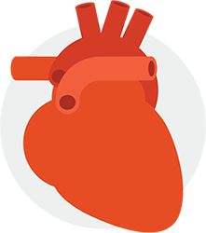

Customer Empathy

You relentlessly take a customer perspective and are even better at listening to customers then selling to them.

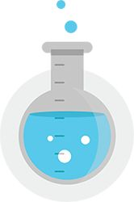

Experimentation Skills

You systematically seek evidence that supports your ideas and tests your vision. You experiment at the earliest stages to learn what works and what doesn’t.

Sell Your Colleagues on Value Proposition Design

|  |
| --- |
| I am… |
| concerned that we don’t have a methodology to track our progress on the development of that new value proposition and business model. |
| worried that we focus too much on products and features instead of creating value for customers. |
| astonished at how poorly aligned product development, sales, and marketing are when it comes to developing new value propositions. |
| surprised at how often we make stuff nobody wants, despite our good ideas and good intentions. |
| really disappointed by how much we talked about value propositions and business models at our last meeting without really getting tangible results. |
| blown away by how unclear that last presentation on that new value proposition and business model was. |
| amazed by how many resources we wasted when that great idea in that last business plan turned out to be flop because we didn’t test it. |
| concerned that our product development process doesn’t use a more customer-focused methodology. |
| surprised that we invest so much in research and development (R&D), but fail to invest in developing the right value propositions and business models. |
| not sure if everybody in our team has a shared understanding of what a good value proposition actually is. |

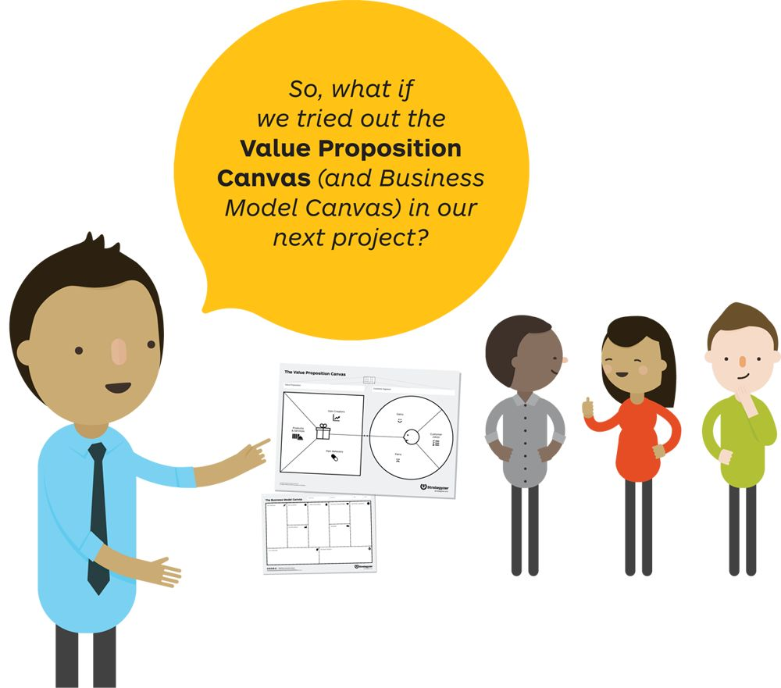

 [Get a slide deck with 10 arguements to use the Value Proposition and Business Model Canvas](http://strategyzer.com/vpd/intro)

1: Canvas

The Value Proposition Canvas has two sides. With the Customer Profile you clarify your customer understanding. With the Value Map you describe how you intend to create value for that customer. You achieve Fit between the two when one meets the other.

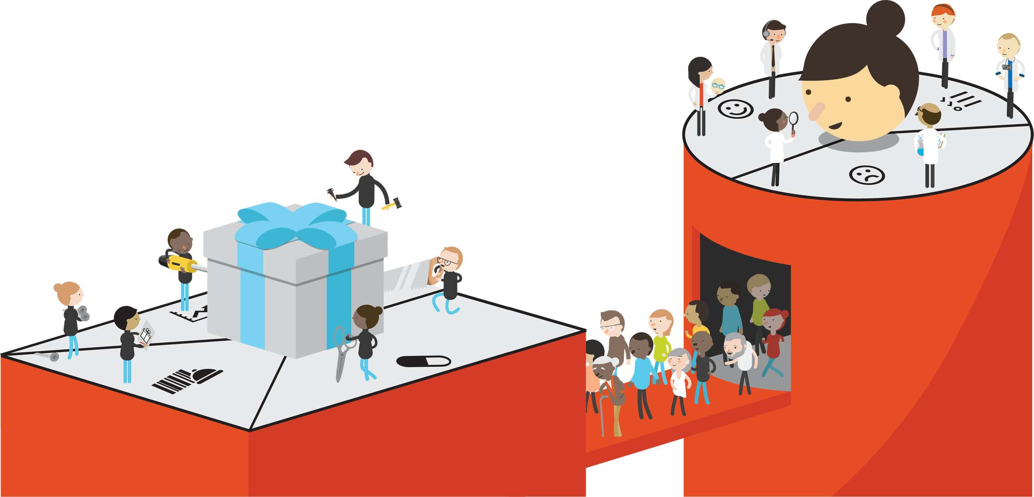



Create Value

The set of value proposition benefits that you design to attract customers.





Observe Customers

The set of customer characteristics that you assume, observe, and verify in the market.

DEF-I-NI-TION

VALUE PROPOSITION

Describes the benefits customers can

expect from your products and services.

Value Map

The Value (Proposition) Map describes the features of a specific value proposition in your business model in a more structured and detailed way. It breaks your value proposition down into products and services, pain relievers, and gain creators.

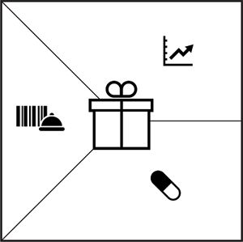

|  |  |
| --- | --- |
| 00036.jpeg | Gain Creators describe how your products and services create customer gains. |
| 00037.jpeg | Pain Relievers describe how your products and services alleviate customer pains. |
| 00038.jpeg | This is a list of all the Products and Services a value proposition is built around. |



Customer Profile

The Customer (Segment) Profile describes a specific customer segment in your business model in a more structured and detailed way. It breaks the customer down into its jobs, pains, and gains.

You achieve Fit when your value map meets your customer profile—when your products and services produce pain relievers and gain creators that match one or more of the jobs, pains, and gains that are important to your customer.

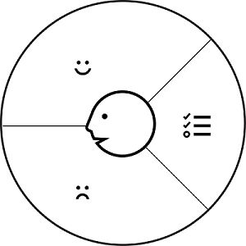

|  |  |
| --- | --- |
| 00040.jpeg | Gains describe the outcomes customers want to achieve or the concrete benefits they are seeking. |
| 00041.jpeg | Pains describe bad outcomes, risks, and obstacles related to customer jobs. |
| 00042.jpeg | Customer Jobs describe what customers are trying to get done in their work and in their lives, as expressed in their own words. |

1.1  
Customer Profile

Customer Jobs

Jobs describe the things your customers are trying to get done in their work or in their life. A customer job could be the tasks they are trying to perform and complete, the problems they are trying to solve, or the needs they are trying to satisfy. Make sure you take the customer’s perspective when investigating jobs. What you think of as important from your perspective might not be a job customers are actually trying to get done.*

Distinguish between three main types of customer jobs to be done and supporting jobs:

Functional jobs

When your customers try to perform or complete a specific task or solve a specific problem, for example, mow the lawn, eat healthy as a consumer, write a report, or help clients as a professional.

Social jobs

When your customers want to look good or gain power or status. These jobs describe how customers want to be perceived by others, for example, look trendy as a consumer or be perceived as competent as a professional.

Personal/emotional jobs

When your customers seek a specific emotional state, such as feeling good or secure, for example, seeking peace of mind regarding one’s investments as a consumer or achieving the feeling of job security at one’s workplace.

Supporting jobs

Customers also perform supporting jobs in the context of purchasing and consuming value either as consumers or as professionals. These jobs arise from three different roles:

* BUYER OF VALUE: jobs related to buying value, such as comparing offers, deciding which products to buy, standing in a checkout line, completing a purchase, or taking delivery of a product or service.
* COCREATOR OF VALUE: jobs related to cocreating value with your organization, such as posting product reviews and feedback or even participating in the design of a product or service.
* TRANSFERRER OF VALUE: jobs related to the end of a value proposition’s life cycle, such as canceling a subscription, disposing of a product, transferring it to others, or reselling it.

Job context

Customer jobs often depend on the specific context in which they are performed. The context may impose certain constraints or limitations. For example, calling somebody on the fly is different when you are traveling on a train than when you are driving a car. Likewise, going to the movies with your kids is different than going with your partner.

The jobs to be done concept was developed independently by several business thinkers including Anthony Ulwick of the consulting firm Strategyn, consultants Rick Pedi and Bob Moesta, and Professor Denise Nitterhouse of DePaul University. It was popularized by Clay Christensen and his consulting firm Innosight and Anthony Ulwick’s Strategyn.

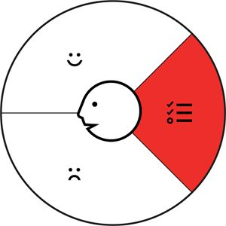

Job importance

It is important to acknowledge that not all jobs have the same importance to your customer. Some matter more in a customer’s work or life because failing to get them done could have serious ramifications. Some are insignificant because the customer cares about other things more. Sometimes a customer will deem a job crucial because it occurs frequently or because it will result in a desired or unwanted outcome.



 [Download trigger questions to help find customer jobs](http://strategyzer.com/vpd/canvas/1.1)



Customer Pains

Pains describe anything that annoys your customers before, during, and after trying to get a job done or simply prevents them from getting a job done. Pains also describe risks, that is, potential bad outcomes, related to getting a job done badly or not at all.

Seek to identify three types of customer pains and how severe customers find them:

Undesired outcomes, problems, and characteristics

Pains are functional (e.g., a solution doesn’t work, doesn’t work well, or has negative side effects), social (“I look bad doing this”), emotional (“I feel bad every time I do this”), or ancillary (“It’s annoying to go to the store for this”). This may also involve undesired characteristics customers don’t like (e.g., “Running at the gym is boring,” or “This design is ugly”).

Obstacles

These are things that prevent customers from even getting started with a job or that slow them down (e.g., “I lack the time to get this job done accurately,” or “I can’t afford any of the existing solutions”).

Risks (undesired potential outcomes)

What could go wrong and have important negative consequences (e.g., “I might lose credibility when using this type of solution,” or “A security breach would be disastrous for us”).

Tip: Make pains concrete.

To clearly differentiate jobs, pains, and gains, describe them as concretely as possible. For example, when a customer says “waiting in line was a waste of time,” ask after how many minutes exactly it began to feel like wasted time. That way you can note “wasting more than x minutes standing in line.” When you understand how exactly customers measure pain severity, you can design better pain relievers in your value proposition.

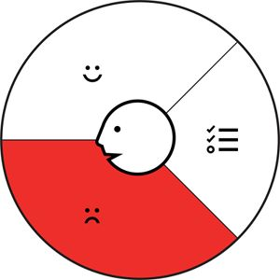

Pain severity

A customer pain can be extreme or moderate, similar to how jobs can be important or insignificant to the customer.



The following list of trigger questions can help you think of different potential customer pains:

* How do your customers define too costly? Takes a lot of time, costs too much money, or requires substantial efforts?
* What makes your customers feel bad? What are their frustrations, annoyances, or things that give them a headache?
* How are current value propositions underperforming for your customers? Which features are they missing? Are there performance issues that annoy them or malfunctions they cite?
* What are the main difficulties and challenges your customers encounter? Do they understand how things work, have difficulties getting certain things done, or resist particular jobs for specific reasons?
* What negative social consequences do your customers encounter or fear? Are they afraid of a loss of face, power, trust, or status?
* What risks do your customers fear? Are they afraid of financial, social, or technical risks, or are they asking themselves what could go wrong?
* What’s keeping your customers awake at night? What are their big issues, concerns, and worries?
* What common mistakes do your customers make? Are they using a solution the wrong way?
* What barriers are keeping your customers from adopting a value proposition? Are there upfront investment costs, a steep learning curve, or other obstacles preventing adoption?

 [Download trigger questions](http://strategyzer.com/vpd/canvas/1.1)

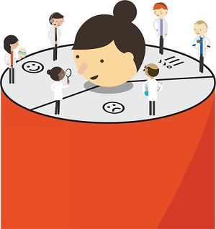



Customer Gains

Gains describe the outcomes and benefits your customers want. Some gains are required, expected, or desired by customers, and some would surprise them. Gains include functional utility, social gains, positive emotions, and cost savings.

Seek to identify four types of customer gains in terms of outcomes and benefits:

Required gains

These are gains without which a solution wouldn’t work. For example, the most basic expectation that we have from a smartphone is that we can make a call with it.

Expected gains

These are relatively basic gains that we expect from a solution, even if it could work without them. For example, since Apple launched the iPhone, we expect phones to be well-designed and look good.

Desired gains

These are gains that go beyond what we expect from a solution but would love to have if we could. These are usually gains that customers would come up with if you asked them. For example, we desire smartphones to be seamlessly integrated with our other devices.

Unexpected gains

These are gains that go beyond customer expectations and desires. They wouldn’t even come up with them if you asked them. Before Apple brought touch screens and the App Store to the mainstream, nobody really thought of them as part of a phone.

Tip: Make gains concrete.

As with pains, it’s better to describe gains as concretely as possible to clearly differentiate jobs, pains, and gains from one another. Ask how much they’d expect or dream of when a customer indicates “better performance” as a desired gain. That way you can note “would love an increased performance of more than x.” When you understand how exactly customers measure gains (i.e., outcomes and benefits), you can design better gain creators in your value proposition.

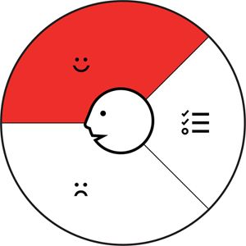

Gain relevance

A customer gain can feel essential or nice to have, just like pains can feel extreme or moderate to them.



The following list of trigger questions can help you think of different potential customer gains:

* Which savings would make your customers happy? Which savings in terms of time, money, and effort would they value?
* What quality levels do they expect, and what would they wish for more or less of?
* How do current value propositions delight your customers? Which specific features do they enjoy? What performance and quality do they expect?
* What would make your customers’ jobs or lives easier? Could there be a flatter learning curve, more services, or lower costs of ownership?
* What positive social consequences do your customers desire? What makes them look good? What increases their power or their status?
* What are customers looking for most? Are they searching for good design, guarantees, specific or more features?
* What do customers dream about? What do they aspire to achieve, or what would be a big relief to them?
* How do your customers measure success and failure? How do they gauge performance or cost?
* What would increase your customers’ likelihood of adopting a value proposition? Do they desire lower cost, less investment, lower risk, or better quality?

 [Download trigger questions](http://strategyzer.com/vpd/canvas/1.1)



Profile of a “Business Book Reader”

We chose to use potential readers of this book to illustrate the customer profile. We deliberately went beyond jobs, pains, and gains merely related to reading books, since we intended to design an innovative and more holistic value proposition for businesspeople in general.

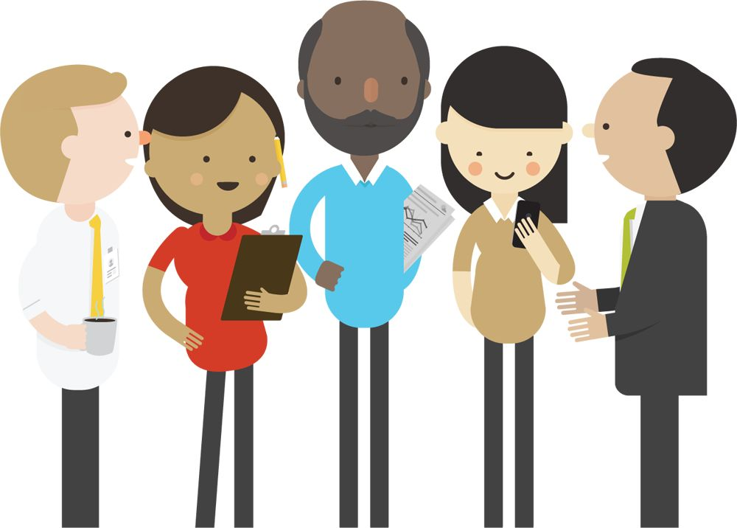

The customer profile sketched out on the right is informed by several interviews we conducted and thousands of interactions we had with workshop participants. However, it is not mandatory to start with preexisting customer knowledge. You may begin exploring ideas by sketching out a profile based on what you believe your potential customers look like. This is an excellent starting point to prepare customer interviews and tests regarding your assumptions about customer jobs, pains, and gains.

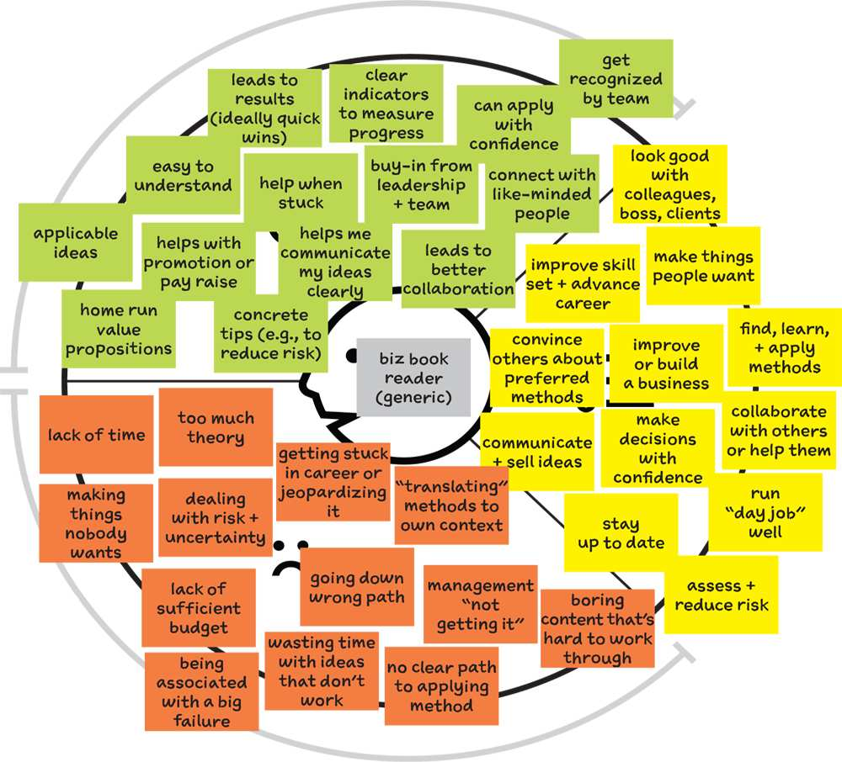

|  |  |
| --- | --- |
| Customer Profile Breakdown |  |
| Gains are benefits, results, and characteristics that customers require or desire. They are outcomes of jobs or wanted characteristics of a value proposition that help customers get a job done well. |  |
|  | The more tangible and specific you make pains and gains, the better. For example, “examples from my industry” is more concrete than “relevant to my context.” Ask customers how they measure gains and pains. Investigate how they measure success or failure of a job they want to get done. |
| Make sure you deeply understand your customer. If you have only a few sticky notes on your profile, that probably indicates a lack of customer understanding. Unearth as many jobs, pains, and gains as you can. Search beyond those directly related to your value proposition. |  |
|  | You should know your customers’ social and emotional jobs in addition to their functional jobs, which are usually easier to identify. |
|  | Make sure you go beyond a superficial understanding of jobs. Why do customers want to “learn new knowledge”? It might be that they want to bring new methods into their organization. Ask “why” several times to get to the most important jobs. |
|  | Make sure you don’t just consider jobs, pains, and gains related to a value proposition or product in mind. Identify those (e.g., “Business books are too long”) as well as other extreme pains (e.g., “lack of time” or “get boss’s attention”). |



Ranking Jobs, Pains, and Gains

Although individual customer preferences vary, you need to get a sense of customer priorities. Investigate which jobs the majority consider important or insignificant. Find out which pains they find extreme versus merely moderate. Learn which gains they find essential and which are simply nice to have.

Ranking jobs, pains, and gains is essential in order to design value propositions that address things customers really care about. Of course, it’s difficult to unearth what really matters to customers, but your understanding will improve with every customer interaction and experiment.

It doesn’t matter if you start out with a ranking that is based on what you think is important to your potential customers as long as you strive to test that ranking until it truly reflects priorities from the customer’s perspective.

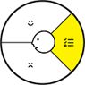

Job importance  
Rank jobs according to their importance to customers.

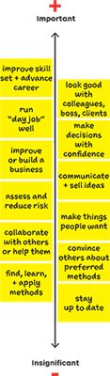

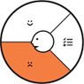

Pain severity  
Rank pains according to how extreme they are in the customers’ eyes.

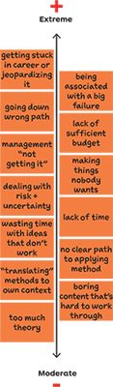

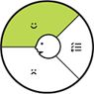

Gain relevance  
Rank gains according to how essential they are in the customers’ eyes.

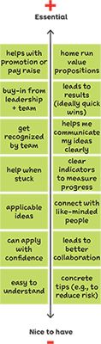



EXERCISE

STEP INTO YOUR CUSTOMERS’ SHOES

### OBJECTIVE

Visualize what matters to your customers in a shareable format

### OUTCOME

One page actionable customer profile

How good is your understanding of your customers’ jobs, pains, and gains? Map out a customer profile.

Instructions

Map the profile of one of your currently existing customer segments to practice using the customer profile. If you are working on a new idea, sketch out the customer segment you intend to create value for.

1. Download the Customer profile Canvas.
2. Grab a set of small sticky notes.
3. Map out your customer profile.

1

Select customer segment.

Select a customer segment that you want to profile.

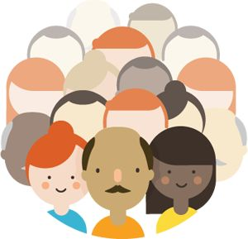

2

Identify customer jobs.

Ask what tasks your customers are trying to complete. Map out all of their jobs by writing each one on an individual sticky note.

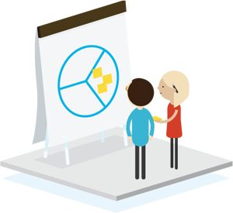

3

Identify customer pains.

What pains do your customers have? Write down as many as you can come up with, including obstacles and risks.

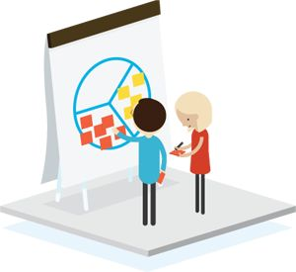

4

Identify customer gains.

What outcomes and benefits do your customers want to achieve? Write down as many gains as you can come up with.

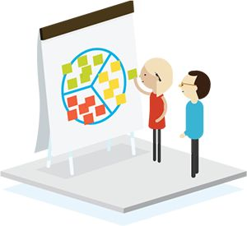

5

Prioritize jobs, pains, and gains.

Order jobs, pains, and gains in a column, each with the most important jobs, most extreme pains, and essential gains on top and the moderate pains and nice-to-have gains at the bottom.

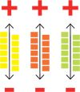

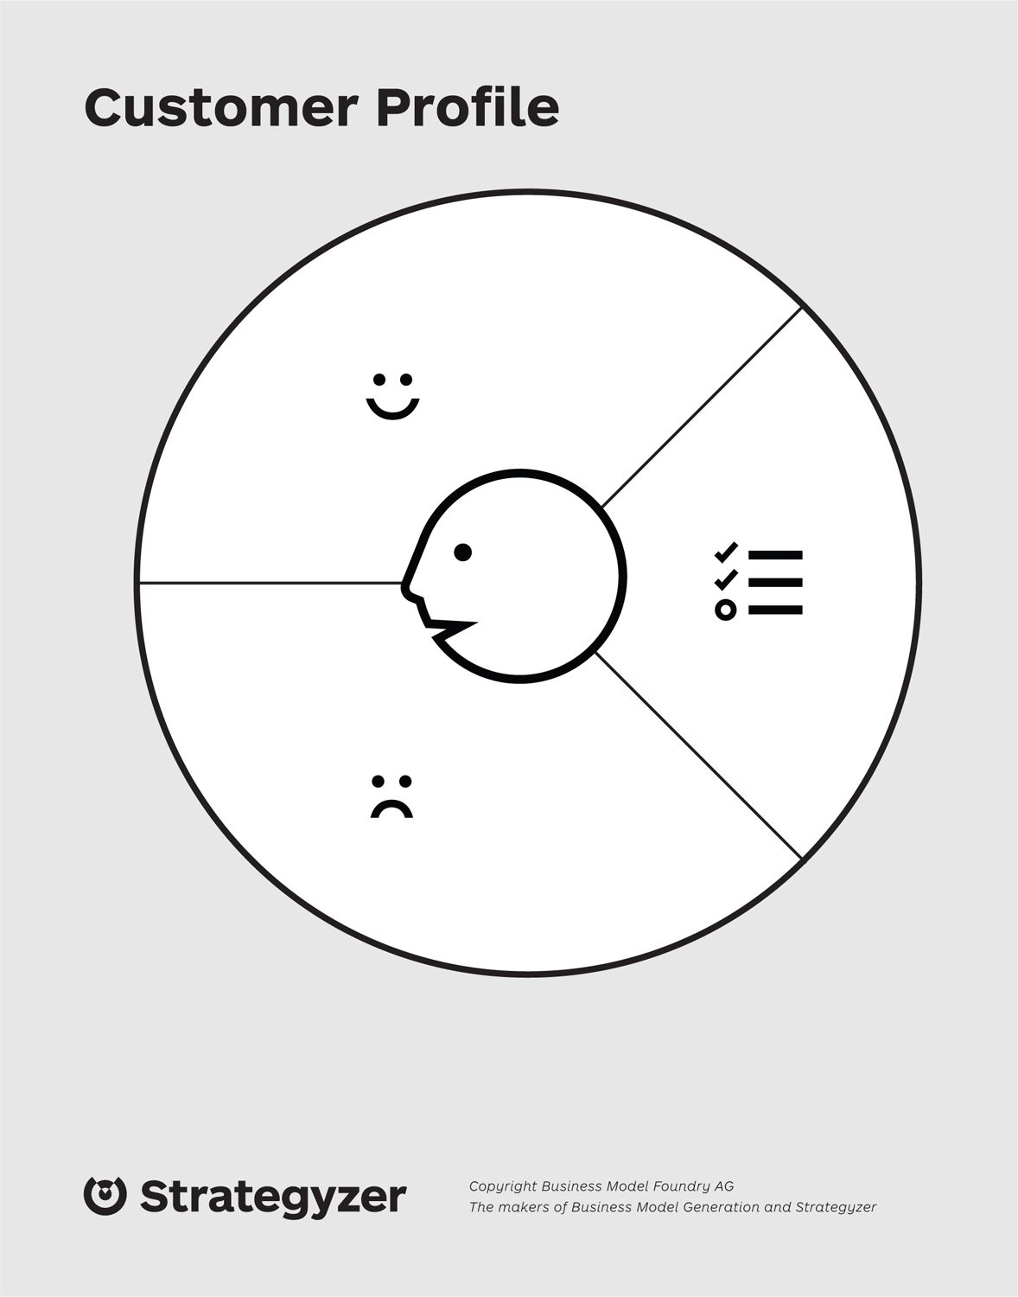



Best Practices for Mapping Jobs, Pains, and Gains

Avoid frequently committed mistakes when profiling a customer, and instead follow these best practices.

 Common Mistakes

Mixing several customer segments into one profile.

Mixing jobs and outcomes.

Focusing on functional jobs only and forgetting social and emotional jobs.

Listing jobs, pains, and gains with your value proposition in mind.

Identifying too few jobs, pains, and gains.

Being too vague in descriptions of pains and gains.

Best Practices

Make a Value Proposition Canvas for every different customer segment. If you sell to companies, ask yourself if you have different types of customers within each company (e.g., users, buyers).

Jobs are the tasks customers are trying to perform, the problems they are trying to solve, or the needs they are trying to satisfy, whereas gains are the concrete outcomes they want to achieve—or avoid and eliminate in the case of pains.

Sometimes social or emotional jobs are even more important than the “visible” functional jobs. “Looking good in front of others” might be more important than finding a great technical solution that helps complete the job effectively.

When you map your customer, you should proceed like an anthropologist and “forget” what you are offering. For example, a business publisher should not map jobs, pains, and gains merely related to books, because a reader has the choice between business books, consultants, YouTube videos, or even completing an MBA program or training. Go beyond the jobs, pains, and gains you intend or hope to address with your value proposition.

A good customer profile is full of sticky notes, because most customers have a lot of pains and expect or desire a lot of gains. Map out all your (potential) customers’ important jobs, extreme pains, and essential gains.

Make pains and gains tangible and concrete. Rather than just writing “salary increase” in gains, specify how much of an increase a customer is seeking. Rather than writing “takes too long” in pains, indicate how long “too long” actually is. This will allow you to understand how exactly customers measure success and failure.

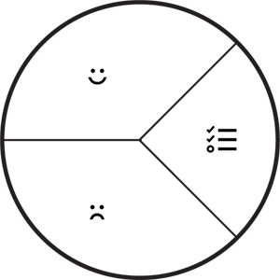

  
Pains vs. Gains

When you get started with the customer profile, you might simply put the same ideas in pains and gains as opposites of each other. For example, if one of the customers’ jobs to be done is “earn more money,” you might start by adding “salary increase” to gains and “salary decrease” to pains.

Here’s a better way to do it:

* Find out precisely how much more money the customer expects to earn so it feels like a gain and investigate what decrease would feel like a pain.
* In the pains, add the barriers that prevent or make it difficult to get a job done. In our example the pain might be “my employer doesn’t give raises.”
* In the pains, add the risks related to not getting the job done. In our example the pain could be “might not be able to afford my child’s future college tuition.”

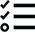  
Ask “why” several times until you really understand your customers’ jobs to be done.

Another issue when you get started with the customer profile is that you might settle with a superficial understanding of your customer’s jobs. To avoid this, you need to ask yourself why a customer wants to perform a certain job to dig deeper toward the real motivations.

For example, why might a customer want to learn a foreign language? Maybe because the “real” customer job to be done is to improve his CV. Why does he want to improve his CV? Maybe because he wants to earn more money.

Don’t settle until you really understand the underlying jobs to be done that really drive customers.





1.2  
Value Map

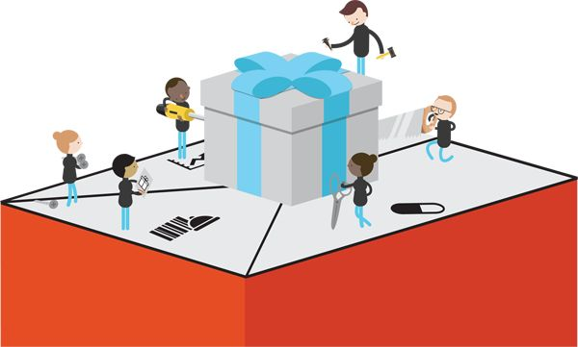

Products and Services

This is simply a list of what you offer. Think of it as all the items your customers can see in your shop window–metaphorically speaking. It’s an enumeration of all the products and services your value proposition builds on. This bundle of products and services helps your customers complete either functional, social, or emotional jobs or helps them satisfy basic needs. It is crucial to acknowledge that products and services don’t create value alone–only in relationship to a specific customer segment and their jobs, pains, and gains.

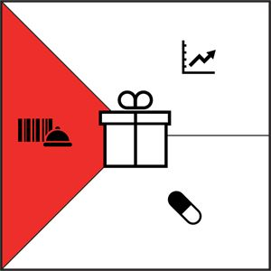

|  |  |
| --- | --- |
| 00036.jpeg | Gain Creators describe how your products and services create customer gains. |
| 00037.jpeg | Pain Relievers describe how your products and services alleviate customer pains. |
| 00038.jpeg | This is a list of all the Products and Services a value proposition is built around. |

Your list of products and services may also include supporting ones that help your customers perform the roles of buyer (those that help customers compare offers, decide, and buy), co-creator (those that help customers co-design value propositions), and transferrer (those that help customers dispose of a product).

Your value proposition is likely to be composed of various types of products and services:

Physical/tangible

Goods, such as manufactured products.

Intangible

Products such as copyrights or services such as after-sales assistance.

Digital

Products such as music downloads or services such as online recommendations.

Financial

Products such as investment funds and insurances or services such as the financing of a purchase.

Relevance

It is essential to acknowledge that not all products and services have the same relevance to your customers. Some products and services are essential to your value proposition; some are merely nice to have.





Pain Relievers

Pain relievers describe how exactly your products and services alleviate specific customer pains. They explicitly outline how you intend to eliminate or reduce some of the things that annoy your customers before, during, or after they are trying to complete a job or that prevent them from doing so.

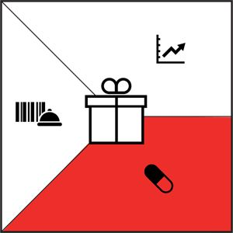

Great value propositions focus on pains that matter to customers, in particular extreme pains. You don’t need to come up with a pain reliever for every pain you’ve identified in the customer profile–no value proposition can do this. Great value propositions often focus only on few pains that they alleviate extremely well.

The following list of trigger questions can help you think of different ways your products and services may help your customers alleviate pains.

Ask yourself: Could your products and services . . .

* produce savings? In terms of time, money, or efforts.
* make your customers feel better? By killing frustrations, annoyances, and other things that give customers a headache.
* fix underperforming solutions? By introducing new features, better performance, or enhanced quality.
* put an end to difficulties and challenges your customers encounter? By making things easier or eliminating obstacles.
* wipe out negative social consequences your customers encounter or fear? In terms of loss of face or lost power, trust, or status.
* eliminate risks your customers fear? In terms of financial, social, technical risks, or things that could potentially go wrong.
* help your customers better sleep at night? By addressing significant issues, diminishing concerns, or eliminating worries.
* limit or eradicate common mistakes customers make? By helping them use a solution the right way.
* eliminate barriers that are keeping your customer from adopting value propositions? Introducing lower or no upfront investment costs, a flatter learning curve, or eliminating other obstacles preventing adoption.

Relevance

A pain reliever can be more or less valuable to the customer. Make sure you differentiate between essential pain relievers and ones that are nice to have. The former relieve extreme issues, often in a radical way, and create a lot of value. The latter merely relieve moderate pains.



 [Download trigger questions](http://strategyzer.com/vpd/canvas/1.2)



Gain Creators

Gain creators describe how your products and services create customer gains. They explicitly outline how you intend to produce outcomes and benefits that your customer expects, desires, or would be surprised by, including functional utility, social gains, positive emotions, and cost savings.

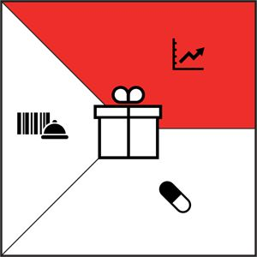

As with pain relievers, gain creators don’t need to address every gain identified in the customer profile. Focus on those that are relevant to customers and where your products and services can make a difference.

The following list of trigger questions can help you think of different ways your products and services may help your customers obtain required, expected, desired, or unexpected outcomes and benefits.

Ask yourself: Could your products and services . . .

* create savings that please your customers? In terms of time, money, and effort.
* produce outcomes your customers expect or that exceed their expectations? By offering quality levels, more of something, or less of something.
* outperform current value propositions and delight your customers? Regarding specific features, performance, or quality.
* make your customers’ work or life easier? Via better usability, accessibility, more services, or lower cost of ownership.
* create positive social consequences? By making them look good or producing an increase in power or status.
* do something specific that customers are looking for? In terms of good design, guarantees, or specific or more features.
* fulfill a desire customers dream about? By helping them achieve their aspirations or getting relief from a hardship?
* produce positive outcomes matching your customers’ success and failure criteria? In terms of better performance or lower cost.
* help make adoption easier? Through lower cost, fewer investments, lower risk, better quality, improved performance, or better design.

Relevance

A gain creator can produce more or less relevant outcomes and benefits for the customer just like we have seen for pain relievers. Make sure you differentiate between essential and nice to have gain creators.



 [Download trigger questions](http://strategyzer.com/vpd/canvas/1.2)



Mapping the Value Proposition of Value Proposition Design

Remarkable value propositions focus on jobs, pains, and gains that matter to customers and achieve those exceedingly well. Again, you should not try to address all customer pains and gains. Focus on those that will make a difference for your customer.

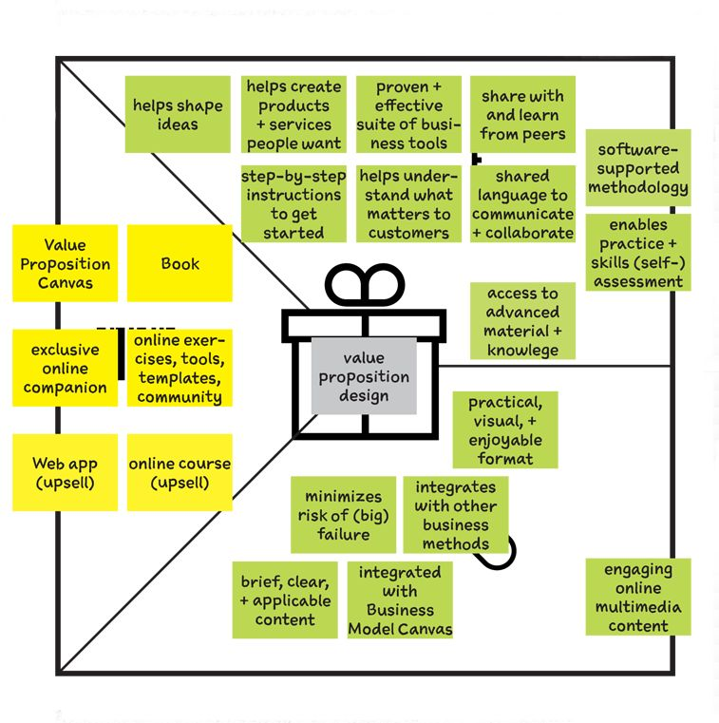

It’s okay to aggregate several value propositions into one.

“Naked" list of the products and services that your value proposition builds on to target a specific customer segment.

Pain relievers outline how exactly your products and services kill customer pains. Each pain reliever addresses at least one or more pains or gains. Don’t add products or services here.

Gain creators highlight how exactly your products and services help customers achieve gains. Each gain creator addresses at least one or more pains or gains. Don’t add products or services here.

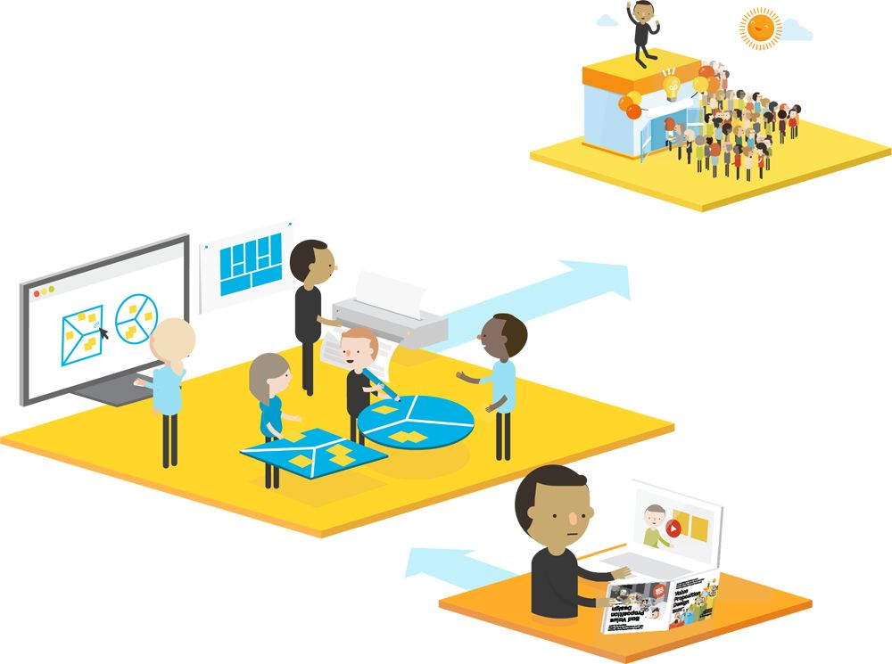

Formal Map of how we believe the products and services around this book create value for customers



EXERCISE

Map How Your Products and Services Create Value

OBJECTIVE

Describe explicitly how your products and services create value

OUTCOME

1 page map of value creation

Instructions

Sketch out the value map of one of your existing value propositions. For example, use one that targets the customer segment you profiled in the previous exercise. It’s easier to get started with an existing value proposition. However, if you don’t have one yet, sketch out how you intend to create value with a new idea. We will cover the creation of new value propositions more specifically later on in this book.

For now:

1. Grab the customer profile you previously completed.
2. Download the value map.
3. Grab a set of small sticky notes.
4. Map out how you create value for your customers.

 [Download the Value Map pdf](http://strategyzer.com/vpd/canvas/1.2)

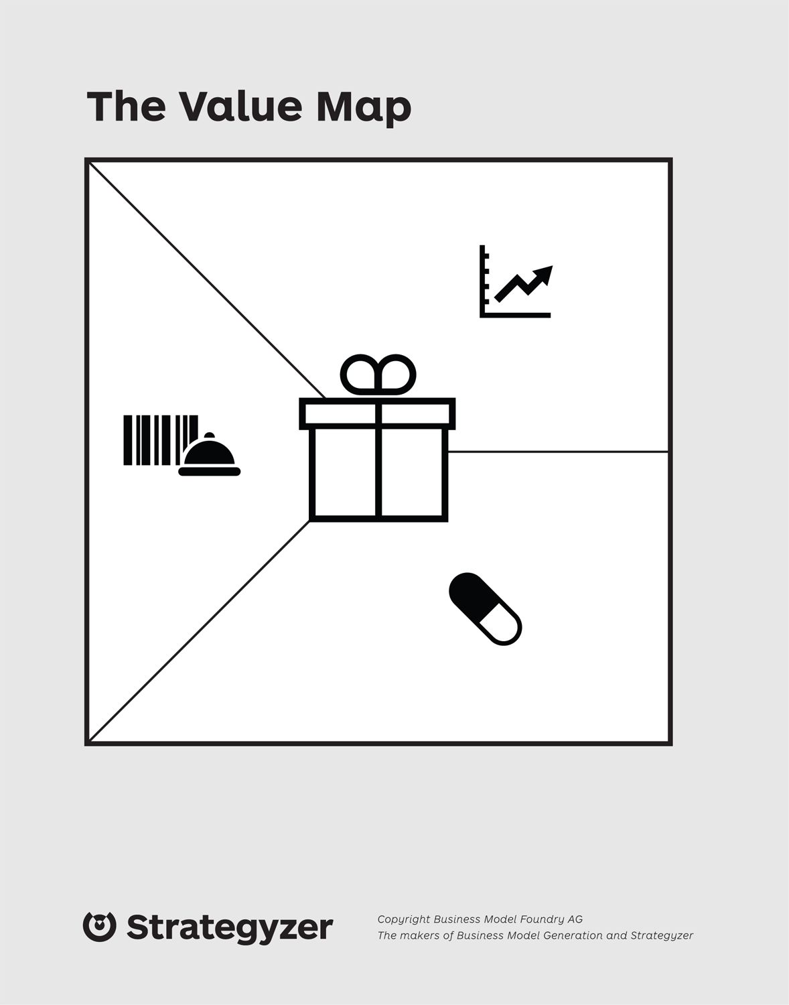

1

List products and services.

List all the products and services of your existing value proposition.

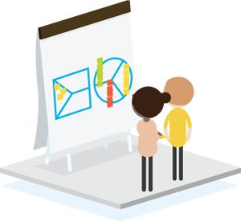

2

Outline pain relievers.

Outline how your products and services currently help customers alleviate pains by eliminating undesired outcomes, obstacles, or risks. Use one sticky note per pain reliever.

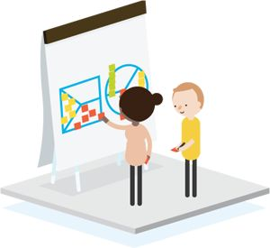

3

Outline gain creators.

Explain how your products and services currently create expected or desired outcomes and benefits for customers. Use one sticky note per gain creator.

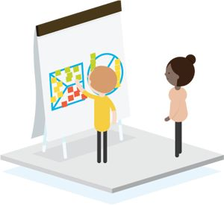

4

Rank by order of importance.

Rank products and services, pain relievers, and gain creators according to how essential they are to customers.



 [Do this exercise online](http://strategyzer.com/vpd/canvas/1.2)

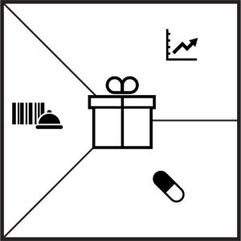

#### 00081.jpeg Pain relievers vs. Gain creators

Pain relievers and gain creators both create value for the customer in different ways. The difference is that the former specifically addresses pains in the customer profile, while the latter specifically addresses gains. It is okay if either of them addresses pains and gains at the same time. The main goal of these two areas is to make the customer value creation of your products and services explicit.

#### 00082.jpeg What is the difference with the pains and gains in the customer profile?

Pain relievers and gain creators are distinctly different from pains and gains. You have control over the former, whereas you don’t have control over the latter. You decide (i.e., design) how you intend to create value by addressing specific jobs, pains, and gains. You don’t decide over which jobs, pains, and gains the customer has. And no value proposition addresses all of a customer’s jobs, pains, and gains. The best ones address those that matter most to customers and do so extremely well.



Best Practices for Mapping Value Creation

 Common Mistakes

List all your products and services rather than just those targeted at a specific segment.

Add products and services to the pain reliever and gain creator fields.

Offer pain relievers and gain creators that have nothing to do with the pains and gains in the customer profile.

Make the unrealistic attempt to address all customer pains and gains.

 Best Practices

Products and services create value only in relationship to a specific customer segment. List only the bundle of products and services that jointly form a value proposition for a specific customer segment.

Pain relievers and gain creators are explanations or characteristics that make the value creation of your products and services explicit. Examples include “helps save time" and “well-designed.

”Remember that products and services don’t create value in absolute terms. It is always relative to customers’ jobs, pains, and gains.

Realize that great value propositions are about making choices regarding which jobs, pains, and gains to address and which to forgo. No value proposition addresses all of them. If your value map indicates so, it’s probably because you’re not honest about all the jobs, pains, and gains that should be in your customer profile.

1.3  
Fit

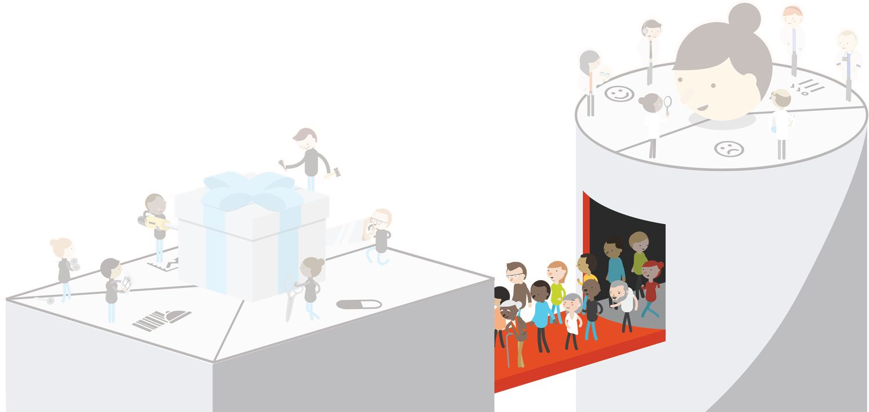

Fit

You achieve fit when customers get excited about your value proposition, which happens when you address important jobs, alleviate extreme pains, and create essential gains that customers care about. As we will explain throughout this book, fit is hard to find and maintain. Striving for fit is the essence of value proposition design.

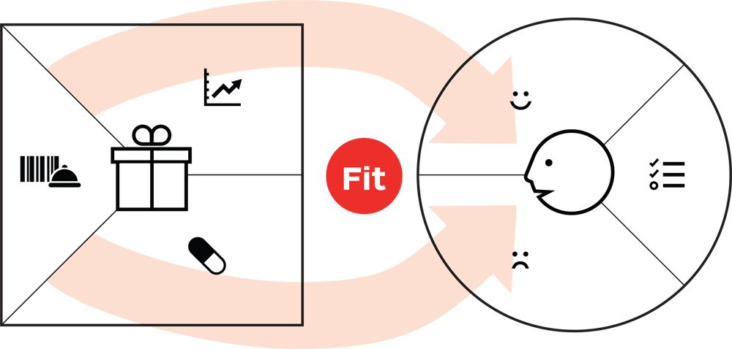

Are you addressing essential customer gains?

Are you addressing extreme customer pains?

Customers expect and desire a lot from products and services, yet they also know they can’t have it all. Focus on those gains that matter most to customers and make a difference.

Customers have a lot of pains. No organization can reasonably address all of them. Focus on those headaches that matter most and are insufficiently addressed.

Your customers are the judge, jury, and executioner of your value proposition. They will be merciless if you don’t find fit!

Fit?

When we designed the value proposition for this book, we strived to address some of the most important jobs, pains, and gains that potential customers have and that are insufficiently addressed by current business book formats.

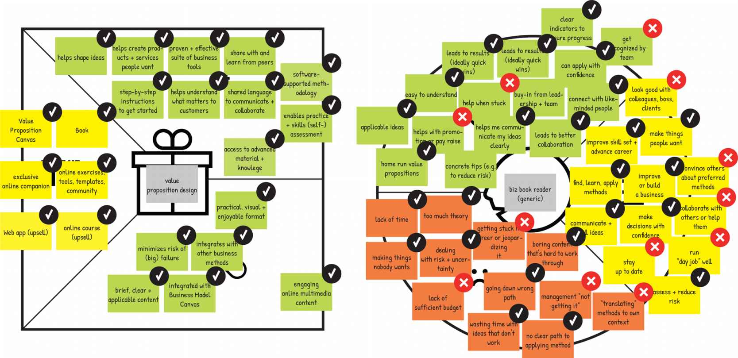

Note

 

Check marks signify that products and services relieve pains or create gains and directly address one of the customers’ jobs, pains, or gains. Xs show which jobs, pains, and gains the value proposition does not address.



EXERCISE

Check Your Fit

OBJECTIVE

Verify if you are addressing what matters to customers

OUTCOME

Connection between your products and services and customer jobs, pains, and gains

 [Do this exercise online](http://strategyzer.com/vpd/canvas/1.3)

1

Instructions

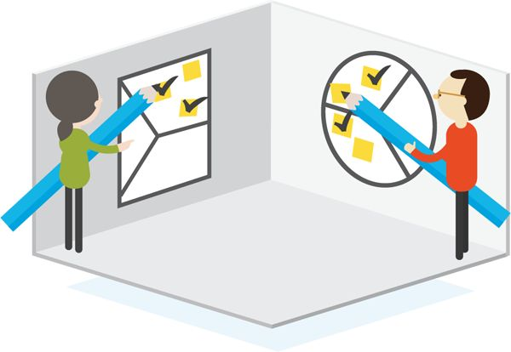

Bring in the Value Proposition Map and Customer Segment Profile you completed earlier. Go through Pain Relievers and Gain Creators one by one, and check to see whether they fit a customer job, pain, or gain. Put a check mark on each one that does.

2

Outcome

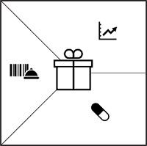

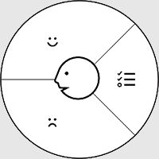

If a pain reliever or gain creator doesn’t fit anything, it may not be creating customer value. Don’t worry if you haven’t checked all pains/gains–you can’t satisfy them all. Ask yourself, how well does your value proposition really fit your customer?

 [Download the Value Proposition Canvas pdf](http://strategyzer.com/vpd/canvas/1.3)



Three Kinds of Fit

Searching for Fit is the process of designing value propositions around products and services that meet jobs, pains, and gains that customers really care about. Fit between what a company offers and what customers want is the number one requirement of a successful value proposition.

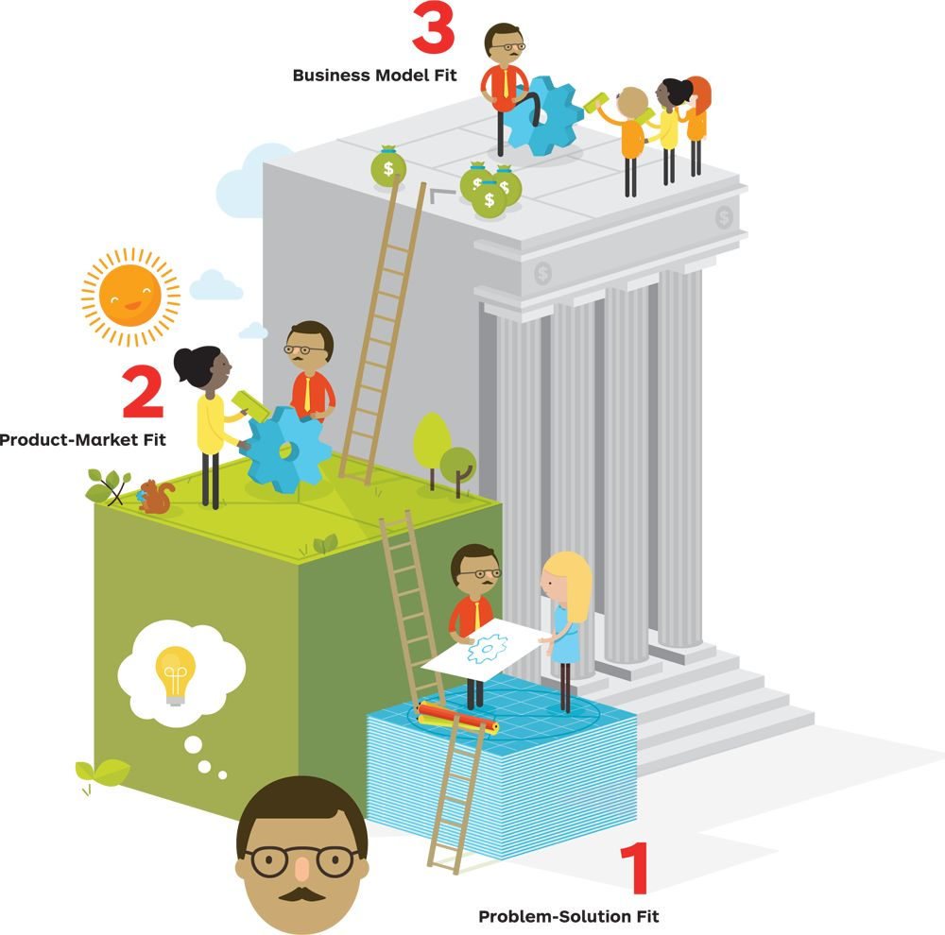

Fit happens in three stages. The first occurs when you identify relevant customer jobs, pains, and gains you believe you can address with your value proposition. The second occurs when customers positively react to your value proposition and it gets traction in the market. The start-up movement calls these problem-solution fit and product-market fit, respectively. The third occurs when you find a business model that is scalable and profitable.

 [Get “Fit” poster](http://strategyzer.com/vpd/canvas/1.3)

 On Paper

1. Problem-Solution Fit

Problem-solution fit takes place when you

* Have evidence that customers care about certain jobs, pains, and gains.
* Designed a value proposition that addresses those jobs, pains, and gains.

At this stage you don’t yet have evidence that customers actually care about your value proposition.

This is when you strive to identify the jobs, pains, and gains that are most relevant to customers and design value propositions accordingly. You prototype multiple alternative value propositions to come up with the ones that produce the best fit. The fit you achieve is not yet proven and exists mainly on paper. Your next steps are to provide evidence that customers care about your value proposition or start over with designing a new one.

 In the Market

2. Product-Market Fit

Product-market fit takes place when you

* Have evidence that your products and services, pain relievers, and gain creators are actually creating customer value and getting traction in the market.

During this second phase, you strive to validate or invalidate the assumptions underlying your value proposition. You will inevitably learn that many of your early ideas simply don’t create customer value (i.e., customers don’t care) and will have to design new value propositions. Finding this second type of fit is a long and iterative process; it doesn’t happen overnight.

 In the Bank

3. Business Model Fit

Business model fit takes place when you

* Have evidence that your value proposition can be embedded in a profitable and scalable business model.

A great value proposition without a great business model may mean suboptimal financial success or even lead to failure. No value proposition–however great–can survive without a sound business model.

The search for business model fit entails a laborious back and forth between designing a value proposition that creates value for customers and a business model that creates value for your organization. You don’t have business model fit until you can generate more revenues with your value proposition than you incur costs to create and deliver it (or “them" in the case of platform models with more than one interdependent value propositions).



Customer Profiles in B2B

Value propositions in business-to-business (B2B) transactions typically involve several stakeholders in the search, evaluation, purchase, and use of a product or service. Each one has a different profile with different jobs, pains, and gains. Stakeholders can tilt the purchasing decision in one direction or another. Identify the most important ones and sketch out a Value Proposition Canvas for each one of them.

Profiles vary according to the sector and size of organization, but they typically include the following roles:

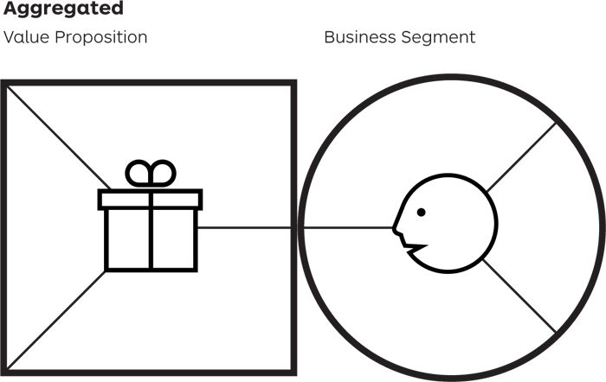

Adapted from Steve Blank, The Four Steps to the Epiphany, 2006.

Aggregated

Value Proposition

Business Segment

+Unbundled

Value propositions to stakeholders within the business

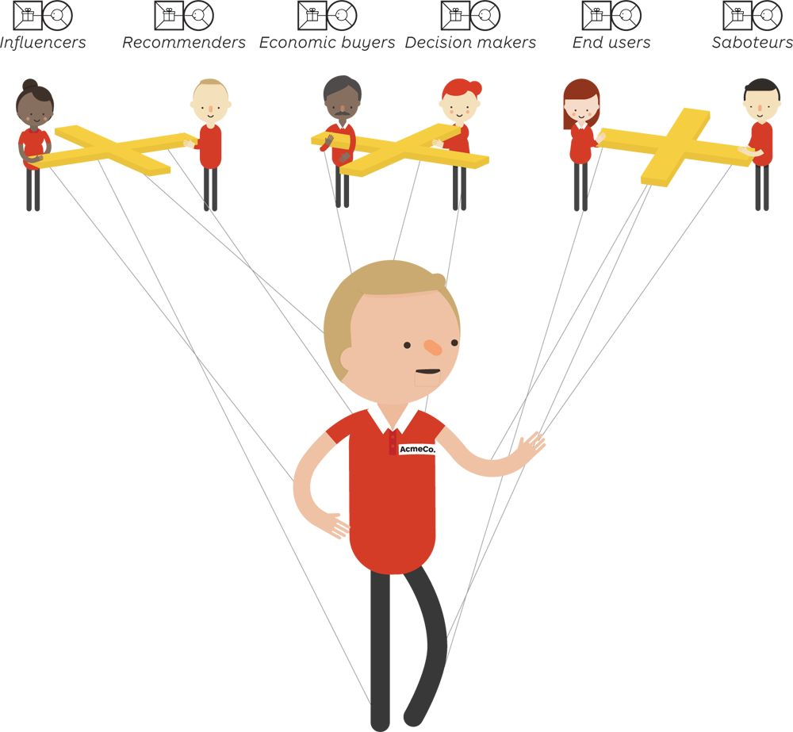

Organizations are customers that are composed of different stakeholders who all have different jobs, pains, and gains. Consider making a Value Proposition Canvas for each one.

#### Influencers

Individuals or groups whose opinions might count and whom the decision maker might listen to, even in an informal way.

#### Recommenders

The people carrying out the search and evaluation process and who make a formal recommendation for or against a purchase.

#### Economic Buyers

The individual or group who controls the budget and who makes the actual purchase. Their concerns are typically about financial performance and budgetary efficiency.

In some cases, the economic buyer may sit outside an organization, such as a government paying for the basic medical supply in nursing homes for elderly citizens.

#### Decision Makers

The person or group ultimately responsible for the choice of a product/service and for ordering the purchase decision. Decision makers usually have ultimate authority over the budget.

#### End Users

The ultimate beneficiaries of a product or service. For a business customer, end users can either be within their own organization (a manufacturer buying software for its designers), or they can be external customers (a device manufacturer buying chips for the smartphones it sells to consumers). End users may be passive or active, depending on how much say they have in the decision and purchase process.

#### Saboteurs

The people and groups who can obstruct or derail the process of searching, evaluating, and purchasing a product or a service.

Decision makers typically sit inside the customer’s organization, whereas Influencers, recommenders, economic buyers, end users, and saboteurs can sit inside or outside the organization.

Unbundling the Family

Value propositions to the consumer may also involve several stakeholders in the search, evaluation, purchase, and use of a product or service. For example, consider a family that intends to buy a game console. In this situation, there is also a difference between the economic buyer, the influencer, the decision maker, the users, and the saboteurs. It therefore makes sense to sketch out a different Value Proposition Canvas for each stakeholder.



Multiple Fits

Some business models work only with a combination of several value propositions and customer segments. In these situations, you require fit between each value proposition and its respective customer segment for the business model to work.

Two common illustrations of multiple fits are intermediary and platform business models.

#### Intermediary

When a business sells a product or service through an intermediary, it effectively needs to cater to two customers: the end customer and the intermediary itself. Without a clear value proposition to the intermediary, the offer might not reach the end customer at all, or at least not with the same impact.

Chinese firm Haier sells home appliances and electronics to households globally. It does this largely through retailers such as Carrefour, Walmart, and others. To be successful, Haier needs to craft an appealing value proposition both to households (the end customer) and to intermediary distributors.

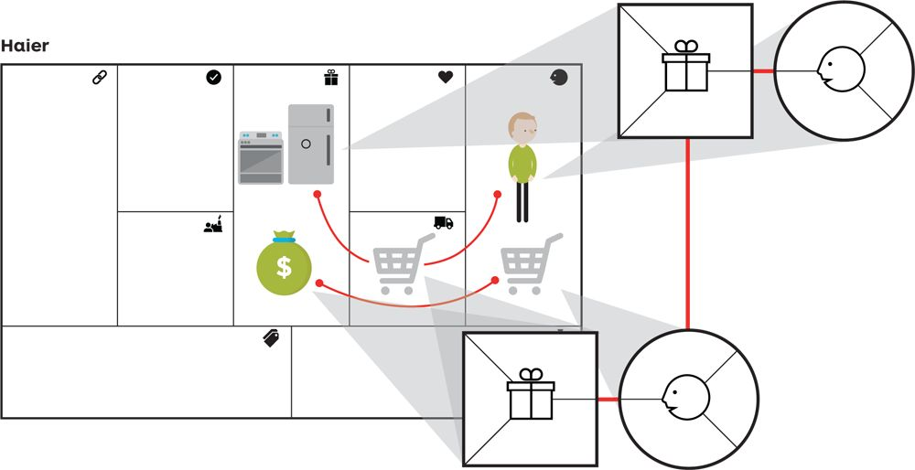

Haier has a value proposition to the end customer, households. Haier has a value proposition to their intermediary customer, the retailers, who are also the main channel for the end customer.

#### Platforms

Platforms function only when two or more actors interact and draw value within the same interdependent business model. Platforms are called double-sided when there are two such actors and multisided when there are more than two. A platform exists only when all sides are present in the model.

Airbnb is an example of a double-sided platform. It is a website that connects local residents with extra space to rent out and travelers looking for alternatives to hotels as a place to stay. In such a case, the business model needs to hold two value propositions, one for local residents (called hosts) and one for travelers.

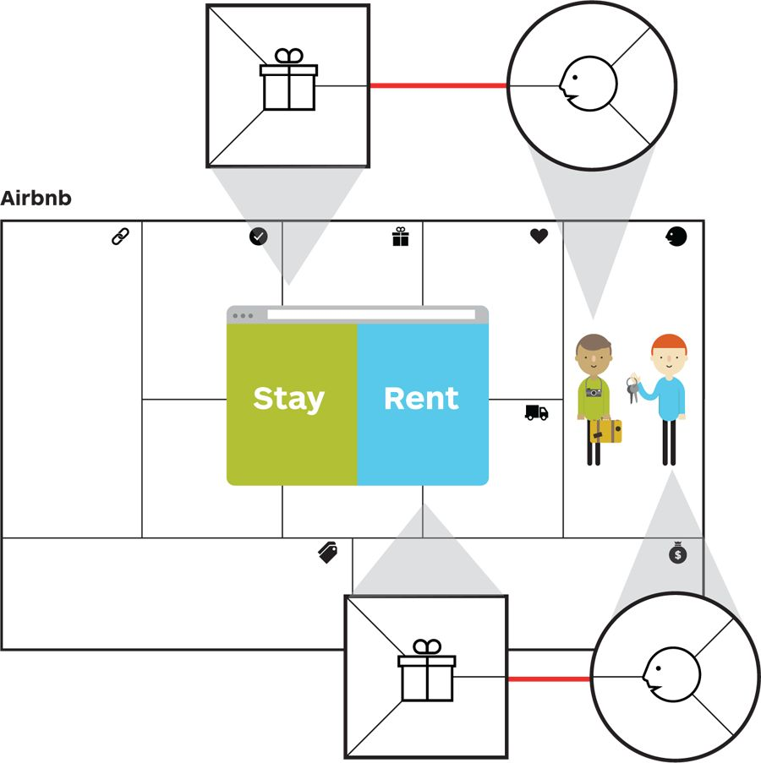



Going to the Movies

Let us walk through the concepts of the Value Proposition Canvas with another simple example. Imagine the owner of a movie theater chain wants to design new value propositions for his customers.

What drives the moviegoer?

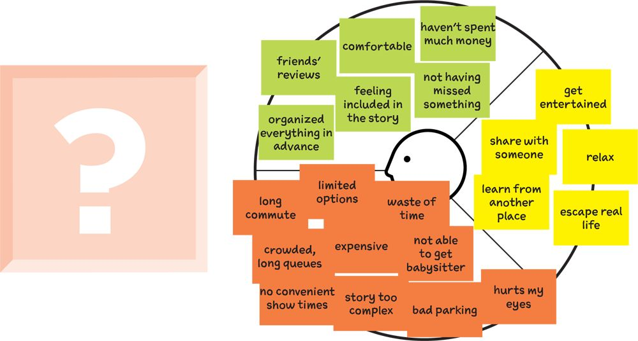

What should the new value proposition look like?

He could start with the value proposition’s features and get excited about the latest generation of big screens, state-of-the-art display technologies, tasty snacks, social happenings, urban experiences, and so on. But, of course, those only really matter if customers care about them. So he sets out to better understand what his customers truly want.

Traditionally he’d sketch out psychodemographic profiles of his customer segments. But this time he decides to complement this type of segmentation with customer profiles that highlight a customer’s jobs, pains, and gains.

#### Tip: A (potential) customer exists independently of your value proposition.

When you sketch out your customer’s profile, don’t just focus on jobs, pains, and gains related to your value proposition. Keep it broad to understand what really drives your customers.

A Movie Theater’s Business Model

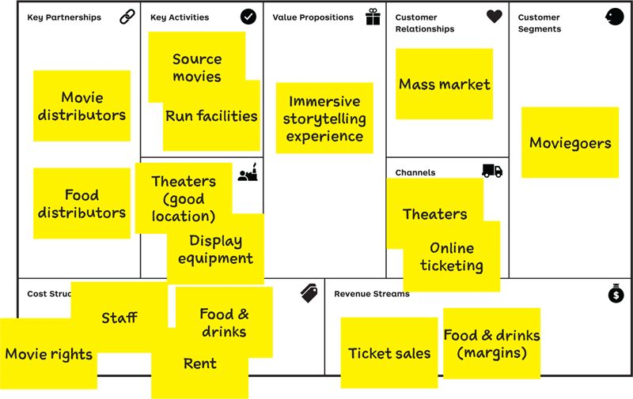

The new approach: focusing on the jobs, pains, and gains that drive customers

By sketching out a customer profile, you aim to uncover what really drives people, rather than just describing their socioeconomic characteristics.

You investigate what they’re trying to achieve, their underlying motives, their objectives, and what’s holding them back. Doing so will broaden your horizon and likely uncover new or better opportunities to satisfy customers.

The traditional approach: psychodemographic profiles



Traditional psychodemographic profiles group consumers into categories that have the same socioeconomic characteristics.

JANE MOVIEGOER

20-30 years old

Upper middle class

Earns $100K/year

Married, 2 children

Movie Behavior:

* Prefers action movies
* Likes popcorn and soda
* Does not like waiting in line
* Buys tickets online
* Goes once a month



Same Customer, Different Contexts

Priorities change depending on a customer’s context. Taking this context into account before you think of a value proposition for that customer is crucial.

With the jobs-to-be-done approach, you uncover the motivations of different customer segments. Yet, depending on the context, some jobs will become more important or matter less than others.

In fact, the context in which a person finds himself or herself often changes the nature of the jobs that the person aims to accomplish.

For example, the clientele of a restaurant is likely to use very different criteria to evaluate their dining experience at lunch versus at dinner. Likewise a mobile phone user will have different job requirements when using the phone in a car, in a meeting, or at home. Hence, the features of your value proposition will be different depending on which context(s) you are focusing.



In our example, the context in which our moviegoer finds herself will influence which jobs matter more or less to her.

Add contextual elements to your customer profiles if necessary. They might serve as constraints for designing value propositions later on.

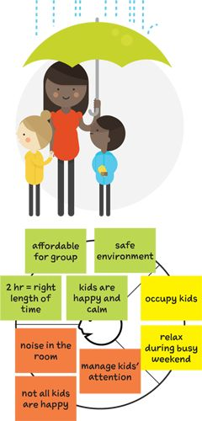

The kids’ afternoon off

When? Wednesday afternoon

Where? Leaving from home

With whom? Kids and maybe their friends

Constraints? After school, before dinner time

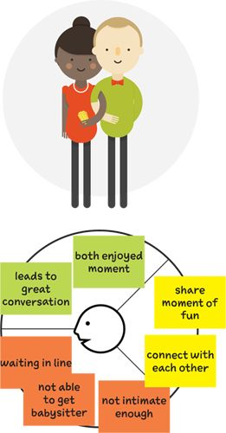

Date night

When? Saturday evening

Where? Leaving from home

With whom? Partner

Constraints? Kids taken care of (if parents)

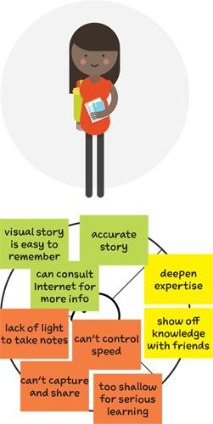

Personal research

When? Any time

Where? Leaving from home

With whom? Alone

Constraints? Needs to be able to take notes



Same Customer, Different Solutions

In today’s hypercompetitive world, customers are surrounded by an ocean of tempting value propositions that all compete for the same limited slots of attention.

Very different value propositions may address similar jobs, pains, and gains. For example, our movie theater chain competes for customer attention not only with other movie theaters but also with a broad range of alternative options: renting a movie at home, going out to dinner, visiting a spa, or maybe even attending an online virtual art exhibit with 3D glasses.

Strive to understand what your customers really care about. Investigate their jobs, pains, and gains beyond what your own value proposition directly addresses in order to imagine totally new or substantially improved ones.



Understand your customers beyond your solution. Unearth the jobs, pains, and gains that matter to them in order to understand how to improve your value proposition or invent new ones.

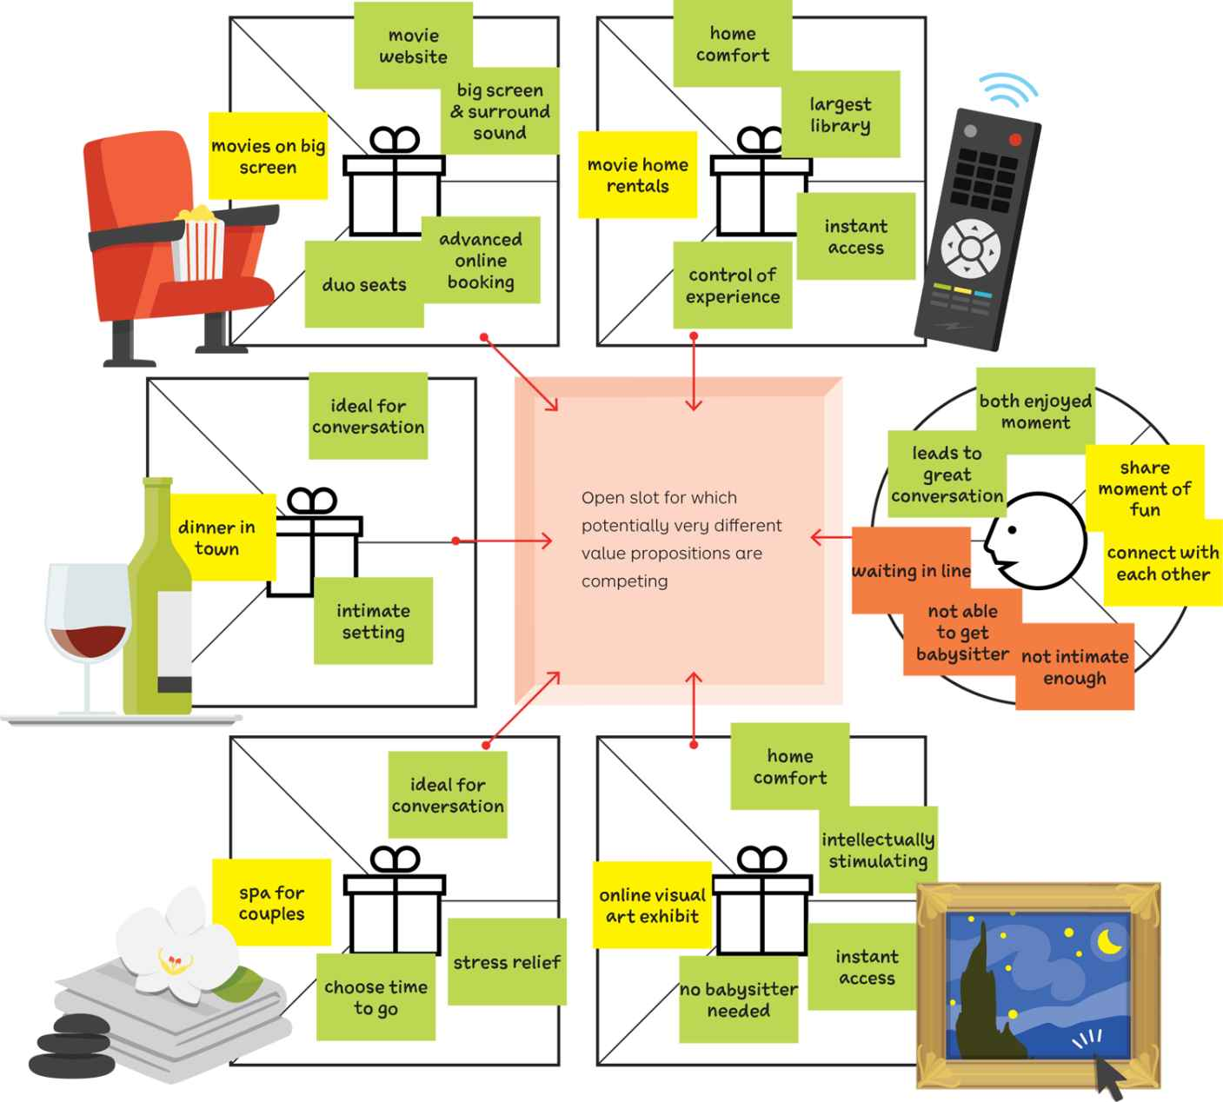



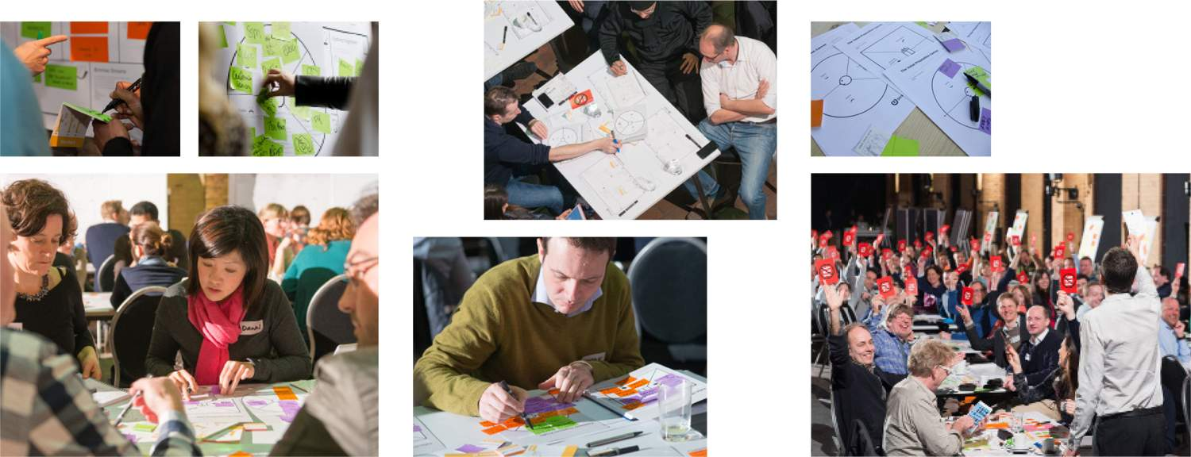

Lessons Learned

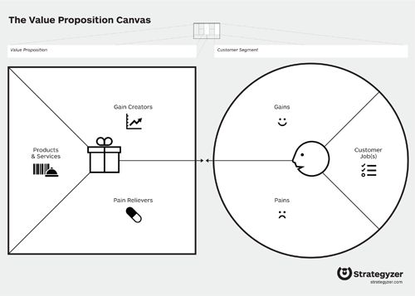

Customer Profile

Use the customer profile to visualize what matters to customers. Specify their jobs, pains, and gains. Communicate the profile across your organization as a one-page actionable document that creates a shared customer understanding. Apply it as a “scoreboard” to track if assumed customer jobs, pains, and gains exist when you talk to real customers.

Value Map

Use the value map to make explicit how you believe your products and services will ease pains and create gains. Communicate the map across your organization as a one-page document that creates a shared understanding of how you intend to create value. Apply it as a “scoreboard” to track if your products actually ease pains and gains when you test them with customers.

Fit

Problem-solution fit: Evidence that customers care about the jobs, pains, and gains you intend to address with your value proposition. Product-market fit: Evidence that customers want your value proposition. Business model fit: Evidence that the business model for your value proposition is scalable and profitable.

 [Download the Value Proposition Canvas pdf](http://strategyzer.com/vpd/canvas/1.3)



Design, Test, Repeat

The search for value propositions that meet customer jobs, pains, and gains is a continuous back and forth between designing prototypes and testing them. The process is iterative rather than sequential. The goal of Value Proposition Design is to test ideas as quickly as possible in order to learn, create better designs, and test again.

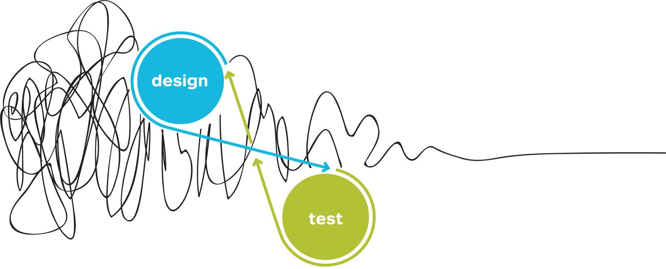



2: Design

Kick-start value proposition design with Prototyping Possibilities for one of your Starting Points. Shape your value propositions by Understanding Customers, then select which ones you want to further explore by Making Choices and Finding the Right Business Model. If you are an existing company, discover the particularities of Designing in Established Organizations.

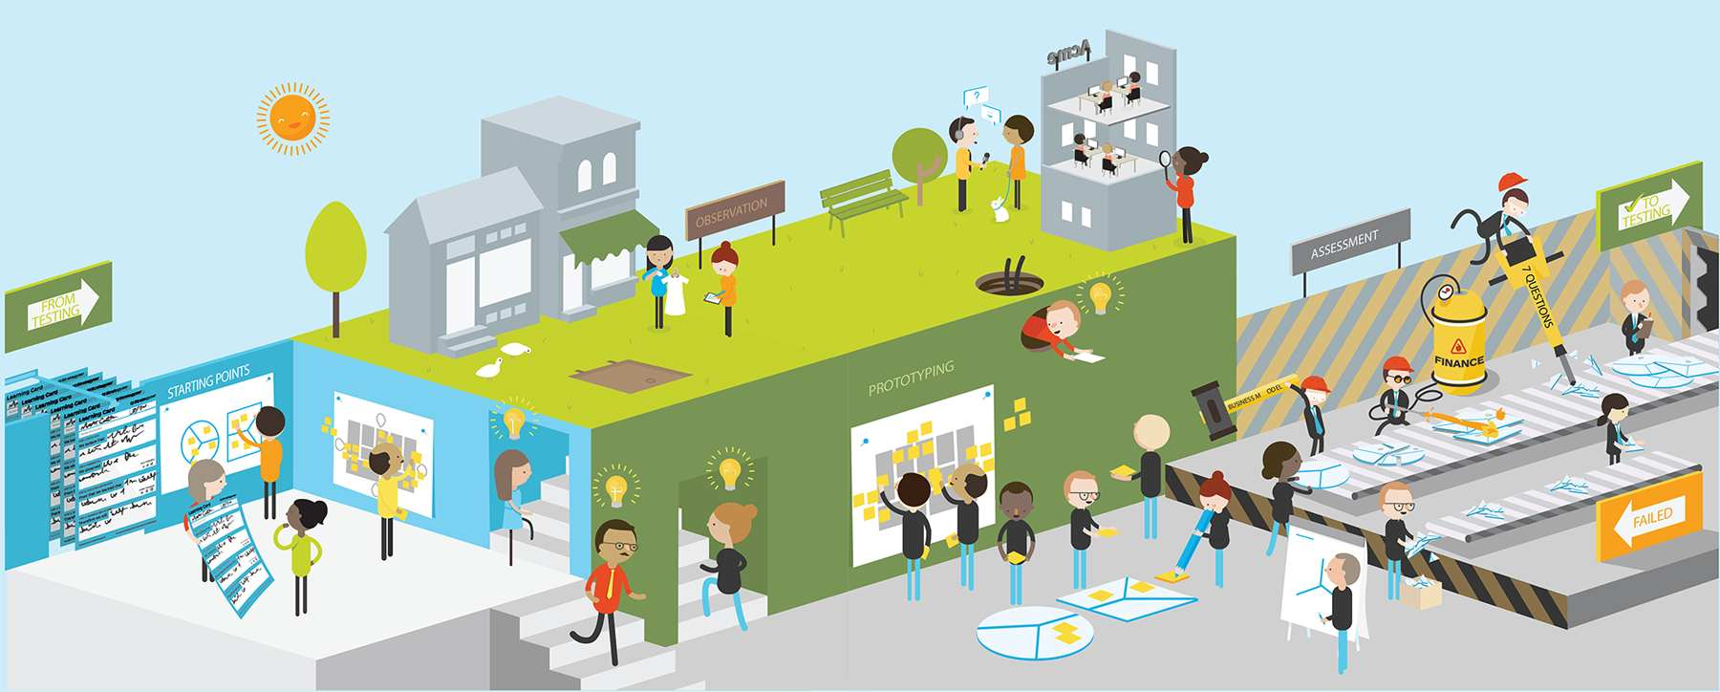

Shaping Your Ideas

Design is the activity of turning your ideas into value proposition prototypes. It is a continuous cycle of prototyping, researching customers, and reshaping your ideas. Design may start with prototyping or with customer discovery. The design activity feeds into the testing activity that we explore in the next chapter (see section 3. Test).

Ideas, Starting Points, and Insights

Starting points for new or improved value propositions may come from anywhere. It could be from your customer insights, from exploration of prototypes, or from many other sources. Be sure not to fall in love with your early ideas, because they are certain to transform radically during prototyping, customer research, and testing.

Prototype Possibilities

Shape your ideas with quick, cheap, and rough prototypes. Make them tangible with napkin sketches, ad-libs, and Value Proposition Canvases. Don’t get attached to a prototype too early. Keep your prototypes light so you can explore possibilities, easily throw them away again, and then find the best ones that survive a rigorous testing process with customers.

Understand Customers

Inform your ideas and prototypes with early customer research. Plough through available data, talk to customers, and immerse yourself in their world. Don’t show customers your value proposition prototypes too early. Use early research to deeply understand your customers’ jobs, pains, and gains. Unearth what really matters to them to prototype value propositions that are likely to survive rigorous testing with customers.

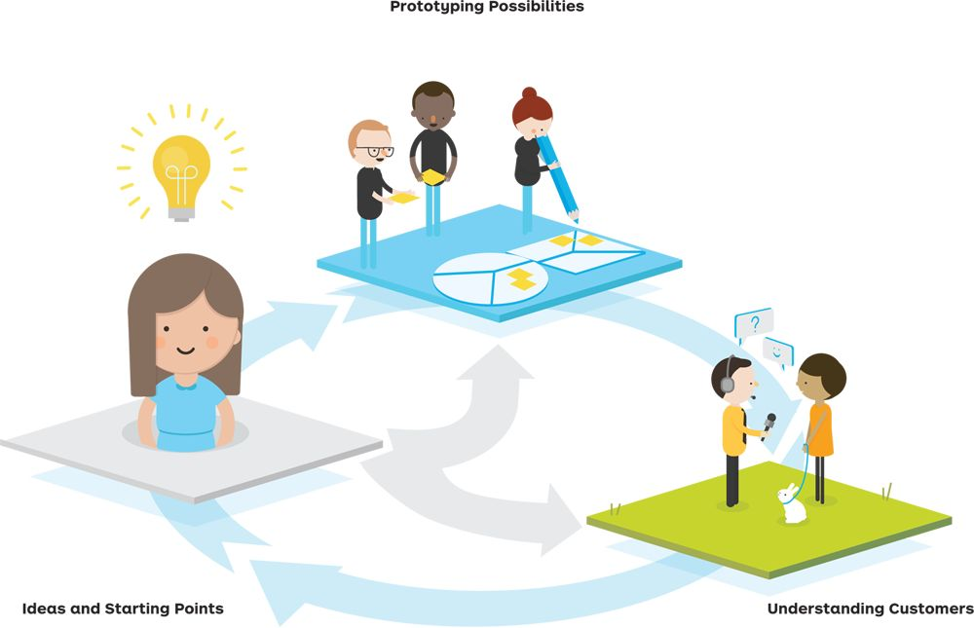

10 Characteristics of Great Value Propositions

Stop for an instant and reflect on the characteristics of great value propositions before reading about how to design them in this chapter. We offer 10 characteristics to get you started. Don’t hesitate to add your own. Great Value Propositions…

 [Get 10 “Characteristics of Great Value Propositions” poster](http://strategyzer.com/vpd/design/2.0)

1

Are embedded in great business models

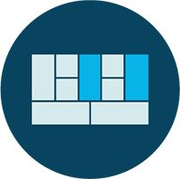

2

Focus on the jobs, pains, and gains that matter most to customers



3

Focus on unsatisfied jobs, unresolved pains, and unrealized gains

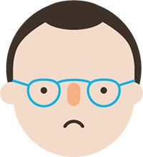

4

Target few jobs, pains, and gains, but do so extremely well



5

Go beyond functional jobs and address emotional and social jobs

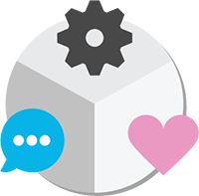

6

Align with how customers measure success



7

Focus on jobs, pains, and gains that a lot of people have or that some will pay a lot of money for

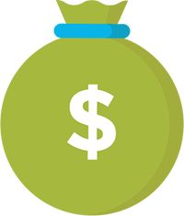

8

Differentiate from competition on jobs, pains, and gains that customers care about

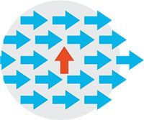

9

Outperform competition substantially on at least one dimension

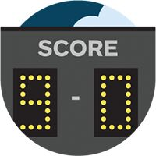

10

Are difficult to copy



# 2.1 Prototyping Possibilities

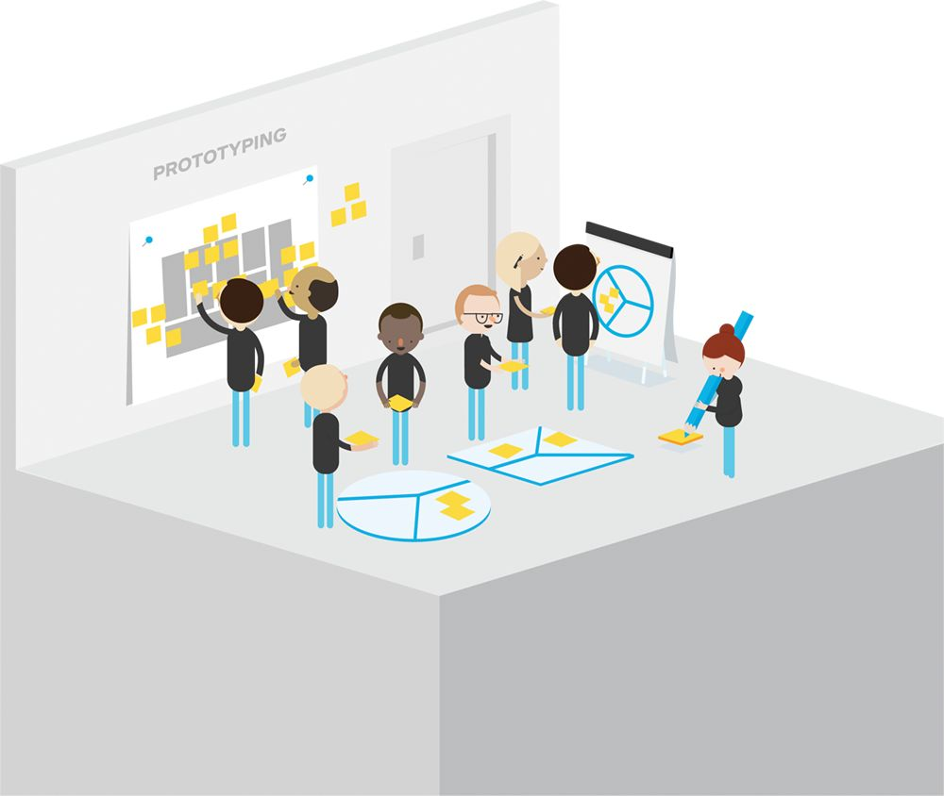

What’s Prototyping?

Use the activity of making quick and rough study models of your idea to explore alternatives, shape your value proposition, and find the best opportunities. Prototyping is common in the design professions for physical artifacts. We apply it to the concept of value propositions to rapidly explore possibilities before testing and building real products and services.

DEF-I-NI-TION  
Prototyping

The practice of building quick, inexpensive, and rough study models to learn about the desirability, feasibility, and viability of alternative value propositions and business models.

Quickly explore radically different directions for the same idea with the following prototyping techniques before refining one in particular.

Napkin Sketches

Make alternatives tangible with napkin sketches. Use a single sketch for every potential direction your idea could take.

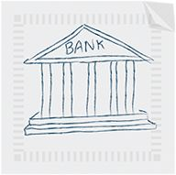

Ad-libs

Pinpoint how different alternatives create value by filling in the blanks in short ad-libs.

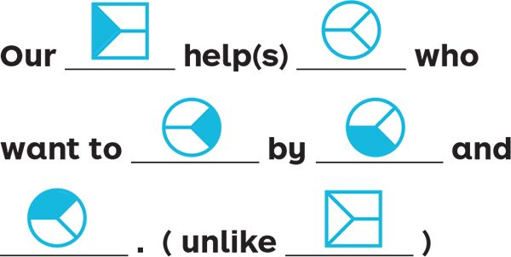

Value Proposition Canvases

Flesh out possible directions with the Value Proposition Canvas. Understand which jobs, pains, and gains each alternative is addressing.

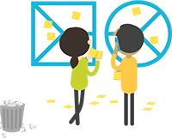

Representation of a Value Proposition

Help customers and partners understand potential value propositions by bringing them to life without building them.

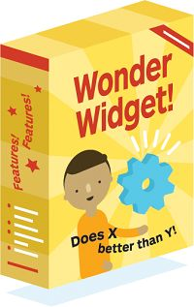

Minimum Viable Product

Build a minimum feature set that brings your value proposition to life and allows testing it with customers and partners.

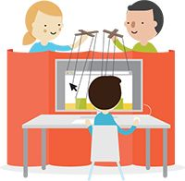

Tips

* Spend a maximum of 5 to 15 minutes on sketching out your early prototypes.
* Always use a visible timer and stick to a predefined time frame.
* Don’t discuss too long which one of several possible directions to prototype. Prototype several of them quickly and then compare.
* Remember constantly that prototyping is an exploratory tool. Don’t spend time on the details of a prototype that is likely to change radically anyway.

10 Prototyping Principles

Unlock the power of prototyping. Resist the temptation of spending time and energy refining one direction only. Rather, use the principles described here to explore multiple directions with the same amount of time and energy. You will learn more and discover better value propositions.

 [Get “10 Prototyping Principles” poster.](http://strategyzer.com/vpd/design/2.1)

## 1

Make it visual and tangible.

These kinds of prototypes spark conversations and learning. Don’t regress into the land of blah blah blah.



## 2

Embrace a beginner’s mind.

Prototype “what can’t be done.” Explore with a fresh mind-set. Don’t let existing knowledge get in the way of exploration.



## 3

Don’t fall in love with first ideas— create alternatives.

Refining your idea(s) too early prevents you from creating and exploring alternatives. Don’t fall in love too quickly.



## 4

Feel comfortable in a “liquid state.”

Early in the process the right direction is unclear. It’s a liquid state. Don’t panic and solidify things too early.



## 5

Start with low fidelity, iterate, and refine.

Refined prototypes are hard to throw away. Keep them rough, quick, and cheap. Refine with increasing knowledge about what works and what doesn’t.

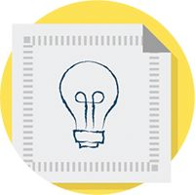

## 6

Expose your work early—seek criticism.

Seek feedback early and often before refining. Don’t take negative feedback personally. It’s worth gold to improve your prototype.

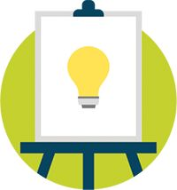

## 7

Learn faster by failing early, often, and cheaply.

Fear of failure holds people back from exploring. Overcome that with a culture of rough and quick prototyping that keeps failure cheap and leads to faster learning.



## 8

Use creativity techniques.

Use creativity techniques to explore groundbreaking prototypes. Dare to break out of how things are usually done in your company or industry.

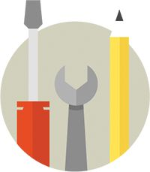

## 9

Create “Shrek models.”

Shrek models are extreme or outrageous prototypes that you are unlikely to build. Use them to spark debate and learning.



## 10

Track learnings, insights, and progress.

Keep track of all your alternative prototypes, learnings, and insights. You might use earlier ideas and insights later in the process.





PROCESS

Make Ideas Visible with Napkin Sketches

### OBJECTIVE

Quickly visualize ideas for value propositions

### Outcome

Alternative prototypes in the form of napkin sketches

Napkin sketches are a rough representation of a value proposition or business model and highlight only the core idea, not how it works. They are rough enough to fit on the back of a napkin and still communicate the idea. Use them early in your prototyping process to explore and discuss alternatives.

##### What is a napkin sketch?

Napkin sketches are a cheap way to make your ideas more tangible and shareable. They avoid going into the details of how an idea works to steer clear of getting hung up with implementation issues.

##### What is it used for?

Use napkin sketches to quickly share and evaluate ideas during the early value proposition design process. Their roughness is deliberate so you can throw ideas away without regret and explore alternatives. You may also use them to gather early feedback from customers.

##### Caveat

Make sure people understand that napkin sketches are an exploratory tool. You will kill or transform many of the sketched out ideas during the prototyping and testing process.

The best napkin sketches…

Contain only one core idea or direction (ideas can be merged later).

Explain what an idea is about, not how it will work (no processes or business models yet!).

Keep things simple enough to get it in a glance (details are for more refined prototypes later on).

Can be pitched in 10 to 30 seconds.

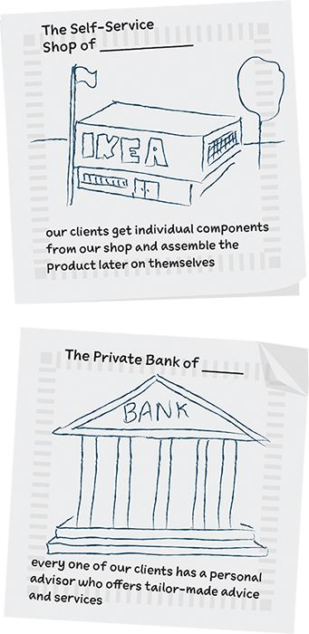

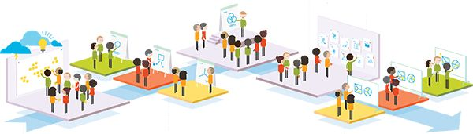

## 1

Brainstorm · 15–20 min

Use different brainstorming techniques, such as trigger questions, 17, 31, 33 or “what if” questions to generate a large quantity of possible directions for interesting value propositions. Don’t worry about choice at this stage. Quantity is better than quality. These are quick and dirty prototypes that will change inevitably.

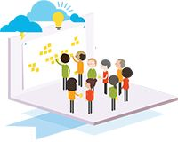

## 2

Draw · 12–15 min

Participants split into break-out groups, and each group quickly picks three ideas for three alternative value propositions. They draw a napkin sketch for each one on a flip chart. Making two or three sketches increases diversity and reduces the risk of endless discussions.



## 3

Pitch · 30 sec per group

One team member of each break-out group takes the stage and pitches the (large) napkin sketches. Each pitch should be no longer than 30 seconds—just enough to outline what the idea is about, not to explain how it works! Make sure there is sufficient diversity across the groups or else send everybody back to the drawing board.

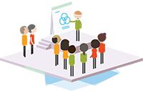

## 4

Display

All napkin sketches are exposed in a sort of gallery on the wall. You should now have a nice diversity of alternative directions.

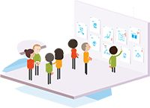

## 5

Dotmocracy · 10–15 min (ideally over a break)

Participants get 10 stickers to vote for their favorite ideas. They can give all votes to one idea or distribute them among several napkin sketches. This is not a decision-making mechanism. It is a process that highlights the ideas that participants are most excited about.



## 6

Prototype

Break-out groups continue by sketching out a value proposition canvas for the one napkin sketch out of their three that got most votes. Potentially redistribute the napkin sketches that got most votes among the different groups.



EXERCISE

Create Possibilities Quickly with Ad-Libs

### OBJECTIVE

Quickly shape potential value proposition directions

### OUTCOME

Alternative prototypes in the form of “pitchable” sentences

Ad-libs are a great way to quickly shape alternative directions for your value proposition. They force you to pinpoint how exactly you are going to create value. Prototype three to five different directions by filling out the blanks in the ad-lib below.

 [Download the template](http://strategyzer.com/vpd/design/2.1)

Our 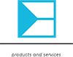 help(s) 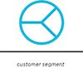 who want to  by  and . (Tip: Add at the beginning or end of sentence: unlike 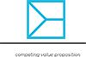)

our  help(s)  who wants to 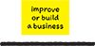 by 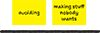 and 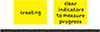.



PROCESS

Flesh out Ideas with Value Proposition Canvases

### OBJECTIVE

Sketch explicitly how different ideas create customer value

### OUTCOME

Alternative prototypes in the form of Value Proposition Canvases

Use the Value Proposition Canvas to sketch out quick alternative prototypes, just like you would with napkin sketches or ad-libs. Don’t just work with the canvas to refine final ideas, but use it as an exploratory tool until you find the right direction.

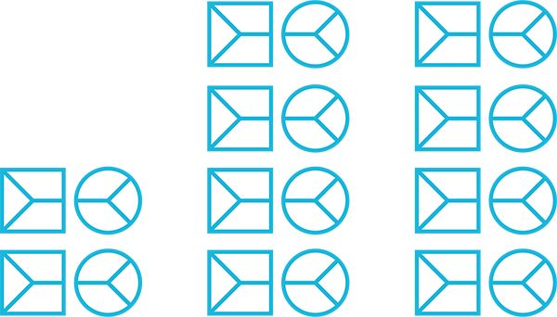

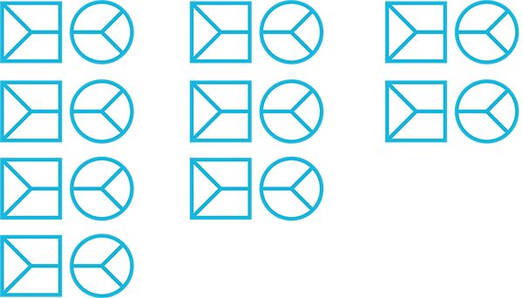



Use a visible timer to constrain the time you spend working on a specific prototype. Keep early prototypes short.



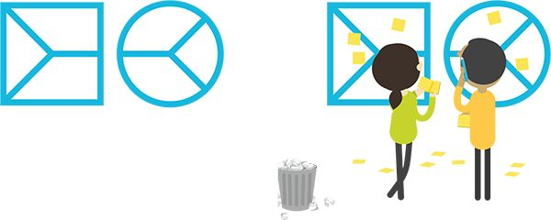

Don't be afraid to prototype radical directions, even if you know you are unlikely to pursue them. Explore and learn.

# 2.2 Starting Points

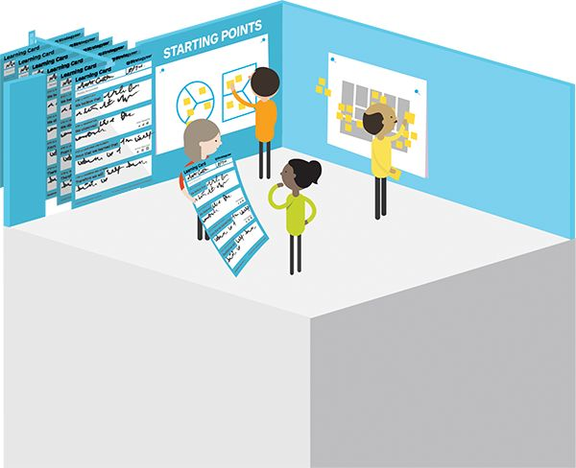

Where to Start

Contrary to popular belief, great new value propositions Don’t always have to start with the customer. They do, however, always have to end with addressing jobs, pains, or gains that customers care about.

On this spread we offer 16 trigger areas to get started with new or improved value propositions. They start from either the customer, your existing value propositions, your business models, your environment, or business models and value propositions from other industries and sectors.

 [Get “ Innovation Starting Points” poster](http://strategyzer.com/vpd/design/2.2)

Could you…

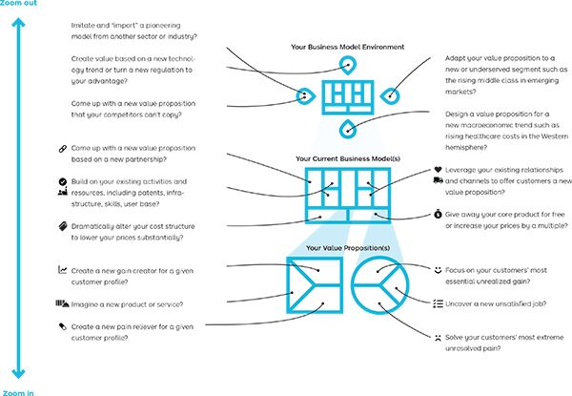



PROCESS

Spark Ideas with Design Constraints

### OBJECTIVE

Force yourself to think outside of the box

### OUTCOME

Ideas that differ from your “usual” value propositions and business models

Use design constraints to force people to think about innovative value propositions embedded in great business models. We outline five constraints of businesses whose value proposition and business model you can copy into your own arena. Don’t hesitate to come up with other ones.

## Servitization

Constraint: Transform from selling a product-based value proposition to a service-based one that generates revenues from a subscription model.

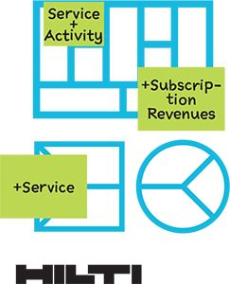

Hilti shifted from selling machine tools to builders to leasing fleet management services to managers at construction companies.

## Razor Blade

Constraint: Create a value proposition composed of a base product and a consumable product that generates recurring revenues.

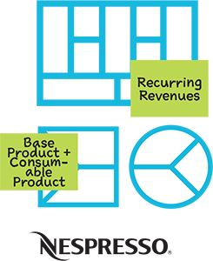

Nespresso transformed the sales of espresso from a transactional business to one with recurring revenues based on consumable pods for its espresso machine.

## Trendsetter

Constraint: Transform a technology (innovation) into a fashionable trend.

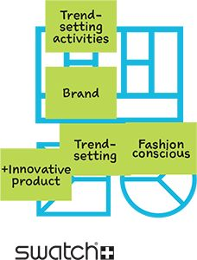

Swatch conquered the world by turning a plastic watch that could be made cheaply due to a reduced number of pieces and innovative production technology into a global fashion trend.

## Low-Cost

Constraint: Reduce the core value proposition to its basic features, target an unserved or underserved customer segment with a low price and sell everything else as an additional value proposition.

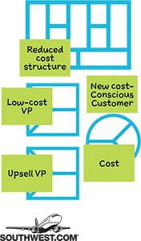

Southwest became the largest low-cost airline by stripping down the value proposition to its bare minimum, travel from point A to point B, and offering low prices. They opened up flying to a new segment.

## Platform

Constraint: Build a platform model that connects several actors with a specific value proposition for each.

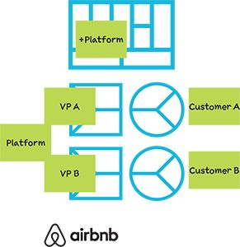

Airbnb made private homes around the world accessible to travelers by connecting them with people who seek to rent out their apartments short term.

Tips

* Assign different constraints to different working groups if you have the opportunity to do so. It allows you to explore alternatives in parallel.
* Use constraints that represent the challenges in your arena, such as free value propositions, decreasing margins, and so on.

 [Download Constraint Cards](http://strategyzer.com/vpd/design/2.2)



PROCESS

Invite Big Ideas to the Table with Books and Magazines

### OBJECTIVE

Broaden horizon and generate fresh ideas

### OUTCOME

ideas that build on relevant topics and integrate latest trends

Use best-selling books and magazines to generate fresh ideas for new and innovative value propositions and business models. It’s a quick and effective way to immerse yourself in various relevant and popular topics and build on current trends.

Bringing books into a workshop is like inviting the world’s best thinkers to brainstorm. This way you can afford a lot more of them at the same time.

## 1

Select books.

Prepare a series of books and magazines representing a trend, important topic, or big idea on a large table. Ask workshop participants to pick up a book each.

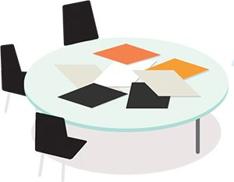

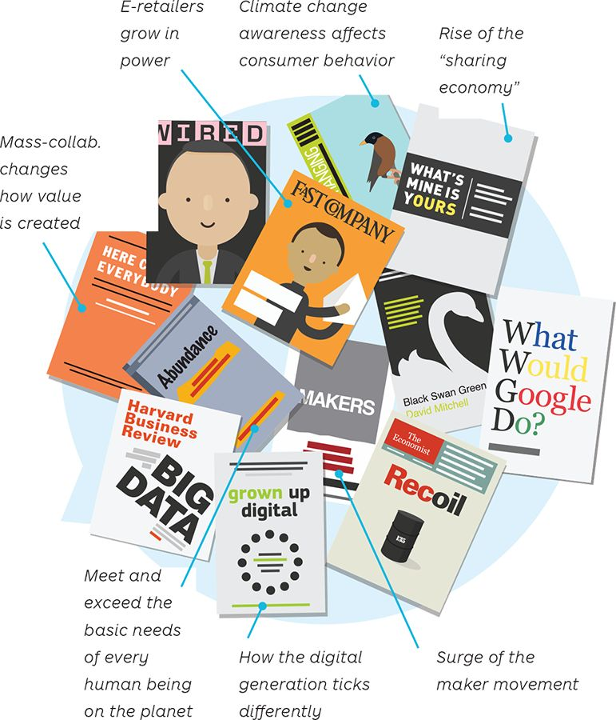

## 2

Browse and extract.

Participants browse their book and capture the best ideas on sticky notes. (45 min)

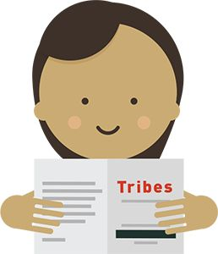

## 3

Share and discuss.

Participants share their highlights in groups of four or five people and capture their insights on a board. (20 min)

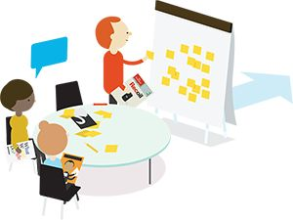

## 4

Brainstorm possibilities.

Each group generates three new value proposition ideas based on their discussions. (30 min)

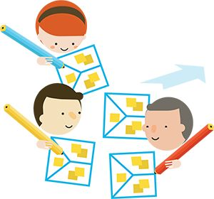

## 5

Pitch.

Each group shares their alternative value propositions with the other groups.

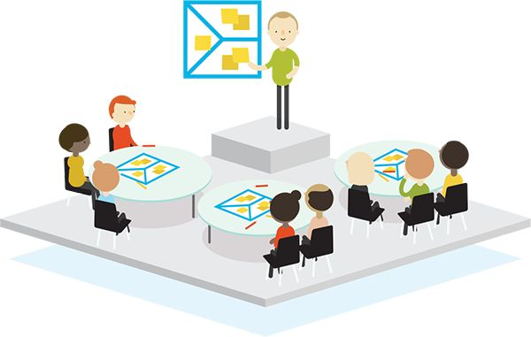

Tips

* Select books about society, technology, and environment that push participants outside of their comfort zone.
* Avoid complicated business theories or methods.
* Mix in YouTube videos of keynote talks by the authors.
* Use napkin sketches to share your value proposition ideas.



Push vs. Pull

The push versus pull debate is a common one. Push indicates that you’re starting the design of your value proposition from a technology or innovation you possess, whereas pull means you’re beginning with a manifest customer job, pain, or gain. These are two common starting points, many of which we outlined previously. Consider both as viable options depending on your preferences and context.

Technology Push

Start from an invention, innovation, or (technological) resource for which you develop a value proposition that addresses a customer job, pain, and gain. In simple terms, this is a solution in search of a problem.

Explore value proposition prototypes that are based on your invention, innovation, or technological resource with potentially interested customer segments. Design a dedicated value map for each segment until you find problem-solution fit. Read more about the build, measure, learn cycle on.

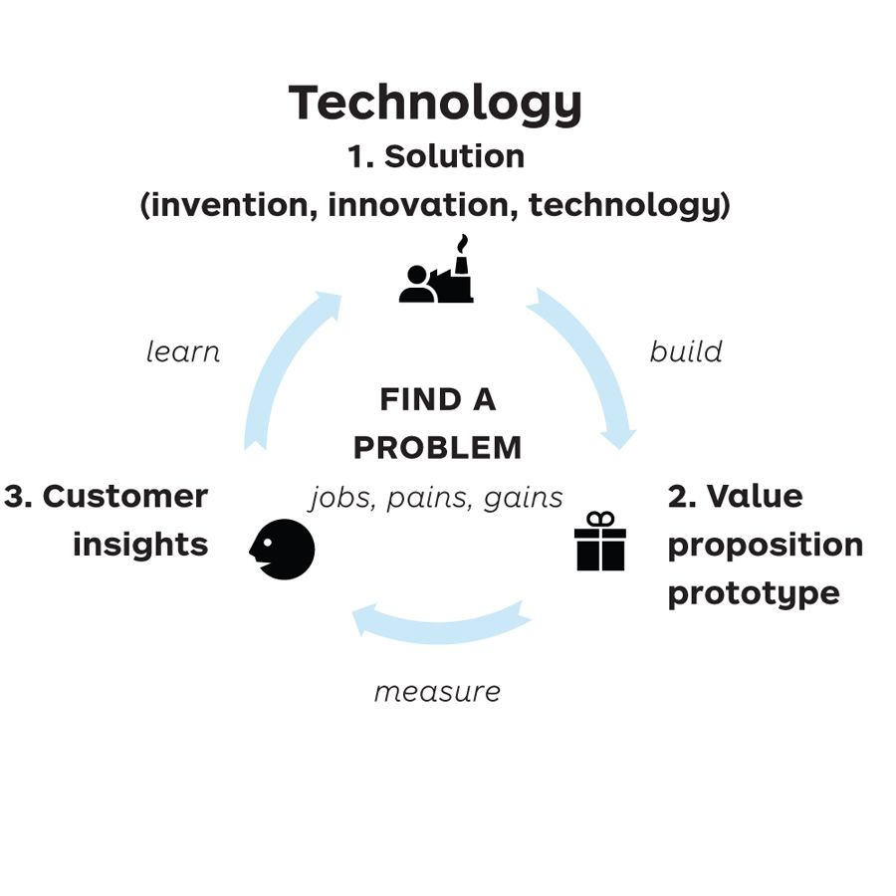

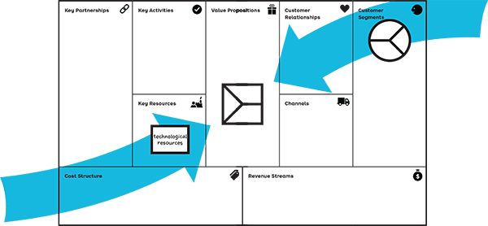

Market Pull

Start from a manifest customer job, pain, or gain for which you design a value proposition. In simple terms, this is a problem in search of a solution.

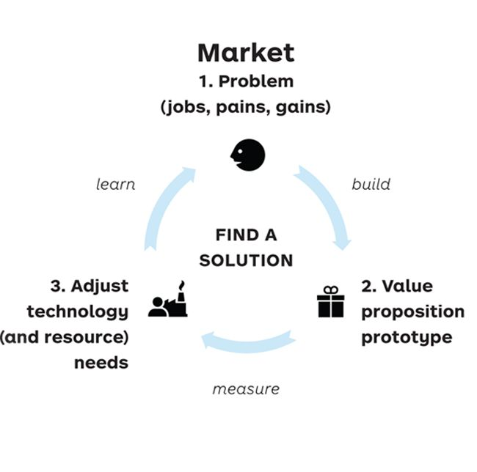

Learn what technologies and other resources are required for each value proposition prototype designed to address manifest customer jobs, pains, and gains. Redesign your value map and adjust resources until you find a viable solution to address customer jobs, pains, and gains. More about the build, measure, learn cycle on.



EXERCISE

Push: Technology in Search of Jobs, Pains, and Gains

OBJECTIVE

Practice the technology-driven approach with no risk

OUTCOME

Improved skills

 This push exercise starts with the solution

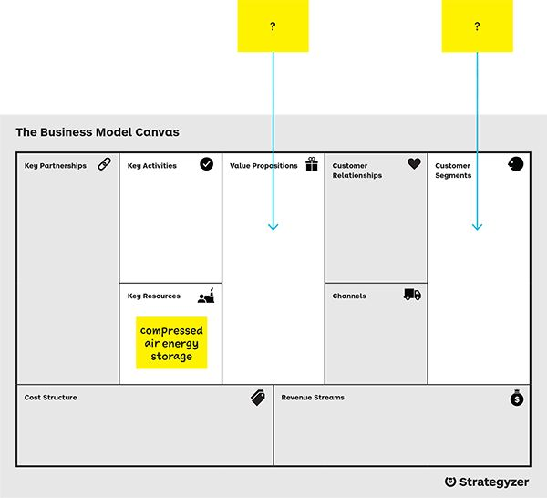

## 1

Design.

Design a value proposition based on the technology outlined in the press excerpt from the Swiss Federal Institute of Technology in Lausanne (EPFL) by targeting a customer segment that might be interested in adopting this technology.

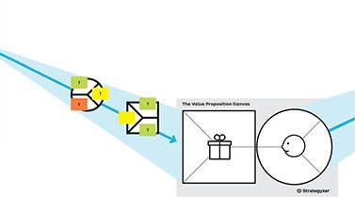

“Solar and aeolian sources are great candidates for the electricity generation of the future… However, solar and wind sources’ peak availability takes place at times that do not usually correspond to peak demand hours. Therefore, a way must be devised to store and later reuse the energy generated.

## 2

Ideate.

Come up with an idea for a value proposition using the compressed air energy storage.

EPFL has worked for over ten years on an original storage system: compressed air. The use of a hydraulic piston delivers the best system performance… The obtained high pressure air can be safely stored in bottles without losses until it is necessary to generate new electricity by expanding the gas in the cylinder. One of the advantages of our system is that it does not require rare materials.

## 3

Segment.

Select a customer segment that could be interested in this value proposition and would be ready to pay for it.

A spin-off has been created to develop this principle and create ‘turnkey’ electrical energy storage and retrieval units. In 2014, a 25 kW pilot will be installed at a photovoltaic park in Jura.… In the future, there will be 250 kW installations at first and 2,500 kW ones afterwards.”

## 4

Profile.

Sketch out the customer’s profile. Make assumptions about jobs to be done, pains, and gains.

## 5

Sketch.

Refine the value proposition by sketching out how it will kill customer pains and create gains.

## 6

Assess.

Assess the fit between the customer profile and the designed value proposition.

Tips

* Add design constraints to technology push exercises. Your organization might not want to address certain customer segments (e.g., B2B, business-to-consumer [B2C], specific regions, etc.). Or you might prefer certain strategic directions, for example, licensing rather than building solutions.
* Follow up on your customer assumptions by researching customers and producing evidence once you’ve selected a potentially interested segment.



Pull: Identify High-Value Jobs



Great value proposition creators master the art of focusing on the jobs, pains, and gains that matter. How will you know which of these jobs, pains, and gains to focus on? Identify high-value jobs by asking if they are important, tangible, unsatisfied, and lucrative.

#### High-value jobs are characterized by pains and gains that are…

## Important

When the customer’s success or failure to get the job done leads to essential gains or extreme pains, respectively.

* Does failing the job lead to extreme pains?
* Does failing the job lead to missing out on essential gains?



## Tangible

When the pains or gains related to a job can be felt or experienced immediately or often, not just days or weeks later.

* Can you feel the pain?
* Can you see the gain?



## Unsatisfied

When current value propositions Don’t help relieve pains or create desired gains in a satisfying way or simply Don’t exist.

* Are there unresolved pains?
* Are there unrealized gains?

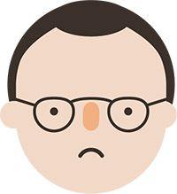

## Lucrative

When many people have the job with related pains and gains or a small number of customers are willing to pay a premium.

* Are there many with this job, pain, or gain?
* Are there few willing to pay a lot?

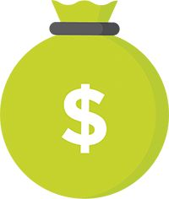

## High-value jobs

Focus on the highest-value jobs and related pains and gains.

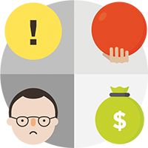

Based on initial work by consultancy, Innosight.



EXERCISE

Pull: Job Selection

OBJECTIVE

Identify high-value customer jobs that you could focus on

OUTCOME

Ranking of customer jobs from your perspective

 This pull exercise starts with the customer.

Imagine your customers are chief information officers (CIOs) and you have to understand which jobs matter most to them. Do this exercise to prioritize their jobs or apply it to one of your own customer profiles.

Tips

* This exercise helps you prioritize jobs from the customer’s perspective. It doesn’t mean you have to mandatorily address the most important ones in your value proposition; those might be outside your scope. However, make sure your value proposition does address jobs that are highly relevant to customers.
* Great value proposition creators often focus on only few jobs, pains, and gains, but do that extremely well.
* Complement this exercise with getting customer insights from the field and experiments that produce evidence.

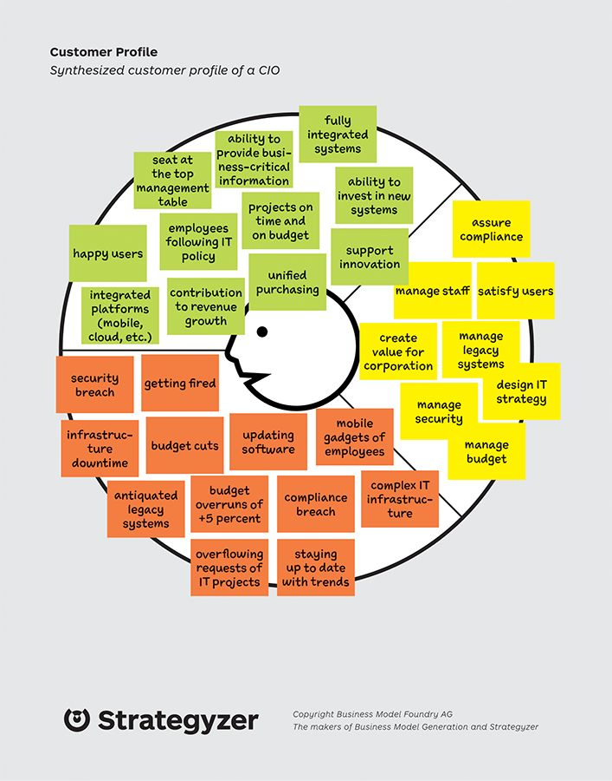

|  |  |  |  |  |  |
| --- | --- | --- | --- | --- | --- |
|  | img | img | img | img | img |
|  | * Does failing the job lead to extreme pains? * Does failing the job lead to missing out on essential gains? | * Can you feel the pain? * Can you see the gain? | * Are there unresolved pains? * Are there unrealized gains? | * Are there many with this job, pain, or gain? * Are there few willing to pay a lot? | Focus on the highest value jobs and related pains and gains. |
| Jobs | Important | Tangible | Unsatisfied | Lucrative | High-value jobs |
| create value for corporation | ••• | • | ••• | •• | = 9 |
| design IT strategy | •• | • | •• | •• | = 7 |
|  |  |  |  |  |  |
|  |  |  |  |  |  |
|  |  |  |  |  |  |
|  |  |  |  |  |  |
|  |  |  |  |  |  |
|  |  |  |  |  |  |
| Scoring scale: · (low) to ···· (high) |  |  |  | Based on initial work by consultancy, Innosight. |  |



Six Ways to Innovate from the Customer Profile

 You’ve mapped your customer profile. What to do from here? Here are six ways to trigger your next value proposition move.

Can you…

## Address more jobs?

Address a more complete set of jobs, including related and ancillary jobs.

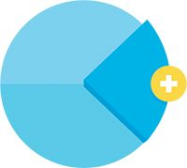

With the iPhone, Apple not only reinvented the mobile phone but enabled us to store and play music and browse the web on one device.

 [Download trigger questions](http://strategyzer.com/vpd/design/2.2)

## Switch to a more important job?

Help customers do a job that is different from what most value propositions currently focus on.

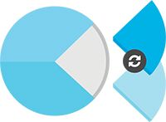

Hilti, the machine tool manufacturer, understood that construction managers needed to keep schedules to avoid penalties, not only drill holes.Their fleet management solution addressed the former in addition to the latter.

## Go beyond functional jobs?

Look beyond functional jobs and create new value by fulfilling important social and emotional jobs.

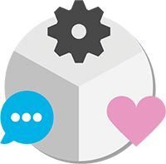

Mini Cooper created a car that became as much a means of transport as a statement of identity.

## Help a lot more customers get a job done?

Help more people do a job that was otherwise too complex or too expensive.

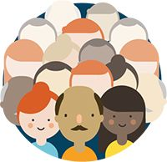

High-end web data storage and computing power used to be reserved to big companies with large IT budgets. Amazon.com made it available to companies of any size and budget with Amazon Web Services.

## Get a job done incrementally better?

Help customers better do a job by making a series of microimprovements to an existing value proposition.



German engineering and electronics multinational Bosch improved on a wide range of features of its circular saw that really mattered to customers and outperformed competition.

## Help a customer get a job done radically better?

This is the stuff of new market creation, when a new value proposition dramatically outperforms older ways of helping a customer get a job done.



The first spreadsheet called VisiCalc not only introduced a new market for such tools but also ushered a whole new realm of possibilities across industries powered by easy, visual calculations.

# 2.3 Understanding Customers

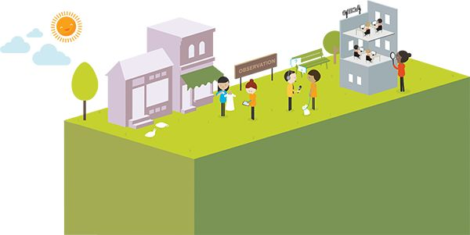

Six Techniques to Gain Customer Insights

Understanding the customer’s perspective is crucial to designing great value propositions. Here are six techniques that will get you started. Make sure you use a good mix of these techniques to understand your customers deeply.

## The Data Detective

Build on existing work with (desk) research. Secondary research reports and customer data you might already have provide a great foundation for getting started. Look also at data outside your industry and study analogs, opposites, or adjacencies.



Difficulty level: ★

Strength: great foundation for further research

Weakness: static data from a different context

## The Journalist

Talk to (potential) customers as an easy way to gain customer insights. It’s a well-established practice. However, customers might tell you one thing in an interview but behave differently in the real world.



Difficulty level: ★★

Strength: quick and cheap to get started with first learnings and insights

Weakness: customers Don’t always know what they want and actual behavior differs from interview answers

## The Anthropologist

Observe (potential) customers in the real world to get good insights into how they really behave. Study which jobs they focus on and how they get them done. Note which pains upset them and which gains they aim to achieve.



Difficulty level: ★★★

Strength: data provide unbiased view and allow discovering real-world behavior

Weakness: difficult to gain customer insights related to new ideas

## The Impersonator

“Be your customer” and actively use products and services. Spend a day or more in your customer’s shoes. Draw from your experience as an (unsatisfied) customer.



Difficulty level: ★★

Strength: firsthand experience of jobs, pains, and gains

Weakness: not always representative of your real customer or possible to apply

## The Cocreator

Integrate customers into the process of value creation to learn with them. Work with customers to explore and develop new ideas.



Difficulty level: ★★★★★

Strength: the proximity with customers can help you gain deep insights

Weakness: may not be generalized to all customers and segments

## The Scientist

Get customers to participate (knowingly or unknowingly) in an experiment. Learn from the outcome.

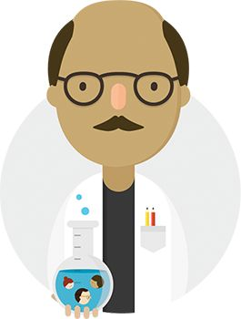

Difficulty level: ★★★★

Strength: provides fact-based insights on real-world behavior; works particularly well for new ideas

Weakness: can be hard to apply in existing organizations because of strict (customer) policies and guidelines



The Data Detective: Get Started with Existing Information

Never before have creators had more access to readily available information and data inside and outside their companies before even getting started with designing value. Use available data sources as a launching pad to getting started with customer insights.

## Google Trends

Compare three search terms representing three different trends related to your idea.

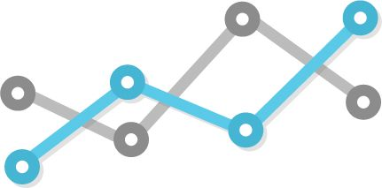

## Google Keyword Planner

Learn what’s popular with potential customers by finding the top five search terms related to your idea. How often are they searched for?

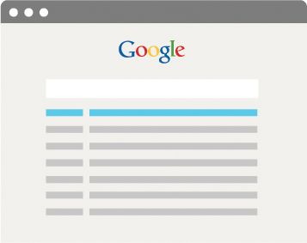

## Government Census Data, World Bank, IMF, and more

Identify the (government) data that are relevant to your idea and at your fingertips via the web.

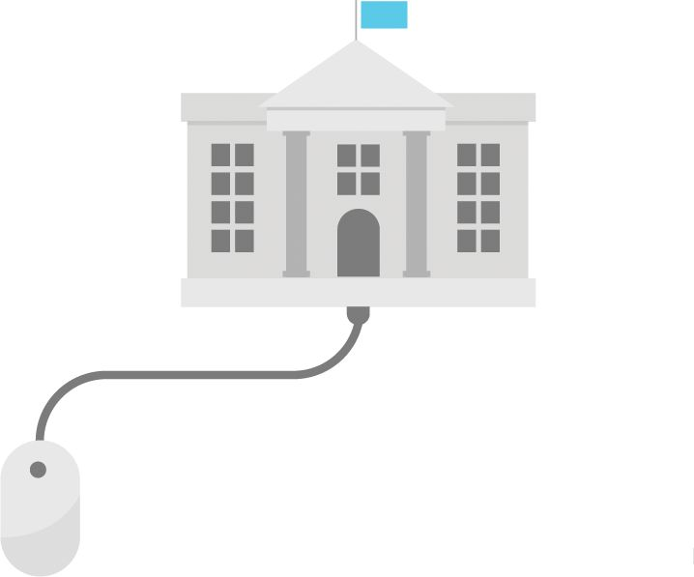

## Third-Party Research Reports

Identify three readily available research reports that can serve you as a starting point to prepare your own customer and value proposition research.

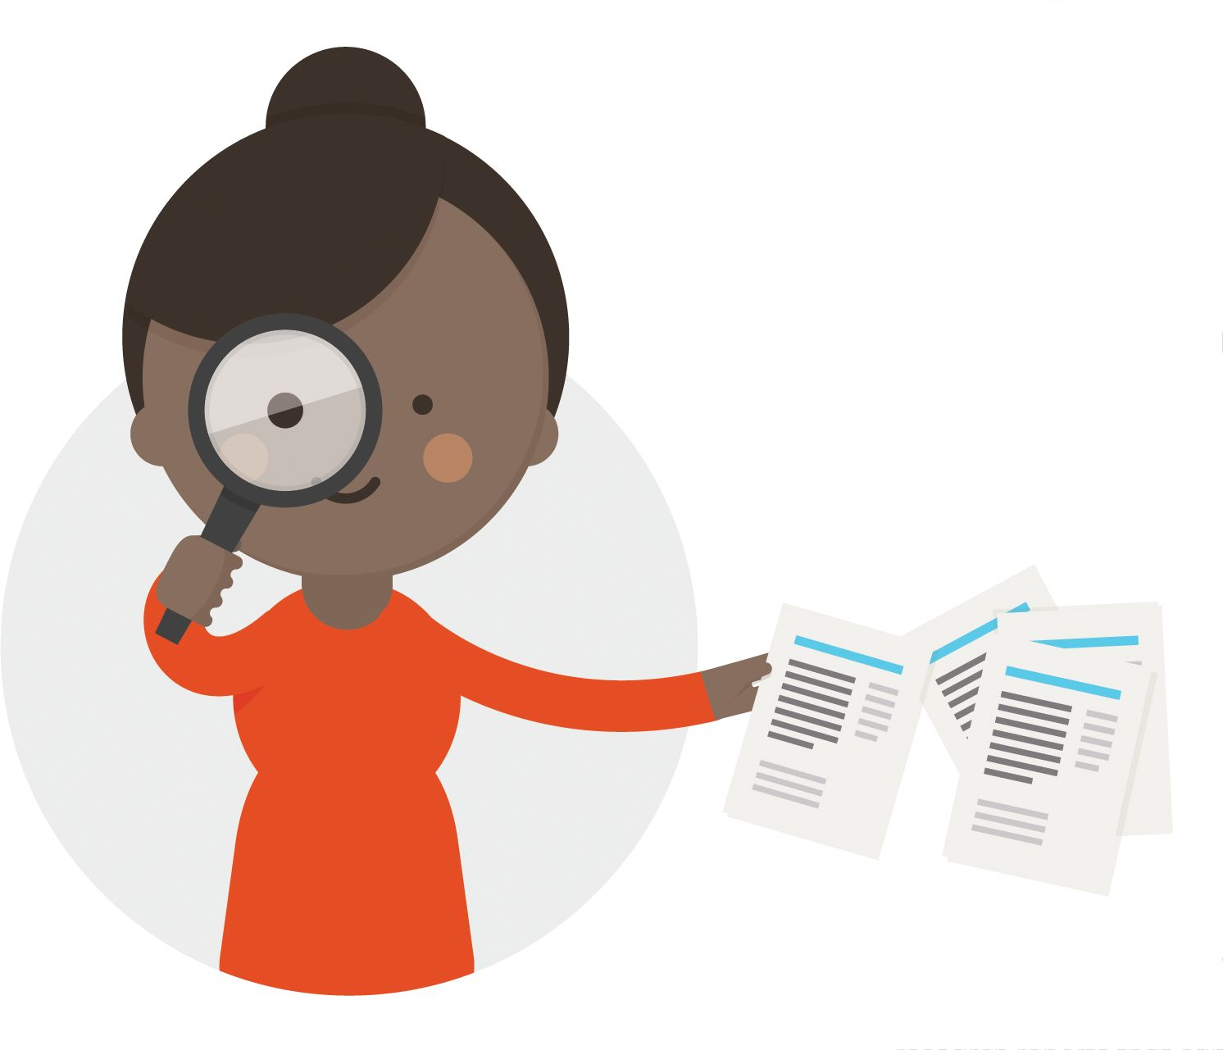

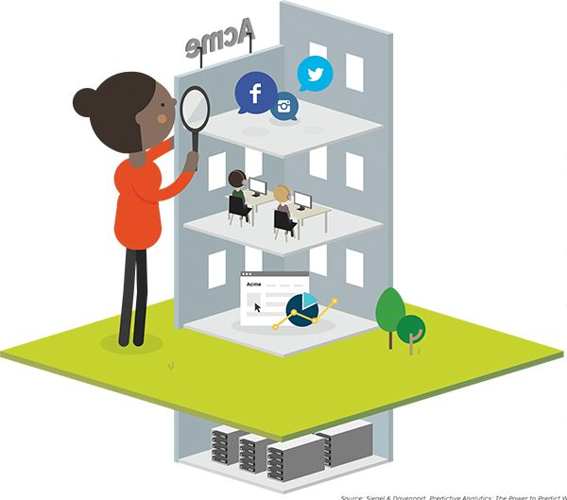

Source: Siegel & Davenport, Predictive Analytics: The Power to Predict Who Will Click, Buy, Lie, or Die, 2013.

##### Social Media Analytics

Existing companies and brands should:

* Identify the shakers and movers related to their brand on social media?
* Spot the 10 most frequently mentioned positive and negative things said about them on social media.

##### Customer Relationship Management (CRM)

* List the top three questions, complaints, and requests that you are getting from your daily interactions with customers (e.g., support).

##### Tracking Customers on Your Website

* List the top three ways customers reach your site (e.g., search, referrals).
* Find the 10 most and least popular destinations on your website.

##### Data Mining

Existing company should mine their data to:

* Identify three patterns that could be useful to their new idea.



EXERCISE

The Journalist: Interview Your Customers

### OBJECTIVE

Gain a better customer understanding

### OUTCOME

First lightly validated customer profile(s)

Talk to customers to gain insights relevant to your context. Use the Value Proposition Canvas to prepare interviews and organize the chaotic mass of information that will be coming at you during the interview process.



## 1

Create a customer profile.

Sketch out the jobs, pains, and gains you believe characterize the customer you are targeting. Rank jobs, pains, and gains in order of importance.

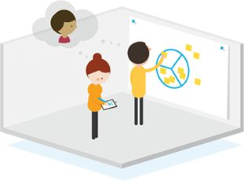

## 2

Create an interview outline.

Ask yourself what you want to learn. Derive the interview questions from your customer profile. Ask about the most important jobs, pains, and gains.

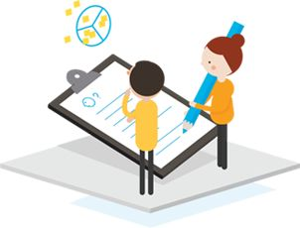

## 3

Conduct the interview.

Conduct the interview by following the interview ground rules outlined on the next page.

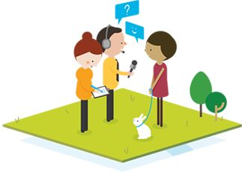

## 4

Capture.

Map out the jobs, pains, and gains you learned about in the interview on an empty customer profile.

Make sure you also capture business model learnings. Write down your most important insights.

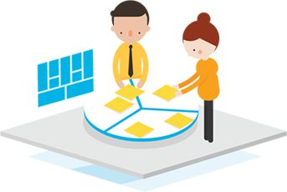

## 5

Review the interview.

Assess if you need to review the interview questions based on what you learned.

## 6

Search for patterns.

Can you discover similar jobs, pains, and gains? What stands out? What is similar or different among interviewees? Why are they similar or different? Can you detect specific (recurring) contexts that influence jobs, pains, and gains?

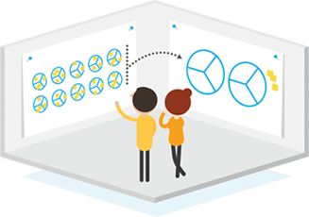

## 7

Synthesize.

Make a separate synthesized customer profile for every customer segment that emerges from all your interviews. Write down your most important insights on sticky notes.

Tip

Capture your biggest insights from all the interviews.



Ground Rules for Interviewing

It is an art to conduct good interviews that provide relevant insights for value proposition design. Make sure you focus on unearthing what matters to (potential) customers rather than trying to pitch them solutions. Follow the rules on this spread to conduct great interviews.

 [Get “Ground Rules for Interviewing” poster](http://strategyzer.com/vpd)



## Rule 1

Adopt a beginner’s mind.

Listen with a “fresh pair of ears” and avoid interpretation. Explore unexpected jobs, pains, and gains in particular.

## Rule 2

Listen more than you talk.

Your goal is to listen and learn, not to inform, impress, or convince your customer of anything. Avoid wasting time talking about your own beliefs, because it’s at the expense of learning about your customer.

## Rule 3

Get facts, not opinions.

Don’t ask, “Would you…?”

Ask, “When is the last time you have…?”

## Rule 4

Ask “why” to get real motivations

Ask, “Why do you need to do…?”

Ask, “Why is ___ important to you?”

Ask, “Why is ___ such a pain?”

## Rule 5

The goal of customer insight interviews is not selling (even if a sale is involved); it’s about learning.

Don’t ask, “Would you buy our solution?” Ask “what are your decision criteria when you make a purchase of…?”

## Rule 6

Don’t mention solutions (i.e., your prototype value proposition) too early.

Don’t explain, “Our solution does…”

Ask, “What are the most important things you are struggling with?”

## Rule 7

Follow up.

Get permission to keep your interviewee’s contact information to come back for more questions and answers or testing prototypes.

## Rule 8

Always open doors at the end.

Ask, “Who else should I talk to?”

Tips

* Interviews are an excellent starting point to learn from customers, but typically they Don’t provide enough or sufficiently reliable insights for making critical decisions. Complement your interviews with other research, just like a good journalist does further research to find the real story behind what people tell. Add real-world observations of customers and experiments that produce hard data to your research mix.
* Conduct interviews in teams of two people. Decide in advance who will lead the interview and who will take notes. Use a recording device (photo, video, or other) if possible, but be aware that interviewees might not answer the same way with a recording device on the table.

Fitzpatrick, The Mom Test, 2013.

The Anthropologist: Dive into Your Customer’s World

Dive deep into your (potential) customers’ worlds to gain insights about their jobs, pains, and gains. What customers do on a daily basis in their real settings often differs from what they believe they do or what they will tell you in an interview, survey, or focus group.

## B2C: Stay with the family.

Stay at one of your potential customers’ home for several days and live with the family. Participate in daily routines. Learn about what drives that person.

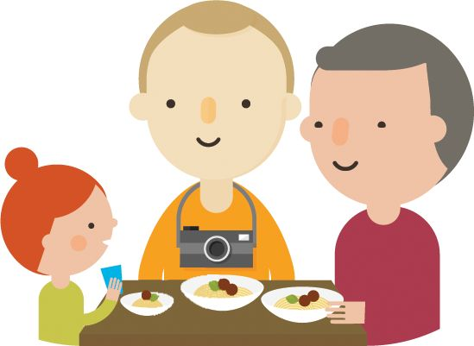

## B2B: Work alongside/consult.

Spend time working with or alongside a (potential) customer (e.g., in a consulting engagement). Observe. What keeps the person up at night?

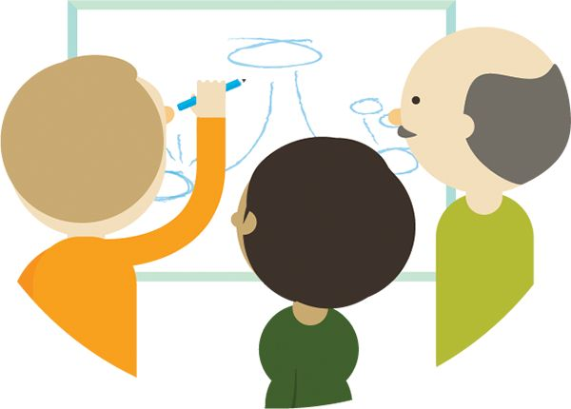

## B2B/B2C?

How could you immerse yourself in your (potential) customer’s life? Be creative! Go beyond the usual boundaries.



## B2C: Observe shopping behavior.

Go to a store where your (potential) customers shop and observe people for 10 hours. Watch. Can you detect any patterns?

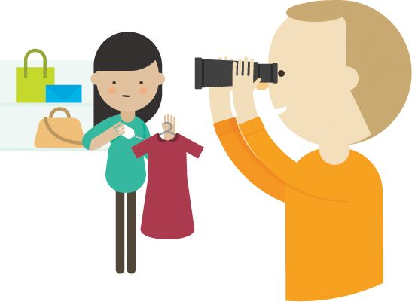

## B2C: Shadow your customer for a day.

Be your (potential) customer’s shadow and follow him or her for a day. Write down all the jobs, pains, and gains you observe. Time stamp them. Synthesize. Learn.

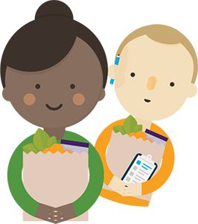





EXERCISE

A Day in the Life Worksheet

### OBJECTIVE

Understand your customer’s world in more detail

### OUTCOME

Map of your customer's day

Capture the most important jobs, pains, and gains of the customer you shadowed.

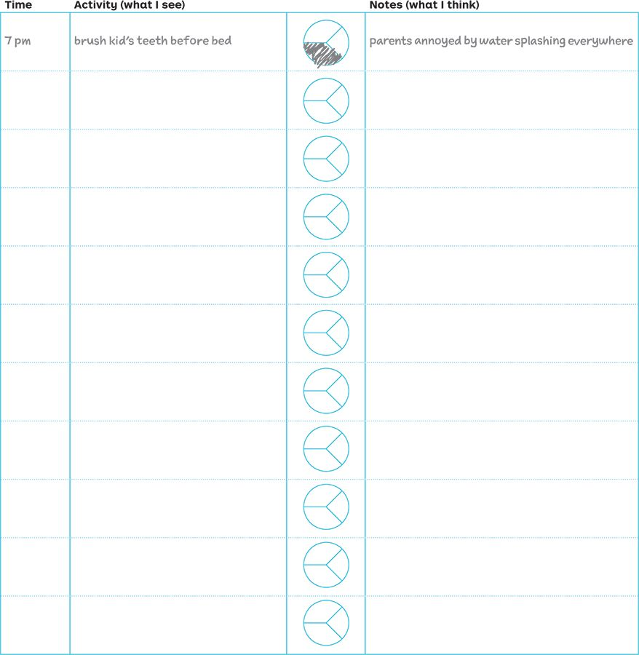

Tips

* Observe and take notes. Hold back with interpretation based on your own experience. Stay nonjudgmental! Work like an anthropologist and watch with “fresh” eyes and an open mind-set.
* Pay attention to both what you see and what you don't see.
* Capture not only what you can observe but also what is not talked about such as feelings or emotions.
* Develop customer empathy as a critical mind-set to perform this type of contextual inquiry effectively.

 [Download “A Day in the Life” worksheet](http://strategyzer.com/vpd/design/2.3)



PROCESS

Identify Patterns in Customer Research

### OBJECTIVE

Crystallize your customer

### OUTCOME

Synthesized Customer Profile(s)

Analyze your data and try to detect patterns once you have a good amount of customer research gathered. Search for customers with similar jobs, pains, or gains or customers that care about the same jobs, pains, or gains and make separate customer profiles.

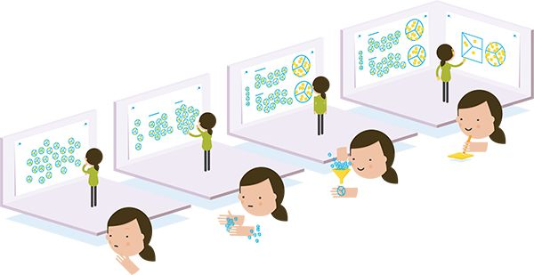

## 1

Display.

Display all the customer profiles from your research on a large wall.

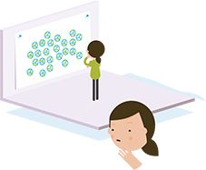

## 2

Group and segment.

Group similar customer profiles in to one or more separate segments if you can identify patterns in the jobs, pains, and gains.

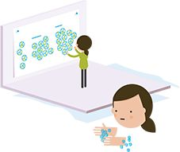

## 3

Synthesize.

Synthesize the profiles from each segment into a single master profile. Identify the most common jobs, pains, and gains and use separate labels to describe them in the master profile.

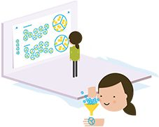

## 4

Design.

Get started with prototyping value propositions after finishing your first attempt at customer segmentation. Design one or more value proposition prototypes with confidence, based on the newly identified patterns in the master profile.

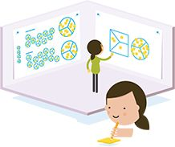

#### Synthesis Example: Master profile of a business professional / book reader

To establish a master profile of book readers, we looked at the jobs, pains, and gains of the different customer profiles from our interviews. We synthesized the most frequent ones into the master profile by using representative labels.

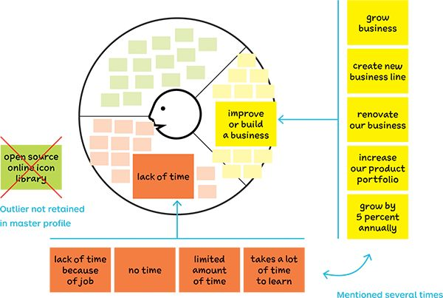

Tips

* Pay special attention to outlier profiles. They might be irrelevant, but they could represent a special learning opportunity. Sometimes the best discoveries lie at the edges.
* Ask yourself if an outlier might be a bellwether and a sign of things to come that you should pay attention to. Or maybe an outlier is different by positive deviance. It may simply be a better solution to jobs, pains, and gains than peers offer.



Find Your Earlyvangelist

Pay attention to earlyvangelists when researching potential customers and looking for patterns. The term was coined by Steve Blank* to describe customers who are willing and able to take a risk on a new product or service. Use earlyvangelists to build a foothold market and shape your value propositions via experimentation and learning.

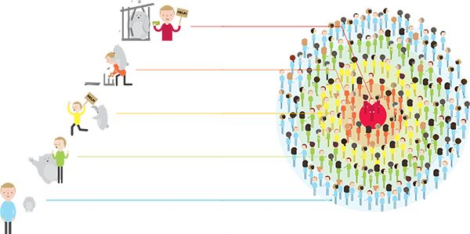

Steve Blank, Bob Dorf, The Start-up Owner's Manual, 2012.

## 1

Has a problem or need.

In other words, there is a job to be done.

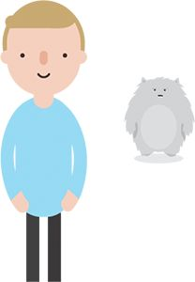

## 2

Is aware of having a problem.

The customer understands that there is a problem or job.

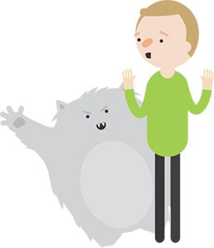

## 3

Is actively looking for a solution.

The customer is searching for a solution and has a timetable for finding it.

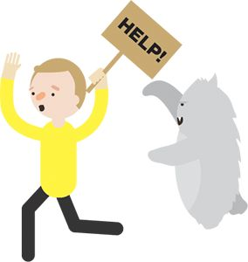

## 4

Has put together solution out of piece parts.

The job is so important that the customer has cobbled together an interim solution.

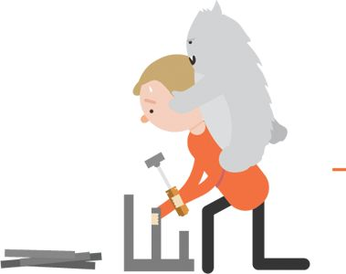

## 5

Has or can acquire a budget.

The customer has committed or can quickly acquire a budget to purchase a solution.

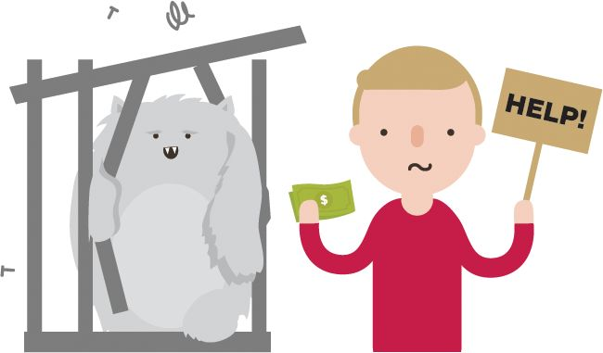

# 2.4 Making Choices

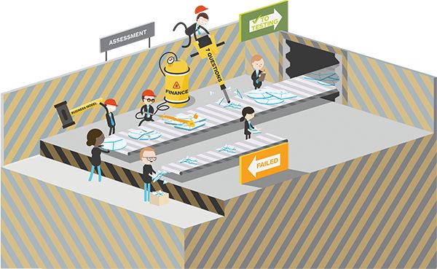

EXERCISE

10 Questions to Assess Your Value Proposition

### OBJECTIVE

Unearth potential to improve your value proposition

### OUTCOME

Value proposition assessment

Use the 10 questions of great value propositions we presented previously to constantly assess the design of your value propositions. Draw on them to integrate your customer insights. Integrate them when you decide which prototypes to explore further and test with customers.

 [Do this exercise online](http://strategyzer.com/vpd/design/2.4)

## 1

Is it embedded in a great business model?





## 2

Does it focus on the most important jobs, most extreme pains, and most essential gains?





## 3

Does it focus on unsatisfied jobs, unresolved pains, and unrealized gains?





## 4

Does it concentrate on only a few pain relievers and gain creators but does those extremely well?





## 5

Does it address functional, emotional, and social jobs all together?

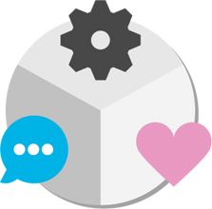



## 6

Does it align with how customers measure success?





## 7

Does it focus on jobs, pains, or gains that a large number of customers have or for which a small number are willing to pay a lot of money?

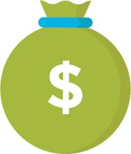



## 8

Does it differentiate from competition in a meaningful way?

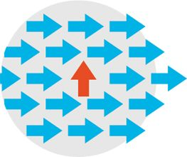



## 9

Does it outperform competition substantially on at least one dimension?





## 10

Is it difficult to copy?







PROCESS

Simulate the Voice of the Customer

### OBJECTIVE

Stress-test your value proposition “in the meeting room”

### OUTCOME

More robust value proposition before validating it “in the market”

Use role-playing to bring the voice of the customer and other stakeholder perspectives “into the room” long before you test your value propositions in the real world.

The success of your value proposition typically depends on a number of key stakeholders. Customers are the obvious one, but there are many others (e.g., stakeholders inside your company). Pick the most important ones, and organize role-plays to stress test your value proposition from the perspective of these stakeholders.



Two workshop participants engage in a role-playing game in which one person plays a company sales rep and the other, a stakeholder, for example, the customer. A third person takes notes.

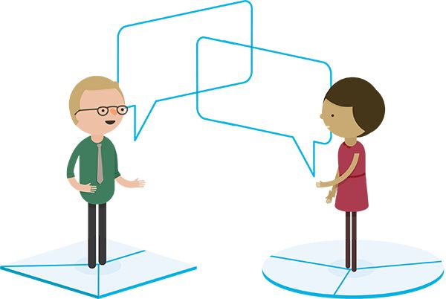

The salesperson

The (critical) customer

#### Quickly evaluate your ideas with role-playing by simulating the voices of key players.

##### Customers

Take the customers’ point of view and focus on customer jobs, pains, and gains and competing value propositions. In a B2B context think of end users, influencers, economic buyers, decision makers, and saboteurs.

##### Chief executive officer (CEO), senior leaders, and board members

Take the company leadership’s point of view (e.g., CEO, chief financial officer [CFO], chief operations officer [COO]). Give feedback from the perspective of the company’s vision, direction, and strategy.

##### Other internal stakeholders

Who else's buy-in in the company do you need for your idea to succeed? Does production play a role? Do you need to convince sales or marketing?

##### Strategic partners

Your value proposition may rely on the collaboration with strategic partners. Are you offering them value?

##### Government officials

What role does the government play? Is it an enabler or a barrier?

##### Investors/shareholders

Will they support or resist your ideas?

##### Local community

Are they affected by your ideas?

##### The planet!

What effect does your value proposition have on the environment?



Understand the Context

Value propositions and business models are always designed in a context. Zoom out from your models to map the environment in which you are designing and making choices about the prototypes to pursue. The environment is made up of competition, technology change, legal constraints, changing customer desires, and other elements. Learn more with the illustration on this spread or read more in Business Model Generation.

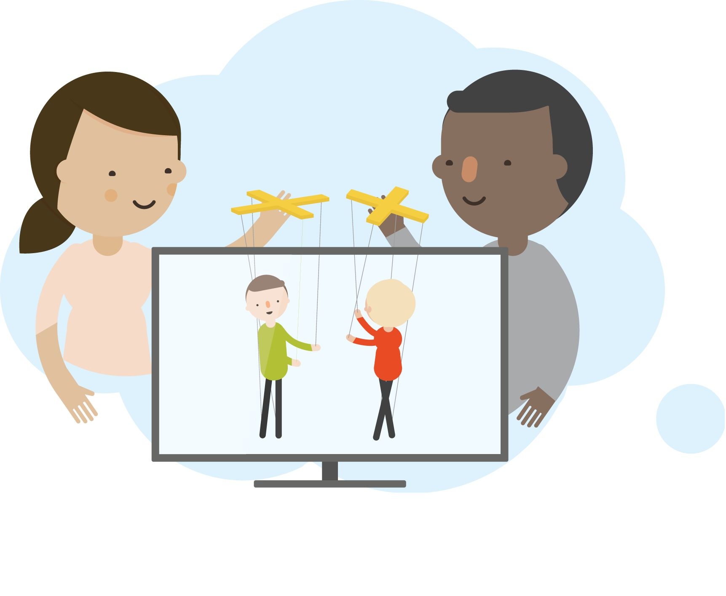

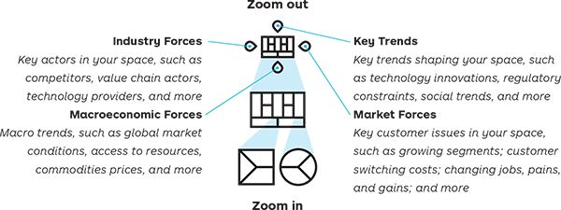

Osterwalder & Pigneur, Business Model Generation, 2010.

##### Participatory TV

Imagine you are a player in the movie industry. So far, you have been making movies and TV series with leading actors for cinema and home viewers globally. But you’d like to explore new avenues.

There is one idea that your innovation teams want to explore more closely: participatory TV—enabling viewers to crowdsource the plot of a TV series.

#### Illustration: Participatory TV

Sketch out your environment and ask which elements look like…

* an opportunity that strengthens the case for your value proposition (in green)
* a threat or a constraint that undermines or limits it (in red)

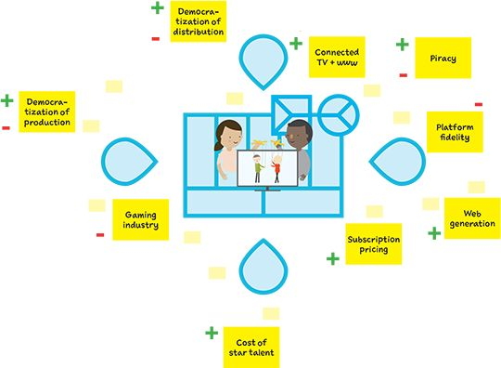

|  |  |  |
| --- | --- | --- |
|  | Strengthens your VP | Undermines your VP |
| Democratization of production | Web tools make it easier for anyone to participate. | User-led content can be a disruptor to professionally produced content. |
| Democratization of distribution | Social media is a powerful marketing channel for passionate viewers. | Size doesn’t matter anymore-anybody can get access to millions of users. |
| Connected TV + www | Integration of TV and web will enable high-engagement experiences. |  |
| Piracy | User-generated content is less prone to piracy. | Piracy is on the rise. |
| Platform fidelity |  | It is difficult to get viewers to leave established platforms such as Netflix or Apple. |
| Web generation | The generation of users who grew up with the Internet participates online on a daily basis. |  |
| Subscription pricing | Pricing models that produce recurring revenues (subscription) fit well with a community of cocreators. |  |
| Cost of star talent | Cost of star talent is dropping. |  |
| Gaming industry |  | Actors in the gaming industry might be better equipped to succeed with a participatory value proposition. |



Value Proposition Design vs. Competitors

Let’s focus on one element of your design and decision making environment: your competitors. Assess how your value proposition performs against those of your competition by comparing them on a Strategy Canvas, a graphical tool from the Blue Ocean Strategy book. This is a simple but powerful way to visualize and compare how the “benefits” of your value proposition perform.

On this spread we compare the performance of Value Proposition Design to the performance of executive education and massive open online courses (so-called MOOCs). We do so by drawing a Strategy Canvas with a number of competitive factors on the x-axis and then plot how the different competitors perform on each one of these factors. We selected the competitive factors from our value map and complemented them with elements from our competitors’ value maps.

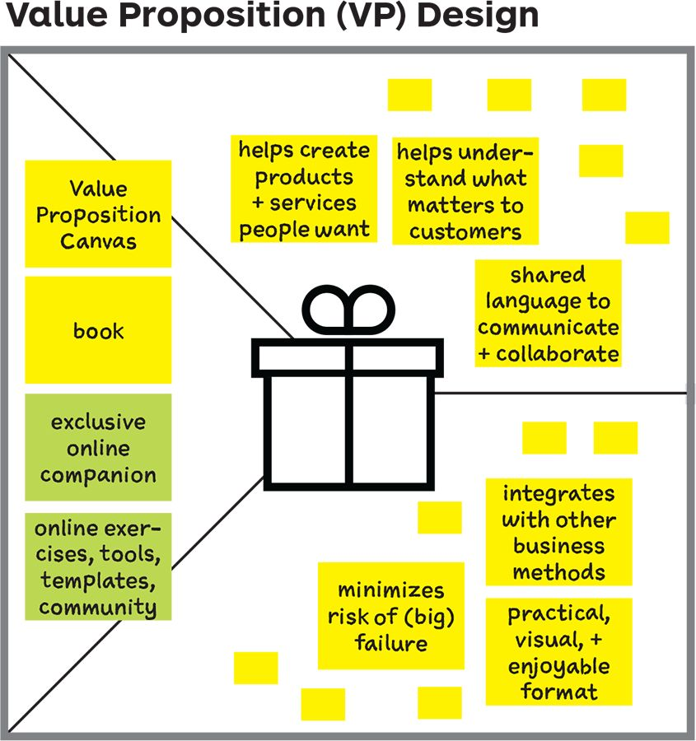

Select the most important features from your VP to use on the Strategy Canvas as factors of competition.

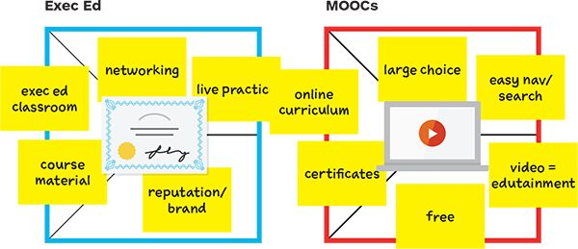

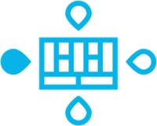

Kim & Mauborgne, Blue Ocean Strategy, 2005.

#### Strategy Canvas

Value proposition of this book vs. executive education vs. MOOCs as compared with each other

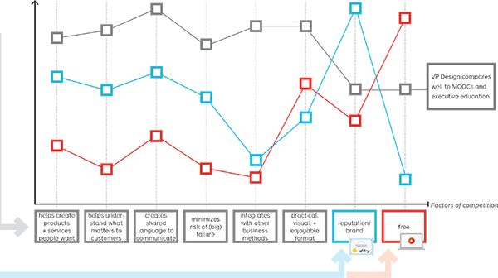



EXERCISE

Compare Your Value Proposition with Competitors

### OBJECTIVE

Understand how you are performing compared to others

### OUTCOME

Visual comparison with competitors

Use the Strategy Canvas from the Blue Ocean Strategy book to plot the performance of your value proposition against those of your competitors. Then compare the curves to assess how you are differentiating.

Instructions

Draw a Strategy Canvas step by step and compare your value proposition with those of your competitors.

1. Prepare or pick a value map for this exercise.
2. Grab a big sheet of paper or use a whiteboard.
3. Follow the steps.

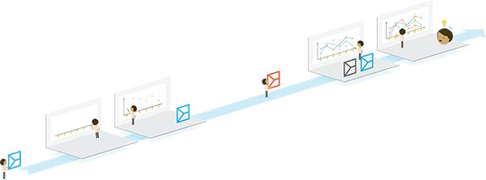

## 1

Select a value proposition.

Select the value proposition (prototype) you want to compare.



## 2

Select factors of competition.

Draw a horizontal axis (x-axis). Pick the pain relievers and gain creators you want to compare with competition. Place them on the axis. These are the factors of competition of your Strategy Canvas.

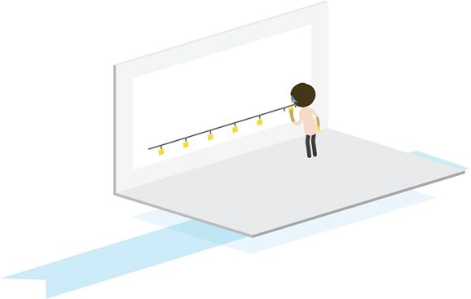

Tip

You can also add pains and gains if you feel like they better describe important factors of competition.

## 3

Score your value proposition.

Draw a vertical axis (y-axis) to represent the performance of a value proposition. Add a scale from low to high or from 0 to 10. Plot how your value proposition performs on each factor of competition on the x-axis (i.e., the pain relievers and gain creators you chose).

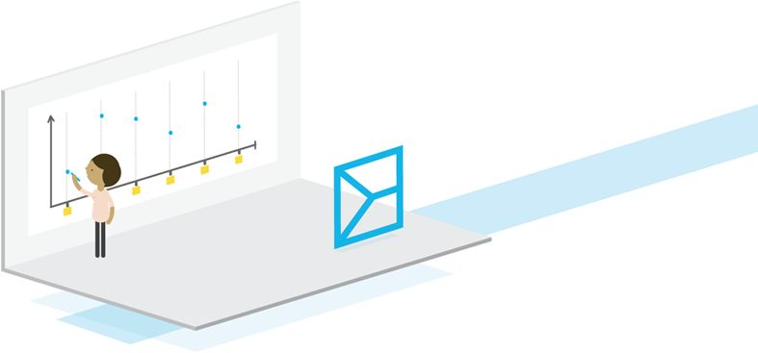

## 4

Add competing value propositions.

Add competing value propositions to the Strategy Canvas. Choose those that are most representative of the competition out there. Add pain relievers and gain creators from their value proposition to the factors of competition on the x-axis if necessary.

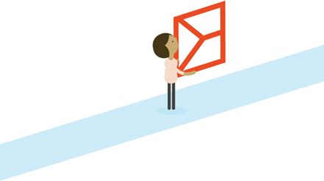

Tip

Consider competing value propositions beyond traditional industry boundaries. Don’t just compare value propositions based on products and services that are similar to yours.

## 5

Score competing value propositions.

Plot how competing value propositions perform, just as you did for your own.

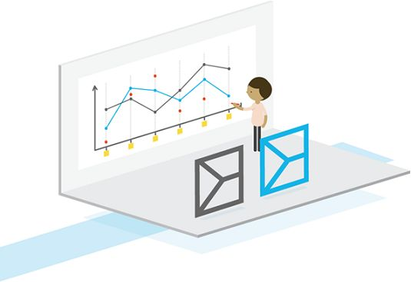

Tip

Use this tool to compare the performance of alternative value propositions you might be considering.

## 6

Analyze your sweet spot.

Analyze the curves and uncover opportunities. Ask yourself if and how you are differentiating from competitors with your value proposition.

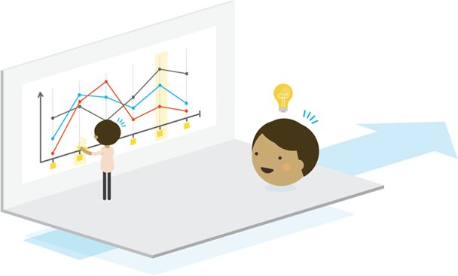

Tip

Make sure the factors of competition that you compare align with the top jobs, pains, and gains in the customer profile. Normally that should be the case, because pain relievers and gain creators are designed to match relevant jobs, pains, and gains.



Avoid Cognitive Murder to Get Better Feedback

Present your value proposition to others to gather feedback, get buy-in, and complement the more “analytical assessment” that we looked at up to this point and the experiments we will study in the testing chapter.

Make sure you get the best from presenting your ideas by explaining them with disarming simplicity and coherence. It would be a waste of time and resources to put all your energy into designing remarkable value propositions only to fail to present them in a convincing way when it matters.

Presenting your ideas and canvases in a clear and tangible way is critical throughout the design process. Present early and rough prototypes before refining to get buy-in from different stakeholders. Only work on more refined presentations later in the design process.

One of the most important aspects of presenting value propositions is to convey messages with customer jobs, pains, and gains in mind. Never just pitch features; instead, think about how your value proposition helps get important jobs done, kills extreme pains, and creates essential gains.

|  |  |
| --- | --- |
| Best Practices for Presenters |  |
| √ Dos | × Don’ts |
| Simple | Complex |
| Tangible | Abstract |
| Presenting only what matters | Presenting all you know |
| Customer-centric | Feature-centric |
| 1 piece of info after the other | All information at once |
| The right media support | No visual support |
| Storyline | Random flow of information |

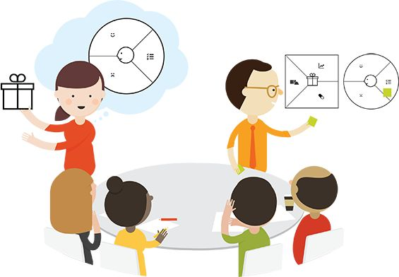

1. Start with an empty canvas. Make sure listeners were given at least a short introduction to the canvas.
2. Begin your presentation wherever it makes most sense. You can start with products or with jobs.
3. Put up one sticky note after the other progressively to explain your value proposition so your audience doesn’t experience cognitive murder. Synchronize what you say and what you put up. Tell a story of value creation by connecting products and services with customer jobs, pains, and gains.

Use low-fidelity prototypes to make your ideas tangible.

Use low-fidelity prototypes to make your ideas tangible.

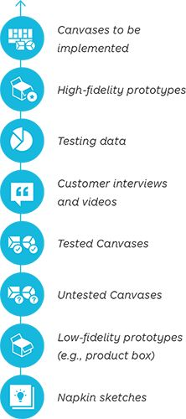

#### What to present and when

Present different types of prototypes depending on how far you are into the design and testing process.



Master the Art of Critique

Practice the art of feedback to help ideas evolve rather than stall. This goes for feedback receivers who present ideas, as well as for feedback providers who give input on ideas.

Learn from the design professions, where people are trained to present ideas early and feedback providers are trained to provide effective design critiques. This contrasts with feedback providers in business who are often leaders in steering boards or advisory committees. They are trained to decide rather than to give feedback. If they cannot get to decisions fast, they often get nervous or become unsatisfied.

Teach feedback providers how to help ideas evolve (rather than to decide on them). Get them to understand that value proposition prototypes are still rough and evolving during the design and testing phase. Prototypes may radically change, in particular based on market facts that matter more than the opinion of feedback providers.

Teach feedback receivers that feedback providers are not as important as customers, however powerful they might be. Listening to feedback providers more than to customers and market facts only postpones failure.

 [Get “Master the Art of Critique” poster](http://strategyzer.com/vpd/design/2.4)

##### In a great feedback culture…

People feel comfortable presenting (bold) new ideas early, knowing that they will evolve substantially, maybe into something very different.

|  |  |  |  |
| --- | --- | --- | --- |
| Distinguish between Three Types of Feedback |  | + | - |
| OPINION | “If we added___I believe we’d have a better chance to make it work…” | Logical reasoning can help improve ideas. | It can lead to pursuing pet ideas of people with more power. |
| EXPERIENCE | “When we did___in our last project, we learned that…” | Past experiences provide valuable learning that can help prevent costly mistakes. | Failing to realize that different contexts lead to different results. |
| (MARKET) FACTS | “We interviewed people about this and learned that___percent struggled with…” | This provides input that reduces uncertainty and (market) risk. | Measuring the wrong data or simply bad data can lead to missing out on a big opportunity. |

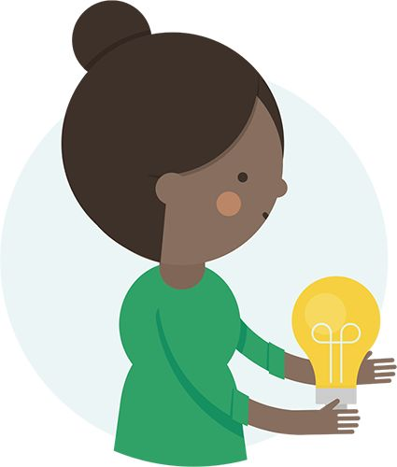

Present early.

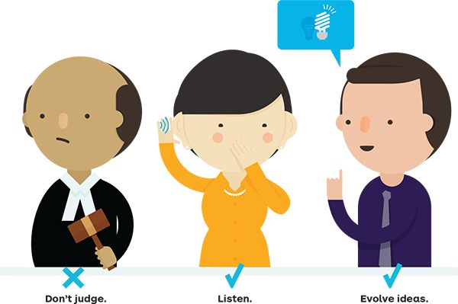

Leaders and decision makers are trained to give feedback on early ideas to help them evolve. They know their opinion can be trumped by market facts and they’re comfortable with that.

|  |  |
| --- | --- |
| Don’t img | Do img |
| Shoot people down for presenting new (bold) ideas. | Create a safe environment in which people feel comfortable to present (bold) ideas. |
| Present only refined ideas to leadership and decision makers. | Foster a culture of early feedback on rapidly evolving ideas. |
| Have long, unstructured, free-flowing, time-consuming discussions. | Run facilitated, structured feedback processes. |
| Allow for proliferation of pure opinion. | Provide feedback based on experience or (market) facts. |
| Create a context that enables politics and personal agendas to supersede value creation. | Encourage a customer-centered feedback culture that neutralizes politics. |
| Create negative vibes that destroy positive creative energy. | Bring in fun and productive feedback processes. |
| Foster culture in which feedback destroys big ideas because they’re hard to implement. | Draw a distinction between hard to do and worth doing. |
| Just ask “why?” | Ask, “Why not?” “What if?” and “What else?” |



PROCESS

Collect Efficient Feedback with de Bono’s Thinking Hats

### OBJECTIVE

Collect feedback effectively and avoid lengthy discussions

### OUTCOME

Understanding of what’s good or bad about ideas and how they can be improved

Collect feedback on ideas, value propositions, and business models using Edward de Bono’s thinking hats. This method is very effective—especially in large groups—and helps you avoid losing time in endless discussions.

Workshop participants put on a metaphorical colored hat that symbolizes a certain type of thinking. This technique allows you to quickly collect different types of feedback and avoid having an idea shot down for purely political reasons. Use four of de Bono’s six thinking hats to gather feedback.

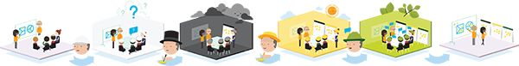

## 1

Pitch

3–15 min depending on stage of idea

The design team presents their idea and value proposition and/or Business Model Canvas.

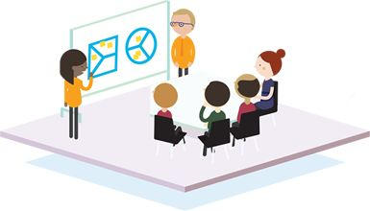

## 2

White hat

Information and data; neutral and objective

2–5 min depending on stage of idea

“Audience” members ask clarifying questions to fully understand the idea.

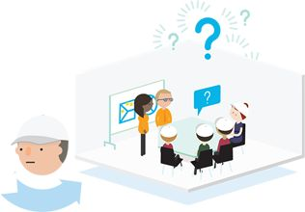

## 3a & 3b

Black hat

Difficulties, weaknesses, dangers; spotting the risks

1 min to write down

Participants write down why it’s a bad idea on a sticky note.

3 min to collect feedback

The facilitator rapidly collects one feedback after the other on a flip chart, while participants read it out loud.

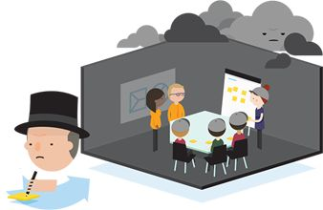

## 4a & 4b

Yellow hat

Positives, plus points; why an idea is useful

1 min to write down

Participants write down why it’s a good idea on a sticky note.

3 min to collect feedback

The facilitator rapidly collects one feedback after the other on a flip chart, while participants read it out loud.

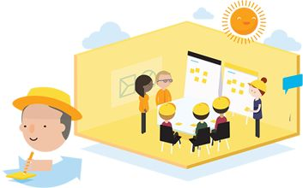

## 5

Green hat

Ideas, alternative, possibilities; solutions to black hat problems

5–15 min of open discussion

The floor is opened to discussion. Participants bring in suggestions regarding how to evolve the ideas that were presented.

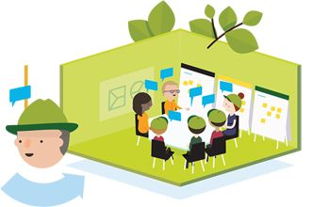

## 6

Evolve

The presenting team evolves their idea equipped with the white, black, yellow, and green hat feedback.

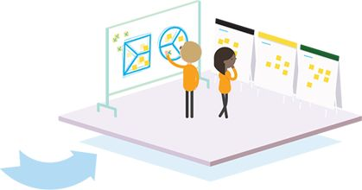

Tips

* This exercise requires strong facilitation skills. Make sure people Don’t voice opinions when it’s time for the white hat to ask clarifying questions.
* Make sure that regardless of whether people hate or love an idea, everybody puts on all hats, white, black, yellow, and green.
* Use the black hat before the yellow hat to neutralize extremely negative people. Once they voiced their feedback, they might even think positively.
* De Bono’s Thinking Hats also works well in small groups or individually to help people come up with all the reasons why an idea might fail or succeed.

Edward de Bono, Six Thinking Hats,1985.



PROCESS

Vote Visually with Dotmocracy

### OBJECTIVE

Visualize the preferences of a group and avoid lengthy discussions

### OUTCOME

Quick selection of ideas

Use Dotmocracy to quickly visualize the preferences of a group, in particular in large workshop settings. This is a simple and speedy technique to prioritize among different value propositions and business model options. It helps to prevent lengthy discussions.

## 1

Idea gallery.

Ideas or canvases are exposed on a wall as a gallery of options.

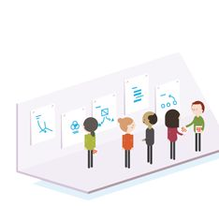

## 2

Stickers.

Each workshop participant gets the same number of stickers (e.g., 10), and each sticker counts as one vote.

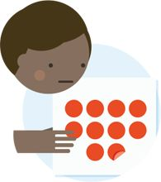

## 3

Criteria.

The voting criteria are defined. For example, participants may be instructed to place a sticker on their favorite ideas.



## 4

Vote.

Participants can put all their stickers on one idea or distribute them across several ideas.

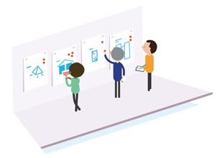

## 5

Count.

Stickers are counted, and preferred ideas are highlighted.

#### Multicriteria

Use a table when you want to use several criteria to select among alternative value propositions and business models.

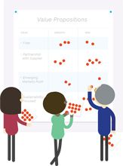

Dotmocracy is used to select ideas based on internal criteria, such as growth potential, risk, and differentiation potential. Apply this technique during the design process to choose among several alternatives before you test them in the real world.



PROCESS

Define Criteria and Select Prototypes

### OBJECTIVE

Select among a range of alternatives

### Outcome

Ranking of prototypes

Decide which criteria are most important to you and your organization and select value propositions and business models accordingly during the design process. You need to prioritize among (hopefully attractive) alternatives, even if your customer is the final judge of your ideas later on in the process.

## 1

Brainstorm criteria.

Come up with as many criteria as you can to assess the attractiveness of your prototypes.

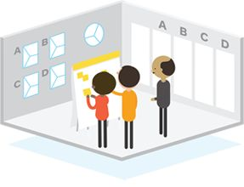

Use the following themes and criteria as an input for your own selection criteria.

##### Fit with Strategy

How the idea fits with the overall direction of the company

|  |  |  |
| --- | --- | --- |
| Aligns with strategy | Good timing | Fits with desired risk level |
| Can replace outdated business models |  |  |

#### Fit with Customer Insights

How the idea relates to the first customer insights gained during first market research

|  |  |  |
| --- | --- | --- |
| Important job | No good solution exists | Visible and tangible pain |
| Strong customer evidence |  |  |

#### Competition and Environment

How the idea allows the company to position itself related to the competition

|  |  |  |
| --- | --- | --- |
| Provides competitive advantage | Fits with tech and other trends | Allows differentiation |

Relation to Current Business Model

How the idea builds or doesn't build on the current business model

|  |  |  |  |
| --- | --- | --- | --- |
| Fit with brand | Fits current business model | Builds on strengths | Plugs weaknesses |
| Disrupts current cash cows |  |  |  |

Financials and Growth

What potential each idea has related to growth and financials

|  |  |  |  |
| --- | --- | --- | --- |
| Market size | Revenue potential | Market growth | Margins |

Implementation Criteria

How difficult it is to implement the idea from design to market

|  |  |  |  |
| --- | --- | --- | --- |
| Time to market | Cost to build | Do we have right team and skills | Access to target customers |
| Technology risk | Implementation Risk | Risk of management resistance |

## 2

Select criteria.

Select the criteria that are most important for your team and organization.

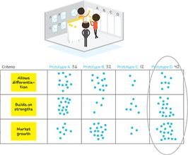

## 3

Score prototypes (0 [low] – 10 [high]).

Score each idea on the criteria you chose

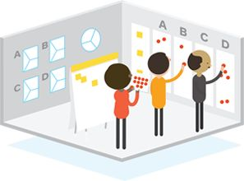

## 4

Evolve prototype and explore with market.

Evolve your prototype (e.g., based on the scores it got), and test it in the market to learn if it really has potential

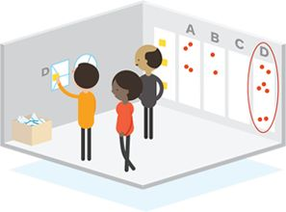

# 2.5 Finding the Right Business Model

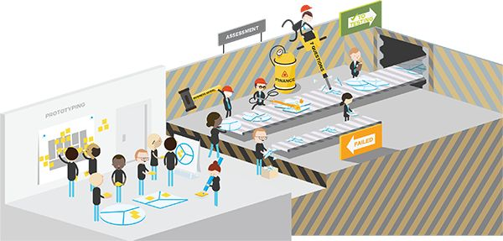

Create Value for Your Customer and Your Business

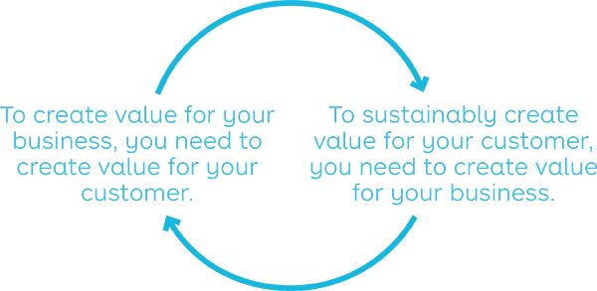

A business that generates fewer revenues than it incurs costs will inevitably disappear, even with the most successful value proposition. This section shows how getting both the business model and the value proposition right is a process of back and forth until you nail it.

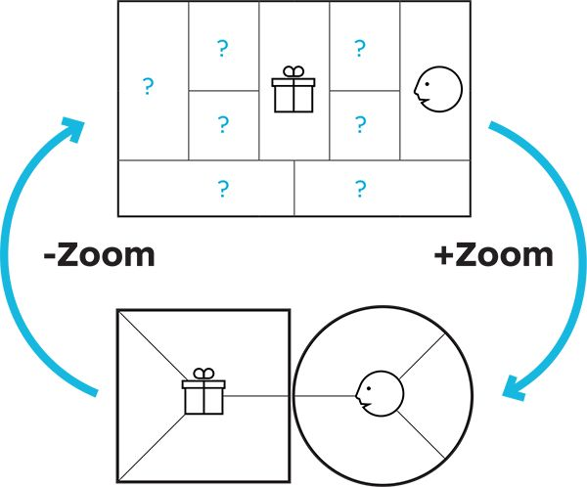

Are you creating value for your business?

Are you creating value for your customer?

The Business Model Canvas makes explicit how you are creating and capturing value for your business. The Value Proposition Canvas makes explicit how you are creating value for your customers.

Zoom out to the bigger picture to analyze if you can profitably create, deliver, and capture value around this particular customer value proposition.

Zoom in to the detailed picture to investigate if thecustomer value proposition in your business model really creates value for your customer.



Azuri (Eight 19): Turning a Solar Technology into a Viable Business

1.6 billion people in the world still live without electricity. Could innovative value propositions and business models around new technology offer answers?

Simon Bransfield-Garth founded Eight19 based on a printed plastic technology originating from Cambridge University. The technology is designed to deliver low-cost solar cells. In 2012 Eight19 launched Azuri to commercialize the technology and bring electricity to off-grid customers in rural emerging markets.

Finding the right value propositions and business models in such a context is not easy. We illustrate how it is a continuous back and forth between both on the following pages.

Azuri Business Model: version 0

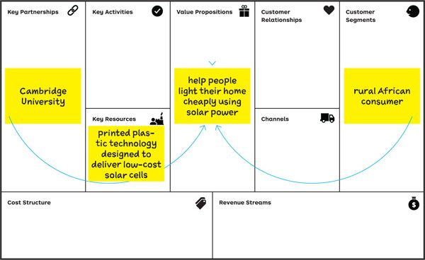

## 1 Initial idea

An opportunity.

Developing low-cost solar technology and providing low-income people with access to electricity.

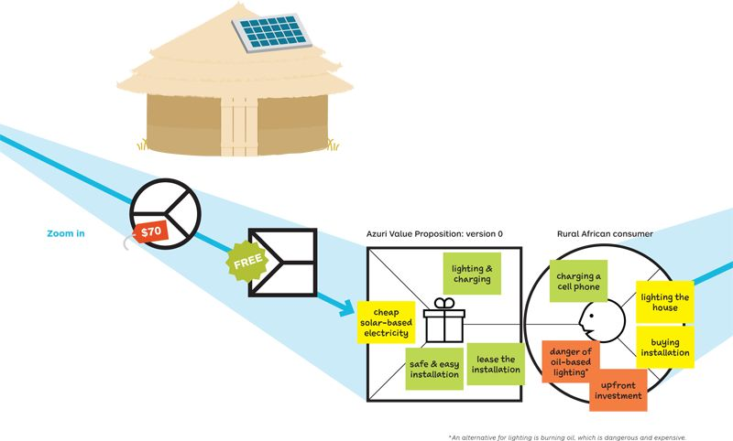

## 2 Observe

The Cost Barrier.

“A rural farmer on $3 per day struggles to afford a $70 solar power system.”

## 3 Design

What If?

Give the solar installations away for free to eliminate the hurdle of upfront investment.

## 4 Iteration 2

Idea for Business Model.

Lease the solar installations and collect regular subscription fees; it works just fine with conventional panels; get resources and partnerships for financing the installations.

Azuri Business Model: version 1

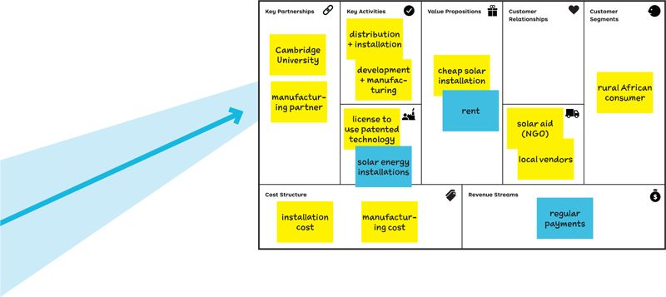

## 5 Observe

The no-banking barrier.

How can regular payments be recovered without any efficient banking system?

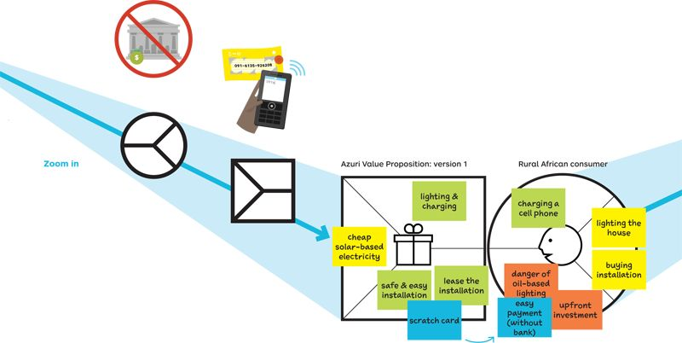

## 6 Design

Low-tech solution.

Combine mobile phone and solar technology with scratch cards to access electricity over a period of time.

## 7 Iteration 3

Idea for the Azuri Business Model.

Azuri provides solar-as-a-service, with Indigo, a pay-as-you-go lighting and charging system for which customers purchase weekly scratch cards: adapt the revenue model accordingly.

Azuri Business Model: version 2

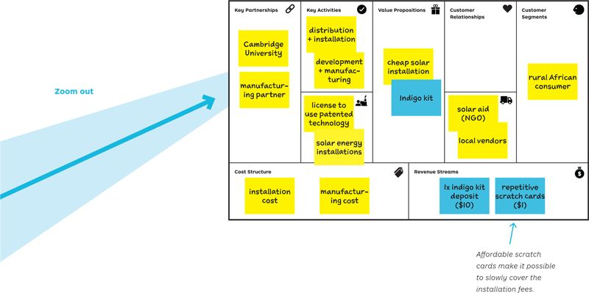

So…

How does the Indigo value proposition look for a customer?

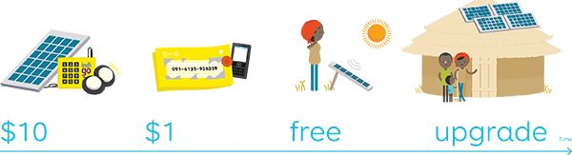

Buy the indigo kit (solar panel, lamps, charger).

Buy scratch cards, use SMS from a mobile phone, enter the resulting passcode into the Indigo unit, and use the installation for a period of time (typically a week).

Own your box after 80 scratch cards, or….

Escalate to a larger system and access more energy; continue to buy scratch cards.



EXERCISE

From Value Proposition to Business Model…

### OBJECTIVE

Practice the connection between value proposition and business model with no risk

### OUTCOME

Improved skills

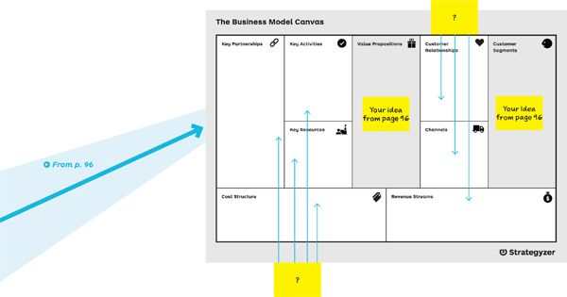

Part A

Design the Full Business Model.  
 On page 96 you imagined a value proposition to commercialize an innovative compressed air energy storage technology. Now map out the remaining business model elements and sketch out the rough numbers (part A).

## A1

Front Stage.

Prototype a revenue model, select distribution channels, and define the relationships that could be adopted with customers.

## A2

Backstage.

Add the Key Resources, Key Activities, and Partners required for the model to work and use that to estimate the cost structure.

## A3

Assessment.

Assess your prototype and detect possible weaknesses of the business model [->]

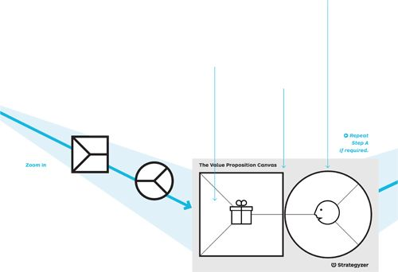

Part B

Revisiting the Value Proposition  
Assess the weaknesses of your first full business model prototype (from part A). Ask yourself how you could improve or change your initial value proposition, maybe by shifting to an entirely different segment by considering the following five questions:

Tip

Follow up on your new customer assumptions by researching customers and producing evidence

## B1

New VP?

Could there be another radically different value proposition for the same technology?

## B2

New segment?

Will you keep the same customer segment, or will you shift to an entirely different, maybe larger, market segment?

## B4

Change or clear your benefits?

Do you need to change or clear the benefits your value proposition created because the customer profile changed?

## B5

Got fit?

Do you have fit between your new customer profile and the newly designed value proposition?

## B3

Refine or clear your profile?

Could you refine your customer profile, or do you need to describe an entirely new one because you switched customer segments?



Stress Testing with Numbers: A MedTech Illustration

A great value proposition without a financially sound business model is not going to get you very far. In the worst case you will fail because your business model incurs more costs than it produces revenues. But even business models that work can produce substantially different results.

Play with different business models and financial assumptions to find the best one. We illustrate this with the medical technology illustration on this spread. We sketched out two models both starting from the same technology that enables building a cheap diagnostic device.

Prototype 1 generates $5.5 million in revenues and a profit of $0.5 million. Prototype 2 starts from the same technology but produces more than $30 million in revenues and a profit of $23 million with a different value proposition and business model. Only the market can judge if either model could work, but you certainly want to explore and test the best options.

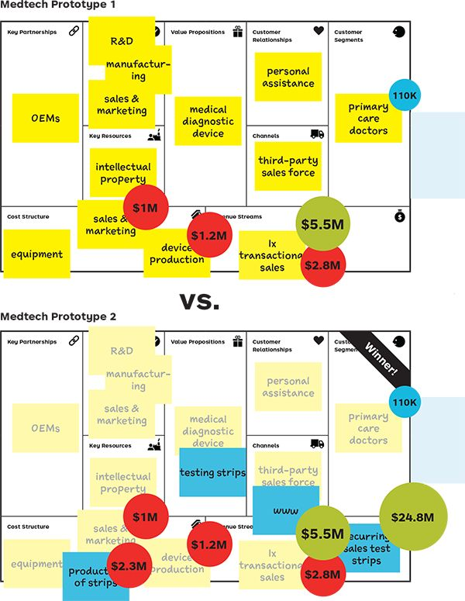

Model 1: Sales of Medical Diagnostic Device

* 1× transactional sales of device to primary care doctors in the United States for $1,000/device
* 5 percent market share
* Sales via third-party sales force -50 percent commission
* Variable production costs of $225/device
* Fixed marketing expenses of $1 million

|  |  |
| --- | --- |
| Costs | Revenues |
| Device Production, 1.2M | Device Sales, 5.5M |
| Sale & Marketing, 1M |  |
| Sales Commission, 2.8M |  |
| Profit 0.5M |  |

Model 2: Recurring Revenues from Consumable Testing Strips

* Each diagnosis requires a consumable testing strip
* Recurring revenues from selling an average of 5 strips/month/device for $75 each
* Variable production costs of testing strips of $7/strip

|  |  |
| --- | --- |
| Costs | Revenues |
| Device Production, 1.2M | Device Sales, 5.5M |
| Sale & Marketing, 1M | Testing Strip Sales, 24.8M |
| Sales Commission, 2.8M |  |
| Testing Strips Prod., 2.3M |  |
| Profit, 23M |  |

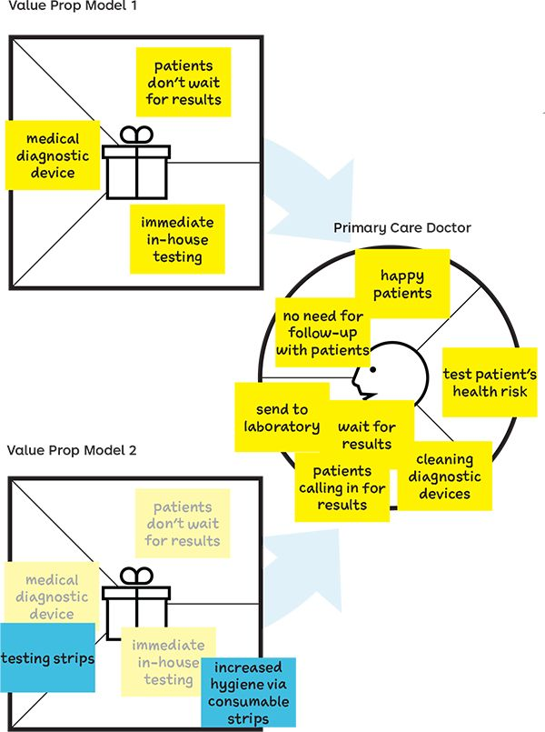

#### Profit 00295.jpeg

A quick sketch of the numbers provides us with a sanity check that this model is not very profitable, so we should go back and explore changes to the business model.

#### Profit 00296.jpeg

The same technology with a different business model now yields a much larger potential profit. Although these numbers aren't validated, it's clearly the more interesting prototype to take to the testing stage.



EXERCISE

Seven Questions to Assess Your Business Model Design

### OBJECTIVE

Unearth potential to improve your business model

### OUTCOME

Business Model Assessment

Great value propositions should be embedded in great business models. Some are better than others by design and will produce better financial results, will be more difficult to copy, and will outperform competitors.

Score your business model design by answering these seven questions:

 [Download “Seven Questions to Assess Your Business Model”](http://strategyzer.com/vpd/design/2.5)



1. Switching Costs

How easy or difficult is it for customers to switch to another company?

My customers are locked in for several years.

10

o

o

o

o

o

o

o

o

o

o

o

0

Nothing holds my customers back from leaving me.

Apple’s iPod got people to copy their entire music library into the iTunes software, which made switching more difficult for customers.



2. Recurring Revenues

Is every sale a new effort or will it result in quasi-guaranteed follow-up revenues and purchases?

100 percent of my sales lead to automatically recurring revenues.

10

o

o

o

o

o

o

o

o

o

o

o

0

100 percent of my sales are transactional.

Nespresso turned the transactional industry of selling coff ee into one with recurring revenues by selling single-portioned pods that fitted only into their machines.

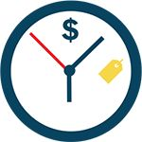

3. Earn Before Spending

Are you earning revenues before you are incurring costs?

I earn 100 percent of my revenues before incurring costs of goods & services sold (CoGs).

10

o

o

o

o

o

o

o

o

o

o

o

0

I incur 100 percent of my costs of CoGs before earning revenues.

Personal computers (PCs) used to be produced well ahead of selling them at the risk of inventory depreciation until Dell disrupted the industry, sold directly to consumers, and earned revenue before assembling PCs.

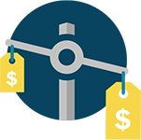

4. Game-changing Cost Structure

Is your cost structure substantially different and better than those of your competitors?

My cost structure is at least 30 percent lower than my competitors.

10

o

o

o

o

o

o

o

o

o

o

o

0

My cost structure is at least 30 percent higher than my competitors

Skype and WhatsApp disrupted the telecom industry by using the Internet as a free infrastructure for calls and messages, while telecoms incurred heavy capital expenditures.

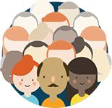

5. Others Who do the Work

How much does your business model get customers or third parties to create value for you for free?

All the value created in my business model is created for free by external parties.

10

o

o

o

o

o

o

o

o

o

o

o

0

I incur costs for all the value created in my business model.

Most of the value in Facebook’s business model comes from content produced for free by more than 1 billion users. Similarly, merchants and shoppers create value for free for credit card companies.



6. Scalability

How easily can you grow without facing roadblocks (e.g., infrastructure, customer support, hiring)?

My business model has virtually no limits to growth.

10

o

o

o

o

o

o

o

o

o

o

o

0

Growing my business model requires substantial resources and eff ort.

Licensing and franchising are extremely scalable, as are platforms like Facebook or WhatsApp that serve hundreds of millions of users with few employees. Credit card companies are also an interesting example of scalability.



7. Protection from Competition

How much is your business model protecting you from your competition?

My business model provides substantial moats that are hard to overcome.

10

o

o

o

o

o

o

o

o

o

o

o

0

My business model has no moats, and I m vulnerable to competition.

Powerful business models are often hard to compete with. Ikea has found few imitators. Similarly, platform models like Apple with the App Store provide powerful moats.

# 2.6 Designing in Established Organizations

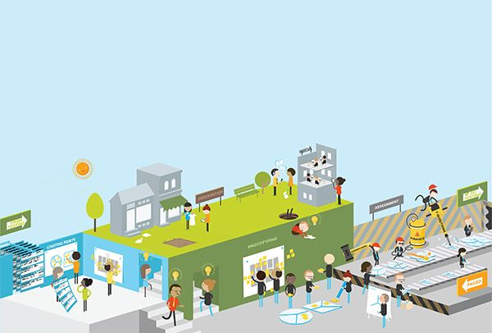

Adopt the Right Attitude to Invent or Improve

Existing organizations need to improve existing value propositions and create new ones proactively. Make sure you understand on which end of the spectrum you are at the beginning of a particular project, because each requires a different attitude and process. Great companies will have a balanced portfolio of projects covering the entire spectrum from improve to invent.

|  |  |  |
| --- | --- | --- |
| 00305.jpeg  invent |  | 00306.jpeg  improve |
| Objective | Design new value propositions regardless of the potential constraints given by existing value propositions and business models (although leadership may define other constraints). | Improve your existing value proposition(s) without radically changing or affecting the underlying business model(s). |
| Helps With | * Proactive bet on the future * Take on a crisis * Emergence of a game-changing technology, regulation, etc. * Response to a disruptive value proposition of a competitor | * Renew outdated products and services. * Ensure or maintain fit. * Improve profit potential or cost structure. * Keep growth going. * Address customer complaints. |
| Financial Goals | At least 50 percent annual revenue growth (caveat: company-specific) | 0 to15 percent annual revenue increase or more (caveat: company-specific) |
| Risk and Uncertainty | High | Low |
| Customer Knowledge | Low, potentially nonexistent | High |
| Business Model | Requires radical adaptions or changes | Little change |
| Attitude to Failure | Part of learning and iteration process | Not an option |
| Mind-set | Open to exploring new possibilities | Focused on making one or several aspects better |
| Design Approach | Radical/disruptive change to value proposition (and business model) | Incremental change and tweaks to existing value proposition |
| Main Activities | Search, test, and evaluate | Refine, plan, and execute |
| Examples | Amazon Web Services  Design of a new IT infrastructure value proposition targeted at a new customer segment. Builds on existing key resources and activities but requires a substantial expansion of Amazon.com's business model. | Amazon Prime  Introduce a membership with special benefits targeted at frequent users of Amazon.com. |

In between: Extend

A common situation in the Improve-Invent spectrum is the need to find new growth engines without investing in substantial changes to the existing business model. This is often required to monetize investments in existing models and platforms.

The objective is to search for new value propositions that substantially extend the existing underlying business model, without modifying too many aspects of it.

For example, with the introduction of the Kindle, Amazon created a new channel to extend its digital offering to Amazon.com customers. Although this presents a great new value proposition to its customers, it remains to a large extent within the parameters of its successfully established and well-mastered e-commerce business model.

Tip

Great companies manage a portfolio of value propositions and business models that cover the entire invent-improve spectrum and make synergies and competitive conflicts explicit. They are proactive and invent while they are still successful, rather than wait for a crisis.



The Business Book of the Future

Imagine if you were a business book publisher. How could you improve your present offering and invent the business book of the future, which might not even be a book anymore? We sketched out three ideas along the invent-improve spectrum.

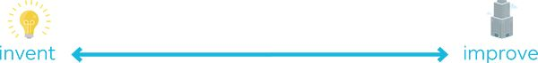

#### The YouTube of business education

An online platform matching videos from business experts with customers who are looking for answers to their problems. This would require a substantial extension or reinvention of the business model of publishing books.

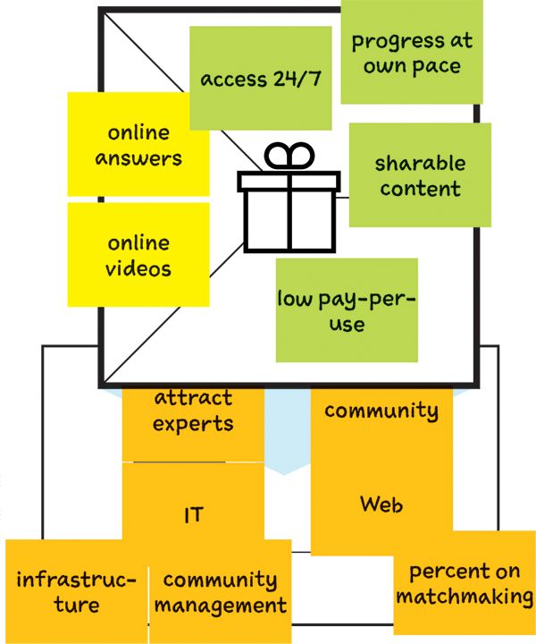

This concept requires an entirely different business model and makes the original one obsolete.

#### The 1-800-Business-Book hotline

A hotline number extending physical business books and offering on-demand answers. This would build on the existing business model but require an extension from a sales to a service model.

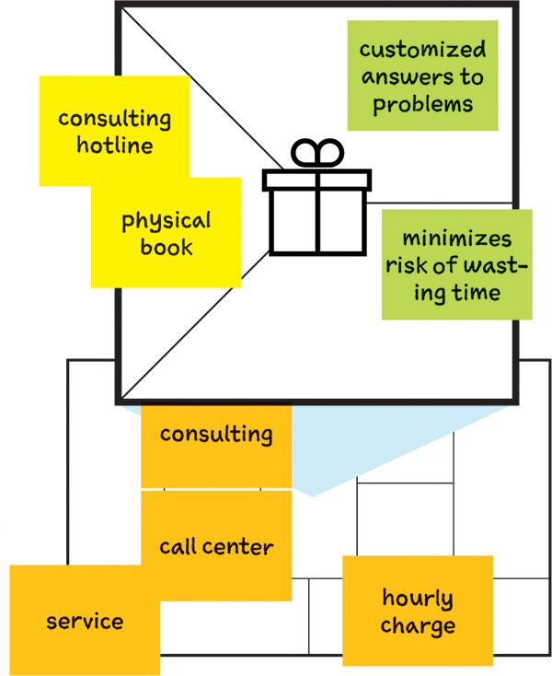

Improvements add to the value proposition and require only minor tweaks to the business model.

#### The practical business book

Improve business books by making them more visual and applicable without altering the core business model behind it substantially.

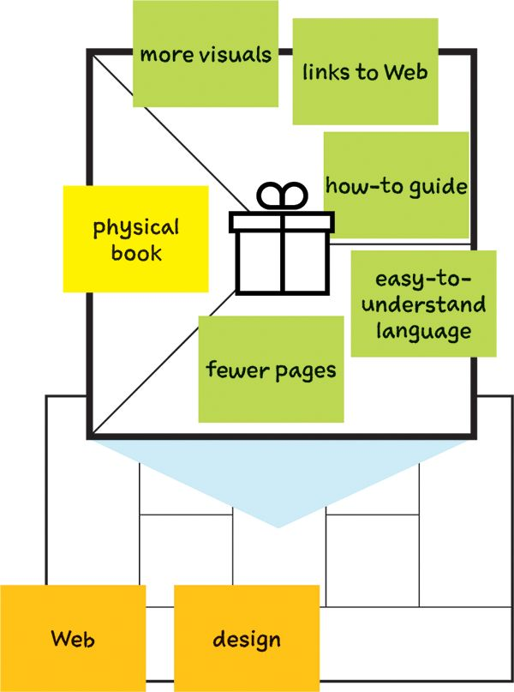

An additional service capability adds a layer to the business model but doesn’t transform it.

The more you move toward the invent end of the spectrum, the more your new value proposition will differ from your existing ones. Inventing new value propositions provides an opportunity to more closely address jobs that really matter to customers (in this case, getting answers to business questions).

Our three-tier value proposition consists of a physical book, sharable practical content online, and advanced learning through our online course. It is our attempt to push the boundaries of business learning and doing.

The value proposition of this book combined with online exercises and material on Strategyzer.com is our attempt to more closely address the jobs we believe matter to our readers.



Reinvent by Shifting from Products to Services

Construction equipment manufacturer Hilti reinvented its value proposition and business model by shifting from products to services. Its move from selling branded machine tools to guaranteeing timely access to them required a substantial overhaul not just of their value proposition but also of their business model. Let’s learn how Hilti did it.

Many organizations aspire to regain a competitive advantage by transforming from a product manufacturer into a service provider. This requires a substantial reinvention.

#### An Expired Model

Hilti’s old model focused mainly on selling high- quality machine tools directly to builders. They were known for breaking less often, lasting longer, and overall being less costly by minimizing time loss. Hilti tools also have a reputation for being particularly safe and enjoyable to work with.

Unfortunately, this old model was one of decreasing margins and subject to competition from lower-cost competitors.

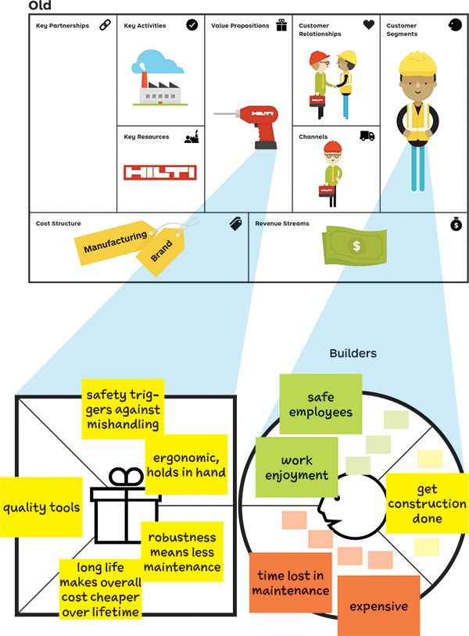

Hilti focused on a new job to be done after discovering that its tools were related to a more important customer job: that of delivering projects on time to avoid financial penalties. They learned that broken, malfunctioning, or stolen tools could lead to major delays and penalties. From there, Hilti moved toward a new value proposition, offering services around machine tools.

#### A Fresh Start

Hilti used its new service-based value proposition to create more value for construction companies by ensuring that they had the right tools at the right place at the right time. This would help construction companies achieve a much more predictable cost management and keep operations profitable.

#### Impact on the Business Model

Moving from products to services sounds like an easy and obvious value proposition shift, but it requires substantially reengineering the business model. Hilti had to add substantial new service resources and activities in addition to manufacturing. But it was worth it. With their new value proposition, Hilti achieves higher margins, recurring revenues, and better differentiation.

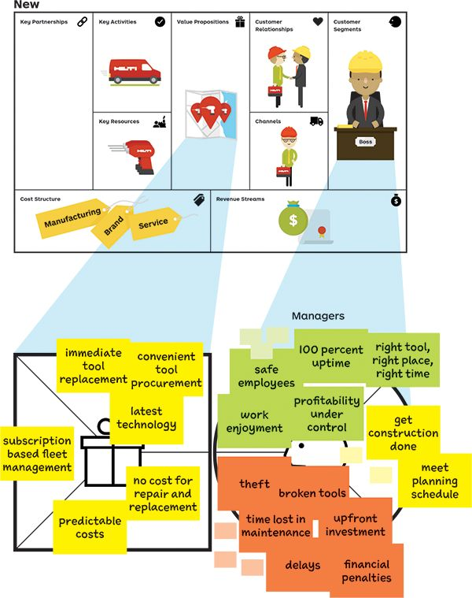

New service created: monthly subscriptions to fleet management utility; “New” customer, more important job identified: delivering on time!



The Perfect Workshop Setting

Workshops are an important part of value proposition design in established organizations. Great workshops can make a big difference in the design process and lead to better results. The questions below will help you create the perfect setting.

#### Who should join?

Invite people with different backgrounds, especially when you know there will be a substantial effect on the business model. Their buy-in is crucial. Get customer-facing staff to participate to leverage their knowledge. Customers or partners may also be a good addition to help evaluate value propositions.

#### What should the format be?

As a rule of thumb, more viewpoints are generally better than fewer at the early stages of value proposition design. With 10 participants or more, you can explore several alternatives in parallel by working in groups of five. Smaller teams need to explore alternatives sequentially. At the later stages of developing and refining value propositions, fewer participants are usually better.

#### How can space be used as an instrument?

Great workshop spaces are an often-overlooked instrument to create outstanding workshops with exceptional outcomes. Choose a space that is sufficiently large and offers large walls or working areas. Set up the space to support creation, collaboration, and productivity. For breakthrough results, choose an unusual and inspiring venue.

#### What tools and materials are needed?

Prepare a self-service area with canvas posters, sticky notes, paper, blue tack, markers, and other tools so participants can help themselves with what they need.

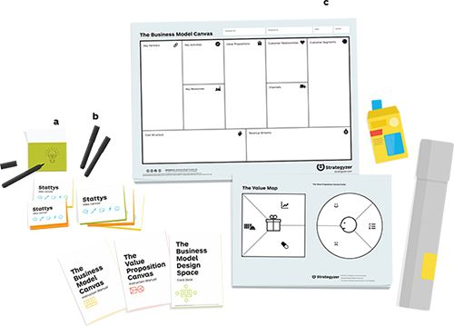

a. Use sticky notes to move ideas around—ideally in several colors for color-coding.

b. Use thick markers so ideas are visible from afar.

c. Use wall-sized posters to sketch out big ideas.

 [Check readily available workshop material](http://strategyzer.com/vpd/design/2.6)

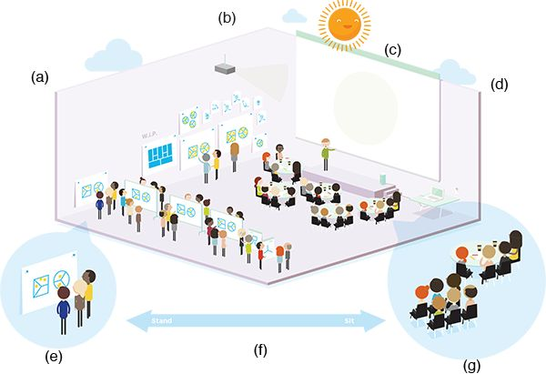

|  |  |
| --- | --- |
| a. Small Group Areas | This is where work gets done. Four or five people per group is best. Do not use chairs or tables unless required for specific work. Keep working groups in the same room rather than a break-out room to retain high energy levels throughout the workshop. |
| b. Work-in-Progress Gallery/Inspiration Wall | Set up an area where you can expose canvases and other work in progress. Add an “inspiration wall” with content that participants can draw from, such as reference models, examples, and models of competitors. |
| c. Projector and Screen | This is used to show slides or customer videos. It should be easily viewable by all. |
| d. Room Control | This space should be set aside for the facilitator and team to access computer, sound system, Wi-Fi, and maybe a printer. |
| e. Plenary Space | Everyone can meet here for plenary presentations and discussions. It can be set up with or without tables. |
| f. Venue Size, Look, and Feel | As a rule of thumb, calculate 50m2 per 10 participants. Favor inspiring venues over boring hotel meeting rooms. |
| g. Walls | Large vertical surfaces are indispensable, whether movable or part of the building. Make sure you can stick large posters, sticky notes, and flip chart paper on them. |



Compose Your Workshop

A great workshop produces tangible and actionable outcomes. Use the tools and processes from this book to start designing a draft workshop outline that leads to great results.

##### Design Principles for a Great Workshop

* Create a workshop agenda with a clear thread that shows participants how the new or improved value proposition(s) or business model(s) will emerge.
* Take participants on a journey of many steps by focusing on one simple task (module) at a time.
* Avoid “blah blah blah” and favor structured interactions with tools like the canvases or processes like the thinking hats.
* Alternate between work in small groups (4–6 people) and plenary sessions for presentations and integration.
* Strictly manage time for each module, in particular for prototyping. Use a timer visible to all participants.
* Design the agenda as a series of iterations for the same value proposition (or business model). Design, critique, iterate, and pivot.
* Avoid slow activities after lunch.

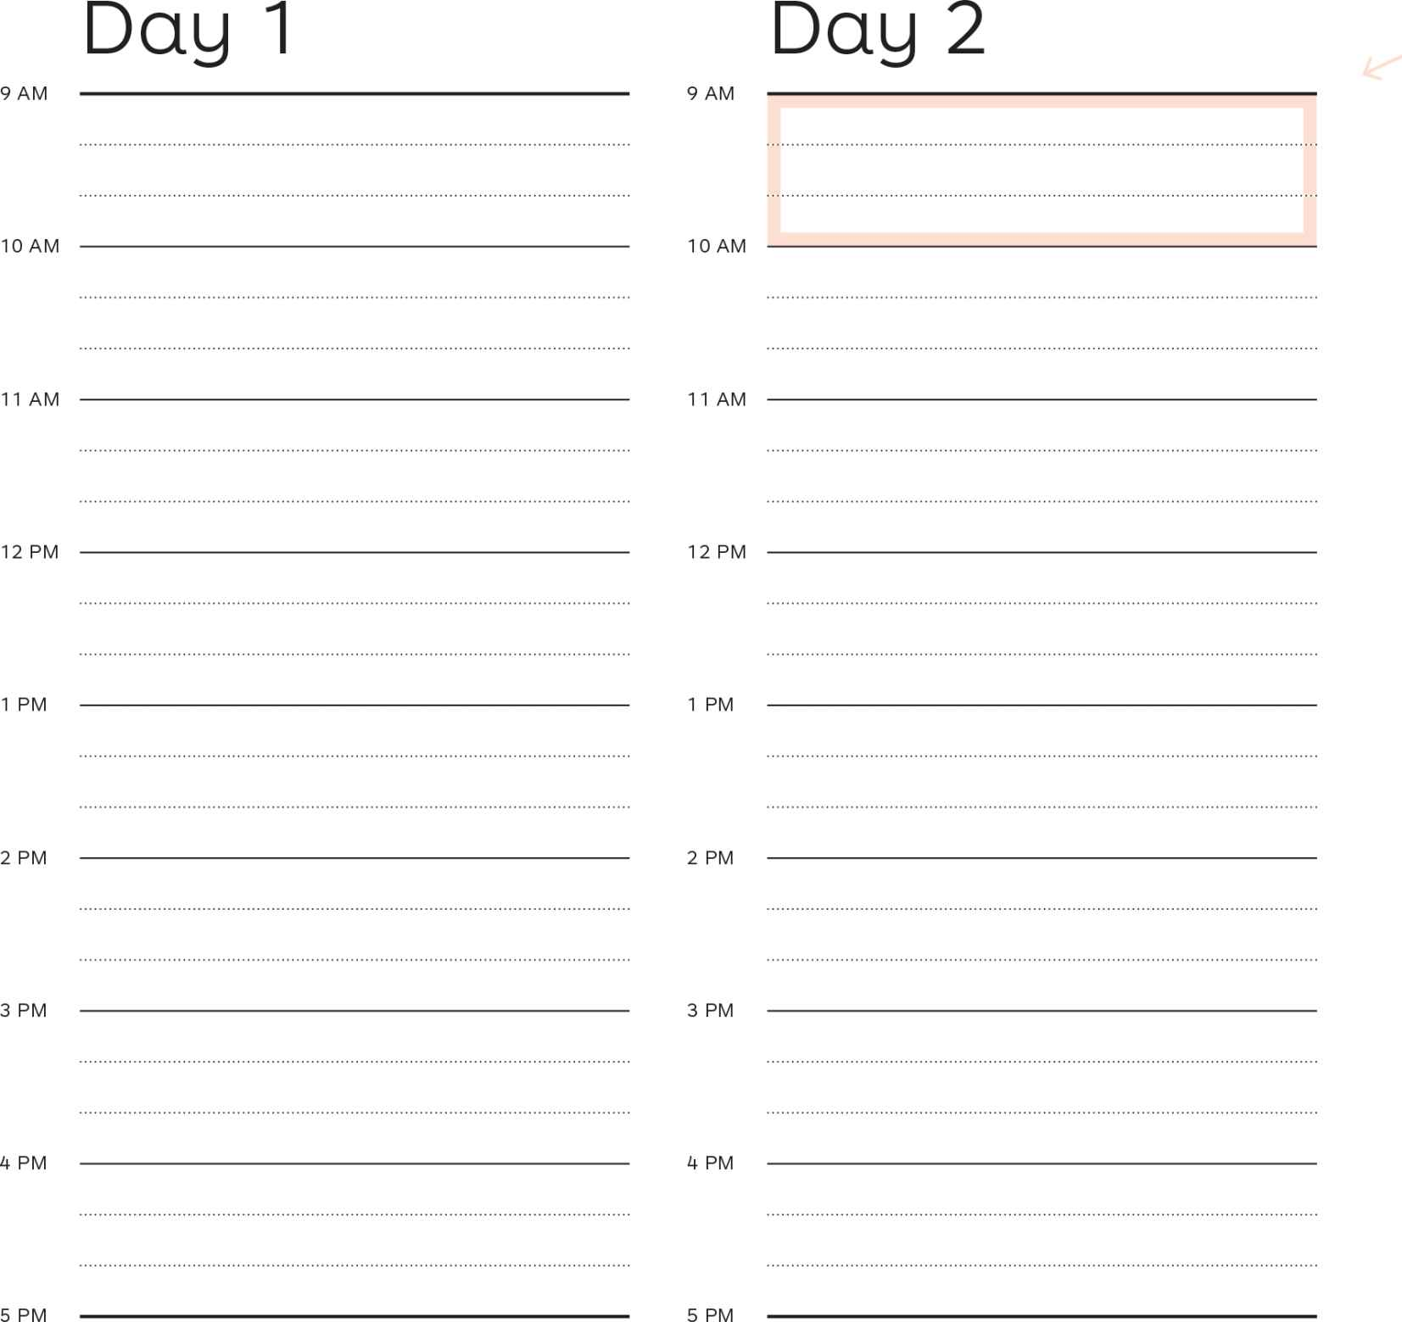

Use the modules below as a menu of options to draft a workshop agenda.

#### Before Your Workshop

Do your homework and gather customer insights

#### After Your Workshop

Get going with testing your value propositions and business models in the real world

#### Get Online For:

* sample agendas
* templates and instructions
* all-in-one material package

|  |
| --- |
| Prototype Possibilities |
| Trigger Questions |
| CS Mapping |
|  |
| VP Mapping |
|  |
|  |
| Napkin Sketches |
| Ad libs |
| Flesh out Ideas with VPC |
| Constraints |
| New Ideas with Books |
| Push / Pull Exercise |
| Six Ways to Innovate |
| Making Choices |
| Rank Jobs, Pains, and Gains |
| Check Your Fit |
| ‘Job’ Selection |
| 10 Questions |
| Voice of Customer |
| Assess against Environment |
|  |
|  |
| Differentiate from Competition |
| De Bono's Hats |
| Dotmocracy |
| Selecting Prototype |
| Back and Forth with Business Model |
| Back and Forth Iteration |
|  |
|  |
| Numbers Projections |
|  |
| 7 BM Questions |
| Preparing Tests |
| Extracting Hypotheses |
|  |
| Prioritizing Hypotheses |
|  |
|  |
| Test Design |
|  |
|  |
| Choose a Mix of Experiments |
|  |
|  |
| Test Road Map |
|  |
|  |
| Breaks |
| Lunch |
|  |
|  |
| Coffee and snacks |



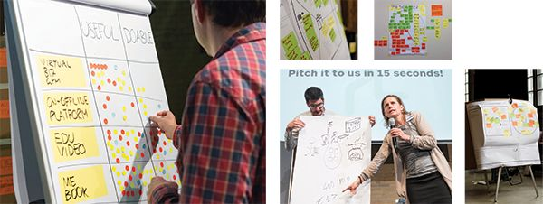

Lessons Learned

Prototyping Possibilities

Rapidly prototype alternative value propositions and business models. Don’t fall in love with your first ideas. Keep your early models rough enough to throw away without regret so that they can evolve and improve.

Understanding Customers

Imagine, observe, and understand your customers. Put yourself in their shoes. Learn what they are trying to get done in their work and in their lives. Understand what prevents them from getting this done well. Unearth which outcomes they are looking for.

Finding the Right Business Model

Search for the right value proposition embedded in the right business model, because every product, service, and technology can have many different models. Even the best value propositions can fail without a sound business model. The right business model can be the difference between success and failure.

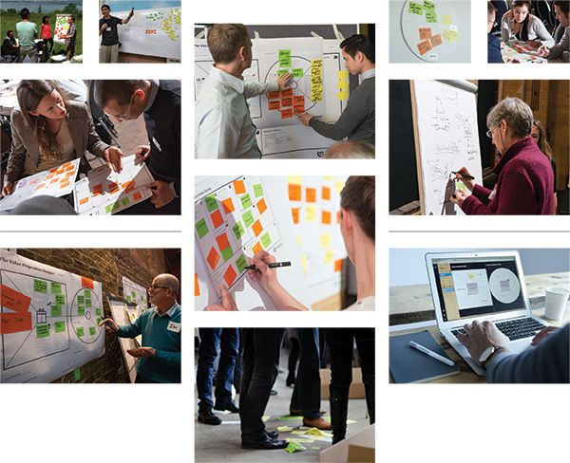



3: Test

Reduce the risk and uncertainty of your ideas for new and improved value propositions by deciding What to Test. Then, get started with Testing Step-by-Step and drawing from the Experiment Library before Bringing It All Together and measuring your progress.

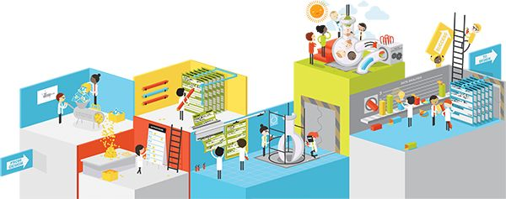

Start Experimenting to Reduce Risk

When you start exploring new ideas, you are usually in a space of maximum uncertainty. You don’t know if your ideas will work. Refining them in a business plan won’t make them more likely to succeed. You are better off testing your ideas with cheap experiments to learn and systematically reduce uncertainty. Then increase spending on experiments, prototypes, and pilots with growing certainty. Test all aspects of your Value Proposition and Business Model Canvases, all the way from customers to partners (e.g., channel partners).

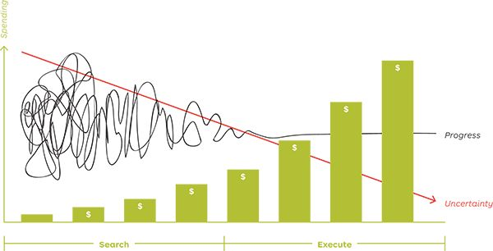

Business Plans vs. Experimentation Processes

The first step in any venture used to be writing a business plan. We now know better. Business plans are great execution documents in a known environment with sufficient certainty. Unfortunately, new ventures often take place under high uncertainty. Therefore, systematically testing ideas to learn what works and what doesn’t is a far better approach than writing a plan. One might even argue that plans maximize risk. Their refined and polished nature gives the illusion that with great execution little can go wrong. Yet ideas dramatically change from inception to market readiness and often die along the way. You need to experiment, learn, and adapt to manage this change and progressively reduce risk and uncertainty. This process of experimentation, which we will explore on the following pages, is known as customer development and lean start-up.

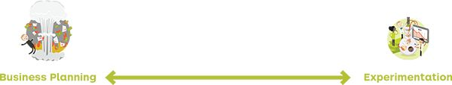

Applied to New Ventures

|  |  |  |
| --- | --- | --- |
| We know | Attitude | Our customers and partners know |
| Business plan | Tools | Business Model and Value Proposition Canvas |
| Planning | Process | Customer development and lean start-up |
| Inside the building | Where | Outside the building |
| Execution of a plan | Focus | Experimentation and learning |
| Historical facts from past success | Decision-basis | Facts and insights from experiments |
| Not addressed adequately | Risk | Minimized via learnings |
| Avoided | Failure | Embraced as means to learn and improve |
| Masked via detailed plan | Uncertainty | Acknowledged and reduced via experiments |
| Granular documents and spreadsheets | Detail | Dependent on level of evidence from experiments |
| Assumptions | Numbers | Evidence-based |

10 Testing Principles

Apply these 10 principles when you start testing your value proposition ideas with a series of experiments. A good experimentation process produces evidence of what works and what doesn’t. It also will enable you to adapt and change your value propositions and business models and systematically reduce risk and uncertainty.

 [Get “10 Testing Principles” poster](http://strategyzer.com/vpd/test/3.0)

1

Realize that evidence trumps opinion.

Whatever you, your boss, your investors, or anybody else thinks is trumped by (market) evidence.

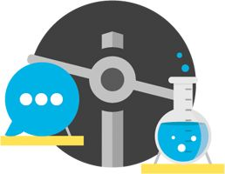

2

Learn faster and reduce risk by embracing failure.

Testing ideas comes with failure. Yet failing cheaply and quickly leads to more learning, which reduces risk.



3

Test early; refine later.

Gather insights with early and cheap experiments before thinking through or describing your ideas in detail.

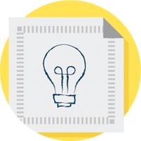

4

Experiments ≠ reality.

Remember that experiments are a lens through which you try to understand reality. They are a great indicator, but they differ from reality.

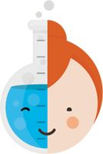

5

Balance learnings and vision.

Integrate test outcomes without turning your back on your vision.



6

Identify idea killers.

Begin with testing the most important assumptions: those that could blow up your idea.

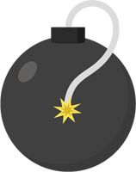

7

Understand customers first.

Test customer jobs, pains, and gains before testing what you could offer them.



8

Make it measurable.

Good tests lead to measurable learning that gives you actionable insights.



9

Accept that not all facts are equal.

Interviewees might tell you one thing and do another. Consider the reliability of your evidence.

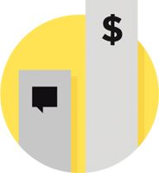

10

Test irreversible decisions twice as much.

Make sure that decisions that have an irreversible impact are particularly well informed.

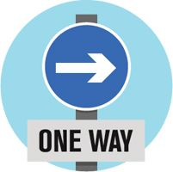

Introducing the Customer Development Process

Customer development is a four-step process invented by Steve Blank, serial entrepreneur turned author and educator. The basic premise is that there are no facts in the building, so you need to test your ideas with customers and stakeholders (e.g., channel partners or other key partners) before you implement them. In this book we use the customer development process to test the assumptions underlying Value Proposition and Business Model Canvases.

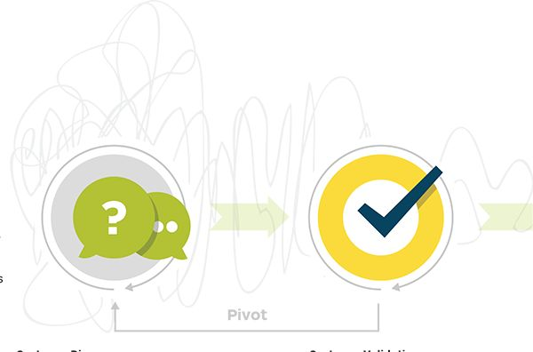



#### Customer Discovery

Get out of the building to learn about your customers’ jobs, pains, and gains. Investigate what you could offer them to kill pains and create gains.



#### Customer Validation

Run experiments to test if customers value how your products and services intend to alleviate pains and create gains.

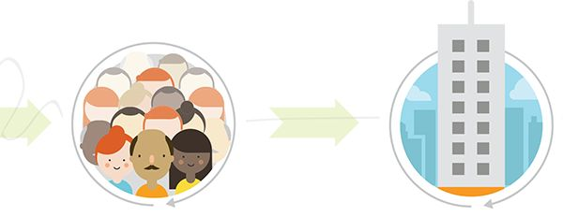



#### Customer Creation

Start building end user demand. Drive customers to your sales channels and begin scaling the business.



#### Company Building

Transition from a temporary organization designed to search and experiment to a structure focused on executing a validated model.

Search vs. Execute

The goal of the search phase is to experiment and learn which value propositions might sell and which business models could work. Your canvases will radically change and constantly evolve during this phase while you test every critical hypothesis. Only when you have validated your ideas do you get into the execution mode and scale. At the early stages of the process, your canvases change rapidly; they will stabilize with increasing knowledge from your experiments.

Tip

Capture every hypothesis, everything you tested, and everything you learned. Use the Value Proposition and Business Model Canvases to track your progress from initial idea and starting point toward a viable value proposition and business model. Keeping track of your progress and evidence produced along the way allows you to refer back to it if necessary.

Blank & Dorf ,The Startup Owner’s Manual, 2012.

Integrating Lean Start-up Principles

Eric Ries launched the Lean Startup movement based on Steve Blank’s customer development process. The idea is to eliminate slack and uncertainty from product development by continuously building, testing, and learning in an iterative process. Here we apply the three steps in combination with the canvases and customer development to test ideas, assumptions, and so-called minimum viable product (MVPs).

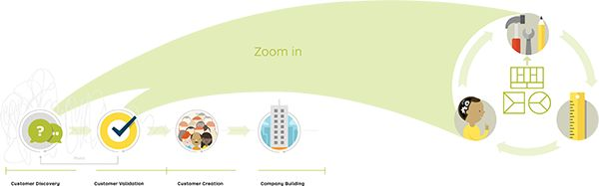

#### 00332.jpeg Customer Discovery

#### 00333.jpeg Customer Validation

#### 00335.jpeg Customer Creation

#### 00336.jpeg Company Building

Zoom in

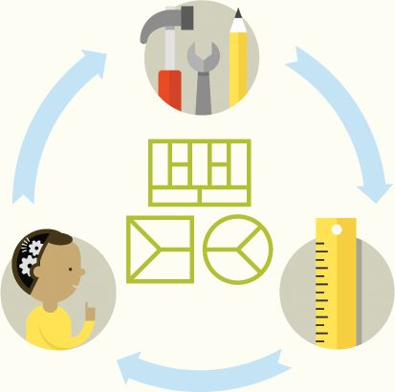

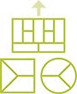

#### 0. Generate a hypothesis.

Start with the Value Proposition and Business Model Canvases to define the critical hypotheses underlying your ideas in order to design the right experiments.

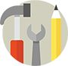

#### 1. Design/build.

Design or build an artifact specifically conceived to test your hypotheses, gain insights, and learn. This could be a conceptual prototype, an experiment, or simply a basic prototype (MVP) of the products and services you intend to offer.



#### 2. Measure.

Measure the performance of the artifact you designed or built.



#### 3. Learn.

Analyze the performance of the artifact, compare to your initial hypotheses, and derive insights. Ask what you thought would happen. Describe what actually happened. Then outline what you will change and how you will do so.

Apply Build, Measure, Learn

Apply the Lean Startup circle to more than just products and services. Use the same three steps of designing/building, testing/measuring, and learning with all the artifacts you create in Value Proposition Design. Apply design/build, test/measure, learn to your…

|  |  |  |  |  |  |
| --- | --- | --- | --- | --- | --- |
|  |  |  | Design/Build | Measure | Learn |
| Conceptual Prototypes  00338.jpeg |  | Design rapid conceptual prototypes to shape your ideas, figure out what could work, and identify which hypotheses need to be true to succeed. Use these prototypes as a tangible way to clearly map, track, iterate, and share your ideas and hypotheses. | Business Model and/ or Value Proposition Canvases to shape your ideas throughout the process | Performance of conceptual prototype: fit between customer profile and value map, ballpark figures, design assessment with 7 business model questions | If and why you need to adapt your conceptual prototypes Assumed financial performance of your business model Assumed fit Which hypotheses you need to test |
| Hypotheses  00343.jpeg |  | Design and build experiments to test the hypotheses that need to be true for your idea to succeed. Start with the most critical hypotheses that could kill your idea. | Interviews, observations, and experiments to test initial value proposition and business model assumptions derived from conceptual prototyping | What actually happens in your experiments compared with what you thought would happen (i.e., your hypotheses) | If and why you need to change any of the building blocks of your Business Model or Value Proposition Canvas |
| Products and services  00344.jpeg |  | Build so-called MVPs to test your value propositions. These are prototypes with a minimum feature set specifically designed to learn rather than to sell. | MVPs with the benefits and features you want to test | If your products and service actually relieve pains and create gains for customers | If and why you need to change the products and services in your value proposition Which pain relievers and gain creators work and which ones don’t |



I present Shrek models, that’s a Yiddish expression for making people nervous.Frank Gehry, Architect



There are no facts in the building… So get the hell out and talk to customers.  
Steve Blank, Entrepreneur & Educator



Fail early to succeed sooner.  
David Kelley, Designer

3.1  
What to Test

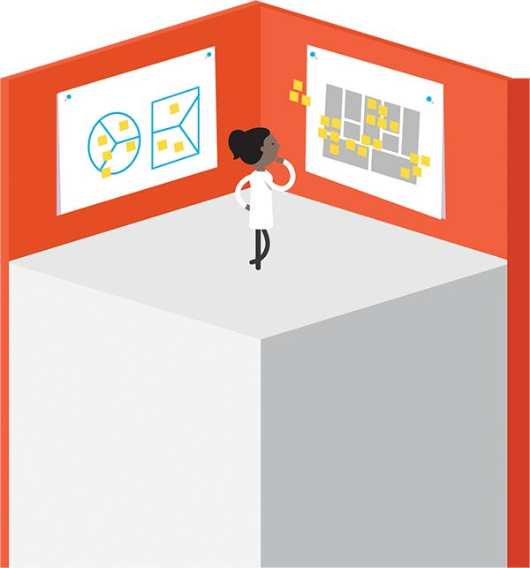

Testing the Circle

Prove which jobs, pains, and gains matter to customer most by conducting experiments that produce evidence beyond your initial customer research. Only after this has been done should you get started with your value proposition. This will prevent you from wasting time with products and services customers don’t care about.

Provide evidence showing what customers care about (the circle) before focusing on how to help them (the square).

Start with jobs, pains, and gains

In the design section we looked at a series of techniques to better understand customers. In this chapter we go a step further. The objective of “testing the circle” is to confirm with evidence that our profile sketches, our initial research, our observations, and our insights from interviews were correct. We aim to know with more certainty which jobs, pains, and gains customers really care about.

Possessing evidence about customer jobs, pains, and gains before you focus on your value proposition is very powerful. If you start by testing your value proposition, you never know if customers are rejecting your value proposition or if you are simply addressing irrelevant jobs, pains, or gains. This is less likely to happen if you have evidence about which jobs, pains, and gains matter to customers.

Of course, this means you need to find creative ways to test customer preferences without already drawing on the use of minimum viable products (MVPs). We show how to do so with the tools in the testing library.

Do you have evidence showing…



|  |  |
| --- | --- |
| 00040.jpeg | * Which gains matter to your customers? * Which ones are most essential? |
| 00042.jpeg | * Which jobs matter to your customers? * Which ones matter most? * Which ones are most extreme? |
| 00041.jpeg | * Which pains matter to your customers? * Which ones are most extreme? |



Testing the Square

Test if and how much your customers care about how you intend to help them. Design experiments that produce evidence showing that your products and services kill pains and create gains that matter to customers.

Do you have evidence showing…



|  |  |
| --- | --- |
| 00038.jpeg | * Which one of your products and services customers really want? * Which ones they want most? |
| 00036.jpeg | * Which one of your gain creators customers really need or desire? * Which ones they crave most? |
| 00037.jpeg | * Which one of your pain relievers  helps your customers with their  headaches? * Which ones they long for most? |

Provide evidence showing that your customers care about how your products and services kill pains and create gains.

The Art of Testing Value Propositions

It is an art to test how much your customers care about your value proposition because the goal is to do so as cheaply and quickly as possible without implementing the value proposition in its entirety.

You need to test your customers’ taste for your products and services one pain reliever and gain creator at a time by designing experiments that are measurable, provide insights, and allow you to learn and improve.

Make sure your experiments allow you to understand which aspects of your products and services customers appreciate, so that you can avoid offering anything unnecessary. In other words, remove any features or efforts that don’t contribute directly to the learning you seek.

Always make sure you aim to find the simplest, quickest, and cheapest way to test a pain reliever or gain creator before you start prototyping products and services.



Testing the Rectangle

Test the most critical assumptions underlying the business model your value proposition is embedded in. Remember, even great value propositions can fail without a sound business model. Provide evidence showing that your business model is likely to work, will generate more revenue than costs, and will create value not only for your customers but for your business.

Provide evidence showing that the way you intend to create, deliver, and capture value is likely to work.

Don’t neglect testing your business model

You can fail even with a successful value proposition if your business model generates less revenue than it incurs costs. Many creators are so focused on designing and testing products and services that they sometimes neglect this obvious equation (profit = revenues - costs) resulting from the building blocks of the Business Model Canvas.

A value proposition that customers want is worth little if you don’t have the channels to reach customers in a way they want to be reached. Likewise, a business model that spends more money on acquiring customers than it will earn from revenue from those same customers won’t survive over the long term. Similarly, a company will obviously go out of business if resources and activities required to create value are more costly than the value they capture. In some markets you might need access to key partners who might not be interested in working with you.

Design experiments that address the most important things that have to be true for your business model to work. Testing such critical assumptions will prevent you from failing with a great value proposition that customers actually want.

Do you have evidence showing…

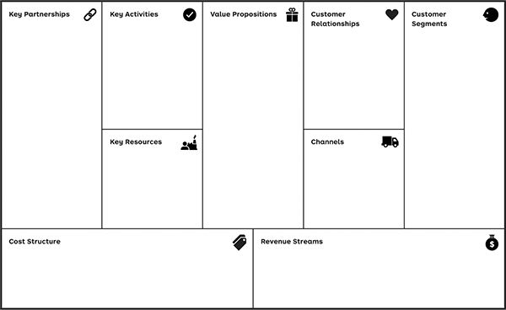

|  |  |
| --- | --- |
| Key Partnerships | That you will have access to the partners required for your model to work? |
| Key Activities | That you will have access to the resources required to create value? |
| Customer Relationships | How you will generate revenues from customers? |
| Channels | Through which channels will you be able to reach customers? |
| Revenue Streams | That you will be able to perform the activities required to create value? |
| Cost Structure | That you can generate more revenue than costs incurred? |
| Key Resources | How you will succeed in acquiring and retaining customers? |

3.2  
Testing Step-by-Step

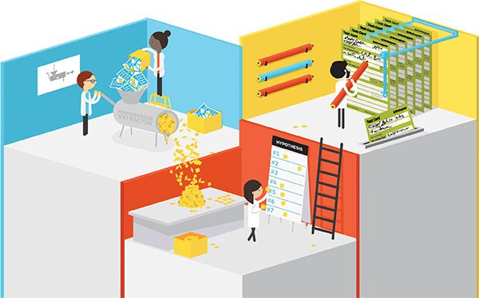

Overview of the Testing Process

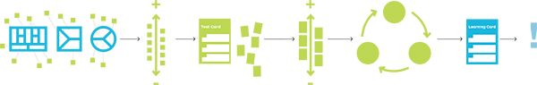

Extract Your Hypotheses: What Needs to Be True for Your Idea to Work?

Use the Value Proposition and Business Model Canvases to identify what to test before you “get out of the building.” Define the most important things that must be true for your idea to work.

 Do the exercise online

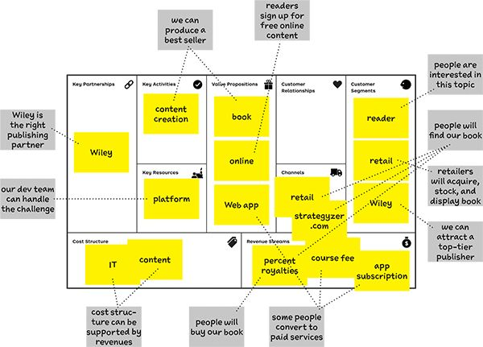

DEF-I-NI-TION

Business Hypothesis

Something that needs to be true for your idea to work partially or fully but that hasn’t been validated yet.

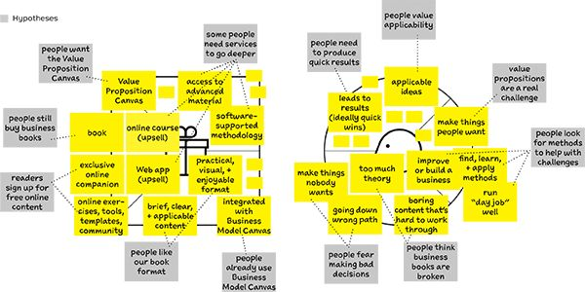

##### To succeed, ask yourself what needs to be true about…

 … your business model?

 … your value proposition?

 … your customer?



Prioritize Your Hypotheses: What Could Kill Your Business

Not all hypotheses are equally critical. Some can kill your business, whereas others matter only once you get the most important hypotheses right. Start prioritizing what’s critical to survival.



#### 00355.jpeg Identify the business killers. These are the hypotheses that are critical to the survival of your idea. Test them first!

#### Rank all your hypotheses in order of how critical they are for your idea to survive and thrive:

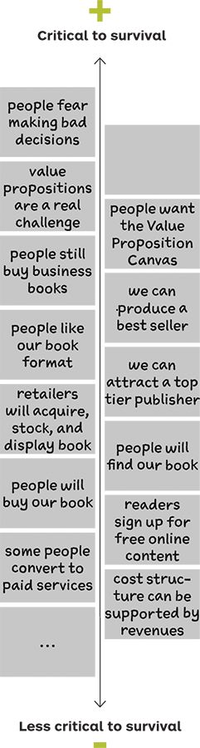

#### 00355.jpeg What priorities matter most?

|  |  |
| --- | --- |
| People fear making bad decisions | people look for methods to help with challenges |

There is no basis for our idea if people aren’t making or don’t fear making bad business decisions (in particular regarding products and services) or if they aren’t looking for methods to help them with such issues.

|  |  |
| --- | --- |
| Value propositions are a real challenge | People want the Value Proposition Canvas |

If people don’t struggle with value propositions and if they don’t see the Value Proposition Canvas as a helpful tool, there is no opportunity for our ideas.

|  |  |
| --- | --- |
| We can attract a top tier publisher | people will find our book |
| Retailers will acquire, stock, and display book | people will buy our book |

It’s critical that people like or love our book, but that’s only the start. If they can’t find it or don’t know about it, they won’t be able to buy it even if they potentially would have liked it.

|  |  |  |
| --- | --- | --- |
| People still buy business books | We can produce a best seller | People like our book format |

There is no foundation for our idea if people don’t buy business books anymore and we can’t produce a best seller in a format they like.

|  |  |
| --- | --- |
| Some people convert to paid services | Readers sign up for free online content |

It’s critical that we can get people to use strategyzer.com so we can upsell to those interested in more services.

duplicate hypothesis— eliminate one sticky note



Design Your Experiments with the Test Card

Structure all of your experiments with this simple Test Card. Start by testing the most critical hypotheses.

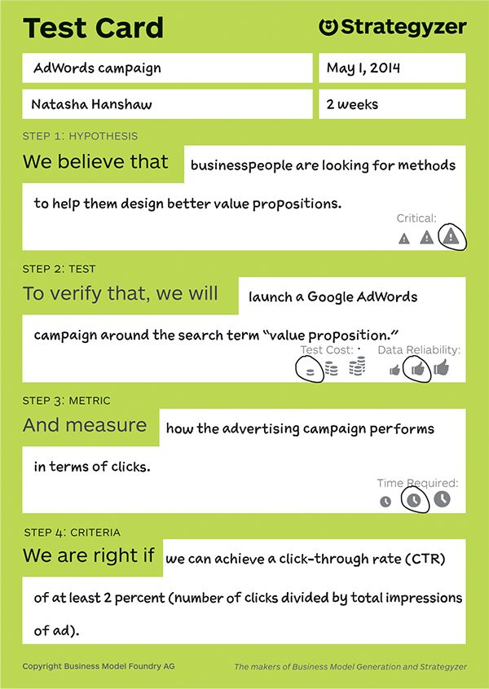

#### 00355.jpeg How will I learn?

#### 1. Design an experiment.

Name the test, set a due date, and list the person responsible.

Describe the hypothesis that you want to test.

Indicate how critical this hypothesis is for the entire idea to work.

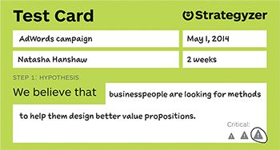

Outline the experiment you are going to design to verify if the hypothesis is correct or needs to be rejected and revised.

Indicate how costly this test will be to execute.

Indicate how reliable the measured data are.

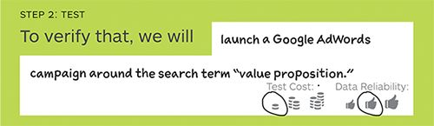

Define what data you are going to measure.

Indicate how long it takes until this test produces results.

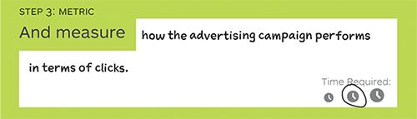

Define a target threshold to validate or invalidate the tested hypothesis.

Caveat: Consider following up with additional experiments to increase certainty.

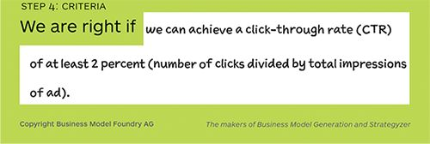

 [Download the Test Card and do the exercise online](http://strategyzer.com/vpd/test/3.2)

#### 00355.jpeg Repeat.

#### 2. Design a series of experiments for the most critical hypotheses.

Tip

Consider testing the most critical hypotheses with several experiments. Start with cheap and quick tests. Then follow up with more elaborate and reliable tests if necessary. Thus, you may create several Test Cards for the same hypotheses.

#### 3. Rank Test Cards.

Prioritize your Test Cards. Rank the most critical hypotheses highest, but prioritize cheap and quick tests to be done early in the process, when uncertainty is at its maximum. Increase your spending on experiments that produce more reliable evidence and insights with growing certainty.

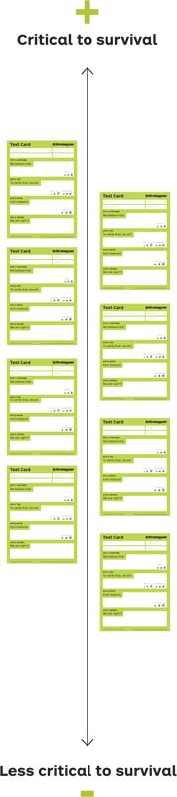

#### 4 Run experiments.

Start performing the experiments at the top of your list.

Caveat: If your first experiments invalidate your initial hypotheses, you might have to go back to the drawing board and rethink your ideas. This might render the remaining Test Cards in your list irrelevant.

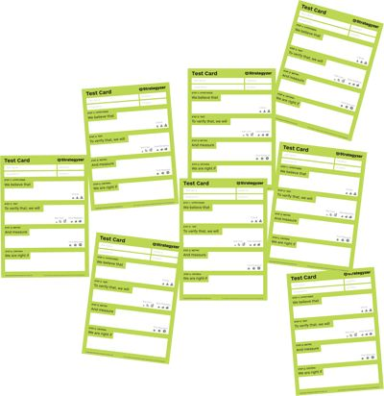

 Where can I get the most learning the fastest?



Capture Your Insights with the Learning Card

Structure all of your insights with this simple Learning Card.

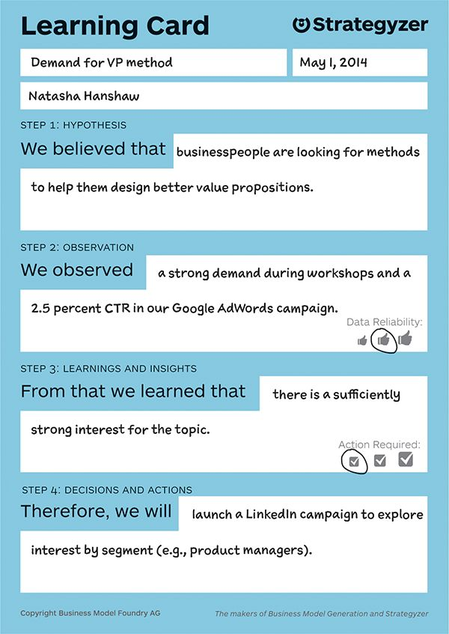

Describe the hypothesis that you tested.

Name the insight, the date of learning, and the person responsible.

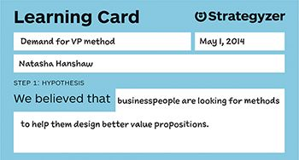

Outline the outcomes of your experiment(s) in terms of data and results. A Learning Card may aggregate the observations from several Test Cards.

Note how reliable the data measured are.

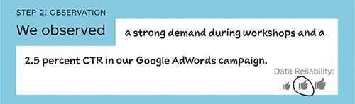

Explain what conclusions and insights you derived from the test results.

Highlight how dramatic the actions required are based on what you learned.

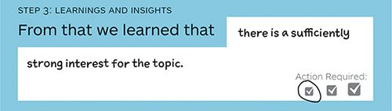

Describe what actions you will take based on your insights.

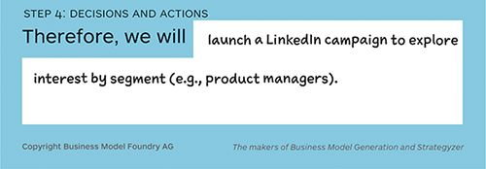

 [Download the Learning Card](http://strategyzer.com/vpd/test/3.2)

#### 00355.jpeg You experimented and learned. Now what?

#### Invalidated

Get back to the drawing board: pivot.

Find new alternative segments, value propositions, or business models to make your ideas work when your tests invalidate your first attempts.

For example, when you have invalidated customer interest for your value proposition around a novel technology, search for new potential customers, value propositions, and business models.

#### Learn more

Seek confirmation.

Design and conduct further tests when quick and early experiments based on a small amount of data indicate the need for drastic actions.

For example, if interviews with potential customers show a strong interest for a service that requires heavy investments to launch, follow up with research and experiments that produce more reliable data validating customer interest.

Deepen your understanding.

Design and conduct further tests to understand why a trend is taking place once you discovered that it is taking place.

For example, if the quantitative data of an experiment show that potential customers are not interested, follow up with qualitative interviews to understand why they are uninterested.

#### Validated

Expand to next building block.

Move on to test your next important hypothesis when you are satisfied with your insights and the data reliability.

For example, when you have validated customer interest for a product, follow up with experiments that validate the willingness of channel partners to stock and promote your product.

Execute.

When you are satisfied with the quality of your insights and the reliability of the data, you may directly start executing based on your findings.

For example, when you have learned and validated exactly what it takes to get channel partners interested in reselling your value proposition, start scaling up sales efforts by hiring salespeople or designing dedicated marketing material.



How Quickly Are You Learning?

The only thing standing between you and finding out what customers and partners really want is the consistency and speed with which you and your team can propel yourself through the design/build, measure, learn cycle. This is called cycle time.

The speed at which you learn is crucial, especially during the early phases of value proposition design. When you start out, uncertainty is at its maximum. You don’t know if customers care about the jobs, pains, and gains you intend to address, let alone if they’re interested in your value proposition.

Therefore, it is critical that your early experiments be extremely fast and produce a maximum of learning so you can adapt rapidly. This is why writing a business plan or conducting a large third-party market study is the wrong thing to start with, although it can make sense later in the process.

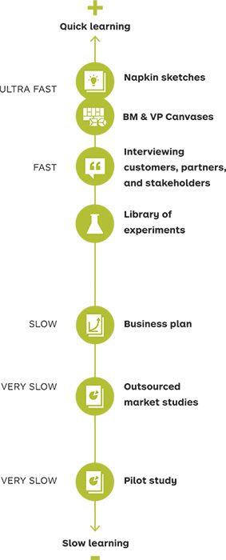

Learning Instruments

Quickly shape your ideas to share, challenge, or iterate them and to generate hypotheses to test.

Quickly gain first market insights. Keep the effort in-house so learnings remain fresh and relevant and so you can move fast and act upon insights.

Use the whole range of experiments from the experiment library p. 214. Start with quick ones when uncertainty is high. Continue with more reliable, slower ones, when you have evidence about the right direction.

Business plans are more refined documents and usually more static. Write one only when you have clear evidence and are approaching the execution phase.

Market studies are often costly and slow. They are not an optimal search tool because they don’t allow you to adapt to circumstances rapidly. They make most sense in the context of incremental changes to a value proposition.

A pilot study is often the default way to test an idea inside a corporation. However, they should be preceded by quicker and cheaper learning tools, because most pilots are based on relatively refined value propositions that involve substantial time and cost.

The faster you iterate, the more you learn and the faster you succeed.

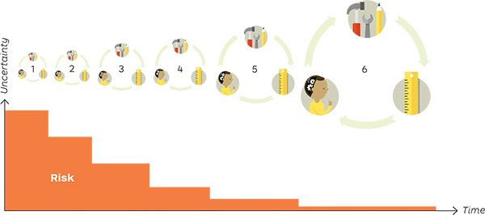

Six rapid iteration cycles based on quick experiments produce more learning than three long iteration cycles based on slower experiments. The faster approach will produce knowledge more quickly and thus reduce risk and uncertainty more substantially than the latter.

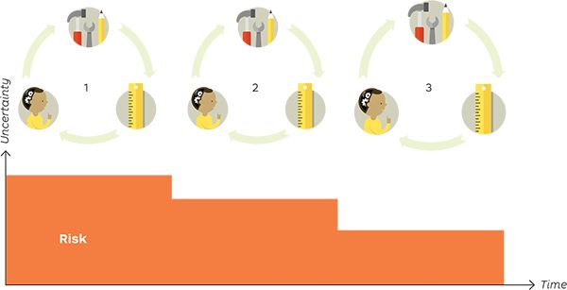

#### Don’t waste your time!

Imagine spending a week, a month, or more on refining and perfecting your idea. Imagine spending all that time thinking hard about what you’d need to do to produce great growth numbers only to find out that your customers and partners don’t really care. That’s wasted time!



Five Data Traps to Avoid

Avoid failure by thinking critically about your data. Experiments produce valuable evidence that can be used to reduce risk and uncertainty, but they can’t predict future success with 100 percent accuracy. Also, you might simply draw the wrong conclusions from your data. Avoid the following five traps to ensure you successfully test your ideas.

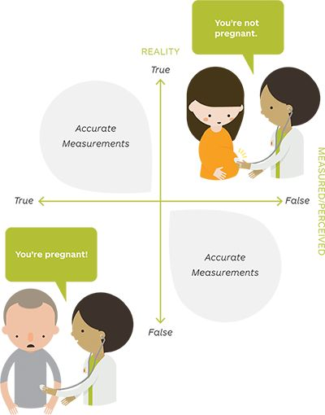

False-Positive Trap



Risk: Seeing things that are not there.

Occurs: When your testing data mislead you to conclude, for example, that your customer has a pain when in fact it is not true.

Tips

* Test the circle before you test the square. Understand what’s relevant to customers to avoid being misled by positive signals for irrelevant value propositions.
* Design different experiments for the same hypothesis before making important decisions.

False- Negative Trap



Risk: Not seeing things that are there.

Occurs: When your experiment fails to detect, for example, a customer job it was designed to unearth.

Tips

Make sure your test is adequate. Dropbox, a file hosting service, initially tested customer interest with Google AdWords. They invalidated their hypotheses, because the ads didn’t perform. But the reason people didn’t search was because it was a new market, not because there was a lack of interest.

The “Local Maximum” Trap

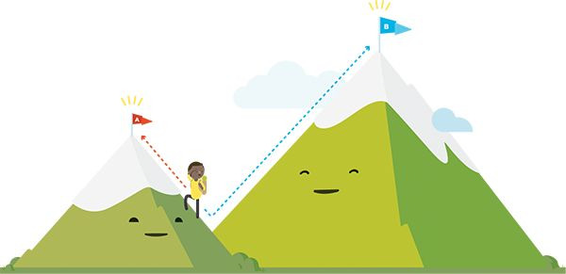

Risk: Missing out on the real potential.

Occurs: When you conduct experiments that optimize around a local maximum while ignoring the larger opportunity. For example, positive testing feedback might result in you sticking with a much less profitable model when a more profitable one exists.

Tip

Focus on learning rather than optimizing. Don’t hesitate to go back to designing better alternatives if the testing data are positive but the numbers feel like they should be better (e.g., larger market, more revenues, better profit).

The “Exhausted Maximum” Trap

Risk: Overlooking limitations (e.g., of a market).

Occurs: When you think an opportunity is larger than it is in reality. For example, when you think you are testing with a sample of a large population but the sample is actually the entire population.

Tip

Design tests that prove the potential beyond the immediately addressed test subjects.

The Wrong Data Trap

Risk: Searching in the wrong place.

Occurs: When you abandon an opportunity because you are looking at the wrong data. For example, you might drop an idea because the customers you are testing with are not interested and you don’t realize that there are people who are interested.

Tip

Go back to designing other alternatives before you give up.

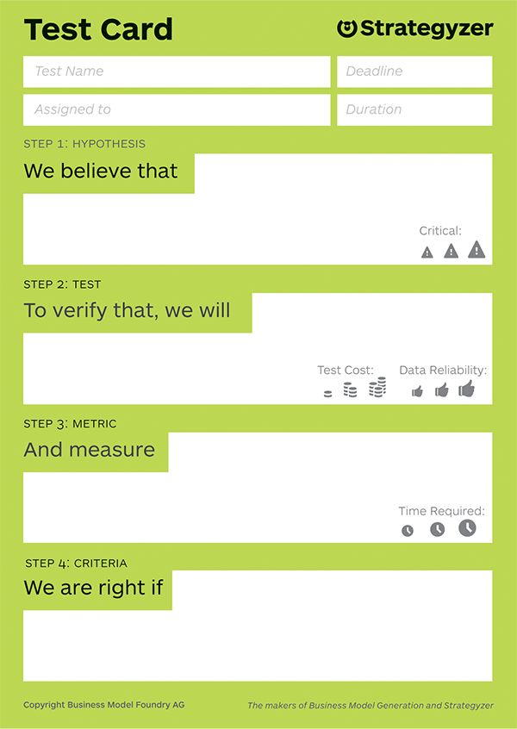

 [Download the Test Card](http://strategyzer.com/vpd/test/3.2)

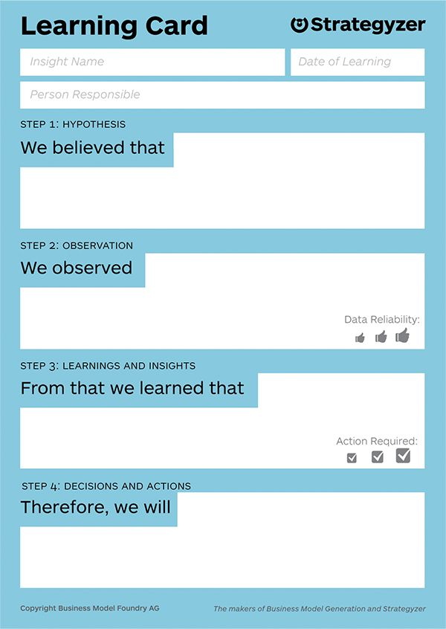

 [Download the Learning Card](http://strategyzer.com/vpd/test/3.2)

3.3  
Experiment Library

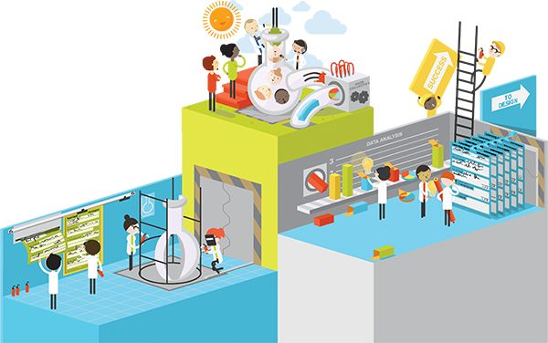

Choose a Mix of Experiments

Every experiment has strengths and weaknesses. Some are quick and cheap but produce less reliable evidence. Some produce more reliable evidence but require more time and money to execute.

Consider cost, data reliability, and time required when you design your mix of experiments. As a rule of thumb, start cheap when uncertainty is high and increase your spending on experiments with increasing certainty.

DEF-I-NI-TION

Experiment

A procedure to validate or invalidate a value proposition or business model hypothesis that produces evidence.

Select a series of tests by drawing from our experiment library or by using your imagination to invent new experiments. Keep two things in mind when you compose your mix:

#### What customers say and do are two different things.

Use experiments that provide verbal evidence from customers as a starting point. Get customers to perform actions and engage them (e.g., interact with a prototype) to produce stronger evidence based on what they do, not what they say.

#### Customers behave differently when you are there or when you are not.

During direct personal contact with customers, you can learn why they do or say something and get their input on how to improve your value proposition. However, your presence might lead them to behave differently than if you weren’t there.

In an indirect observation of customers (on the web, for example) you are closer to a real-life situation that isn’t biased by your interaction with customers. You can collect numerical data and track how many customers performed an action you induced.

Tip

Use these techniques to understand how customers interact with your prototypes. Investments are usually higher but produce concrete and actionable feedback.

Tip

Use these techniques at the early stages of the design process, because investment is low and they produce quick insights.

Tip

Use these techniques to verify whether customers really mean what they say. Produce evidence that the jobs, pains, and gains they mention are real and that they are seriously interested in your products and services.

|  |  |  |
| --- | --- | --- |
|  | DIRECT CONTACT with customers Learn why and how to improve | DIRECT OBSERVATION of customers Learn how many and how much |
| WHAT CUSTOMERS Do Observe their behaviors | Lab studies  00380.jpeg   * Learning prototype/MVP * Life-size prototypes * Wizard of Oz   Anthropologist  00381.jpeg  For field studies | Sale actions  00380.jpeg   * Mock sales * Presales * Crowdfunding   Tracking actions  00380.jpeg   * Ad and link tracking * Landing page * Split testing |
| WHAT CUSTOMERS SAY Observe their attitudes | Participatory design and evaluation  00380.jpeg   * Illustrations, storyboards, and scenarios * Speedboat * Product box * Buy a feature   Journalist  00382.jpeg  For interviews | Detective  00383.jpeg  For data analysis |



Produce Evidence with a Call to Action

Use experiments to test if customers are interested, what preferences they have, and if they are willing to pay for what you have to offer. Get them to perform a call to action (CTA) as much as possible in order to engage them and produce evidence of what works and what doesn’t.



The more a customer (test subject) has to invest to perform a CTA, the stronger the evidence that he or she is really interested. Clicking a button, answering a survey, providing a personal e-mail, or making a prepurchase are different levels of investments. Select your experiments accordingly.

CTAs with a low level of investment are appropriate at the beginning of value proposition design. Those requiring a high level of investment make more sense later in the process.

DEF-I-NI-TION

Call to Action (CTA)

Prompts a subject to perform an action; used in an experiment in order to test one or more hypotheses.

Use experiments to test…

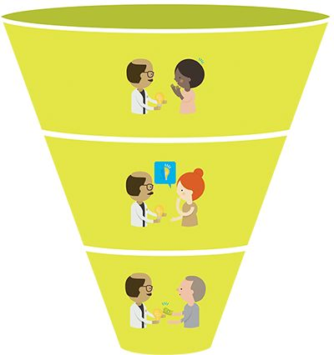



Interest and relevance

Prove that potential customers and partners are genuinely interested and don’t just tell you so. Show that your ideas are relevant enough to them to get them to perform actions that go beyond lip service (e.g., e-mail sign-ups, meetings with decision makers and budget holders, letters of intent, and more).



Priorities and preferences

Show which jobs, pains, and gains your potential customers and partners value most and which ones they value least. Provide evidence that indicates which features of your value proposition they prefer. Prove what really matters to them and what doesn’t.

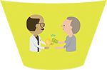

Willingness to pay

Provide evidence that potential customers are interested enough in the features of your value proposition to pay. Deliver facts that show they will put their money where their mouth is.



Ad Tracking

Use ad tracking to explore your potential customers’ jobs, pains, gains, and interest—or lack of it—for a new value proposition. Ad tracking is an established technique used by advertisers to measure the effectiveness of ad spending. You can use the same technique to explore customer interest even before a value proposition exists.

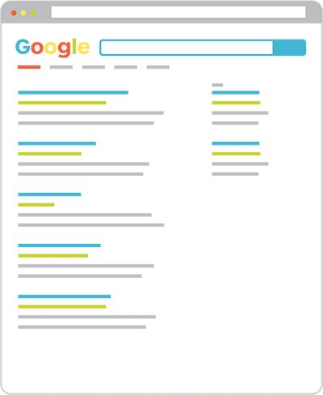

Test customer interest with Google AdWords

We use Google AdWords to illustrate this technique because it’s particularly well suited for testing based on its use of search terms for advertising (other services such as LinkedIn and Facebook also work well).

1. Select search terms.   
   Select search terms that best represent what you want to test (e.g., the existence of a customer job, pain, or gain or the interest for a value proposition).
2. Design your ad/test.   
   Design your test ad with a headline, link to a landing page, and blurb. Make sure it represents what you want to test.
3. Launch your campaign.   
   Define a budget for your ad/testing campaign and launch it. Pay only for clicks on your ad, which represent interest.
4. Measure clicks.   
   Learn how many people click on your ad. No clicks may indicate a lack of interest.

Where to apply?

Test interest early in the process to learn about the existence of customer jobs, pains, gains, and interest for a particular value proposition.



Unique Link Tracking

Set up unique link tracking to verify potential customers’ or partners’ interest beyond what they might tell you in a meeting, interview, or call. It’s an extremely simple way to measure genuine interest.

1

“Fabricate” a unique link.

Make a unique and trackable link to more detailed information about your ideas (e.g., a download, landing page) with a service such as goo.gl.

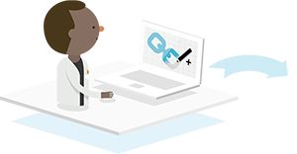

2

Pitch and track.

Explain your idea to a potential customer or partner. During or after the meeting (via e-mail), give the person the unique link and mention it points to more detailed information.

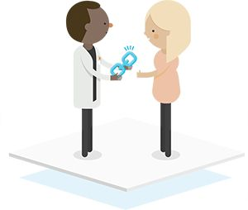

3

Learn about genuine interest.

Track if the customer used the link or not. If the link wasn’t used, it may indicate lack of interest or more important jobs, pains, and gains than those that your idea addresses.

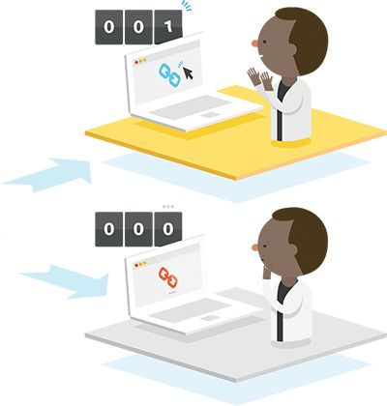

Where to apply?

This works anywhere but is particularly interesting in industries where building MVPs is difficult, such as in industrial goods and medical devices.



MVP Catalog

MVP stands for minimum viable product, a concept popularized by the lean start-up movement to efficiently test the interest in a product before building it entirely. Rather than coining a new term we stick to this established one and adapt it to testing value propositions.

Make it “real” with a representation of a value proposition.

Use the following techniques to make your value propositions feel real and tangible before implementing anything when you test them with potential customers and partners.

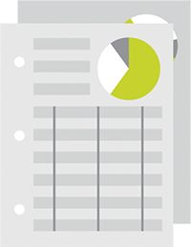

Data Sheet   
 Specs of your imagined value proposition  
 Requirements: Word processor

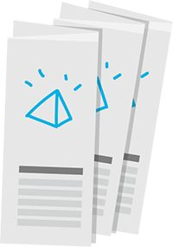

Brochure   
 Mocked-up brochure of your imagined value proposition Requirements: Word processor and design skills

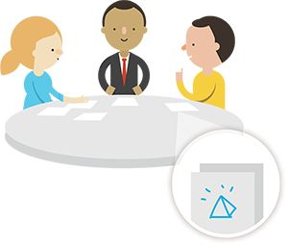

Storyboard   
Illustration of a customer scenario showcasing your imagined value proposition  
Requirements: Sketch artist

What’s an MVP in this book?

A representation or prototype of a value proposition designed specifically to test the validity of one or more hypotheses/assumptions.

The goal is to do so as quickly, cheaply, and efficiently as possible. MVPs are mainly used to explore potential customer and partner interest.

Tip

Start cheaply, even in large companies with big budgets. For example, use your smartphone to make and test reactions to a video before you bring in a video crew to “professionalize” videos and expand testing.

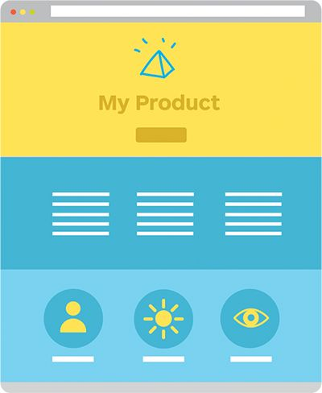

Landing Page   
Website outlining your imagined value proposition (mostly with a CTA).  
Requirements: Web designer

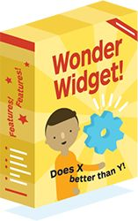

Product Box   
Prototype packaging of your imagined value proposition  
Requirements: Packaging designer and prototype implementation



Video   
Video showcasing your imagined value proposition or explaining how it works  
Requirements: Video crew

Learn with Functional MVPs

Use prototypes designed specifically to learn from experiments with potential customers and partners.

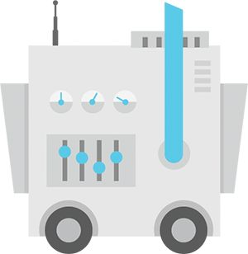

Learning Prototype   
Functioning prototype of your value proposition with the most basic feature set required for learning  
Requirements: Product development

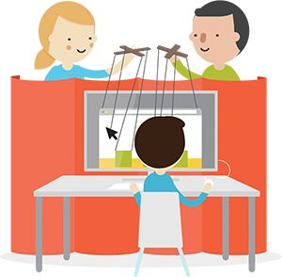

Wizard of Oz   
Set up a front that looks like a real working value proposition and manually carry out the tasks of a normally automated product or service  
Requirements: Getting your hands dirty



Illustrations, Storyboards, and Scenarios

Share illustrations, storyboards, and scenarios related to your value proposition ideas with your potential customers to learn what really matters to them. These types of Illustrations are quick and cheap to produce and make even the most complex value propositions tangible.

Tips

* In a business-to-business (B2B) context think of value propositions for each important customer segment, such as users, budget owners, decision makers, and so on.
* For existing organizations, make sure to include customer-facing staff in the process, notably to get buy-in and gain access to customers to present the illustrations.
* Complement the illustrations with mock data sheets, brochures, or videos to make your ideas even more tangible.
* Run A/B tests with slightly different scenarios to capture which variations get most traction.
* Four or five meetings per customer segment are typically sufficient to generate meaningful feedback.
* Leverage the customer relationship and repeat the process later on with more sophisticated prototypes.

Process adapted from Christian Doll, bicdo.de.

1

Prototype alternative value propositions.

Come up with several alternative prototypes for the same customer segment. Go for diversity (i.e., 8-12 radically different value propositions) and variations (i.e., slightly different alternatives).

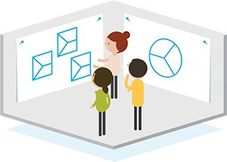

2

Define scenarios.

Sketch out scenarios and storyboards that describe how a customer will experience each value proposition in a real-world setting.

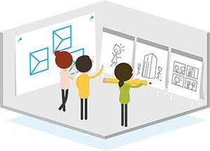

3

Create compelling visuals.

Use an illustrator to consolidate your sketches into compelling visuals that make the customer experience clear and tangible. Use single illustrations for each value proposition or entire story boards.

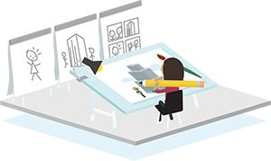

Questions to ask customers:

Which value propositions really create value for you?

Which ones should we keep and move forward with, and which ones should we abandon?

Dig deeper for each value proposition; pay attention to jobs, pains, and gains; and inquire:

* What is missing?
* What should be left aside?
* What should be added?
* What should be reduced?
* Always ask why to capture qualitative feedback.

4

Test with customers.

Meet customers and present the different illustrations, scenarios, and storyboards to start a conversation, provoke reactions, and learn what matters to them. Get customers to rank value propositions from most valuable to least helpful.

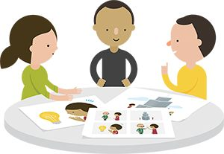

5

Debrief and adapt.

Use the insights from your meetings with customers. Decide which value propositions you will continue exploring, which ones you will abandon, and which ones you will adapt.

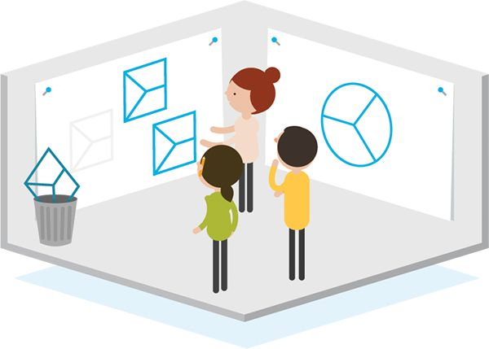



Life-Size Experiments

Get your customers to interact with life-size prototypes and real-world replicas of service experiences. Stick to the principles of rapid, quick, and low-cost prototyping to gather customer insights despite the more sophisticated set-up. Add a CTA to validate interest.

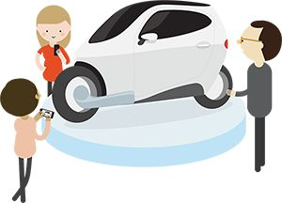

#### Concept Cars and Life-Size Prototypes

These are cars made to showcase new designs and technologies. Their purpose is get reactions from customers rather than to go into mass production directly.

Lit Motors used lean start-up principles to prototype and test a fully electric, gyroscopically stabilized two-wheel drive with customers. Because this type of vehicle represents a completely new concept, it was essential for Lit Motors to understand customer perception and acceptance from the very beginning.

In addition, Lit Motors added a CTA to validate customer interest beyond initial interactions with the prototype. Customers can prereserve a vehicle with a deposit ranging from $250 to $10,000. Deposits go into a holding account until vehicles are ready, with higher deposits moving customers to the front of the waiting list.

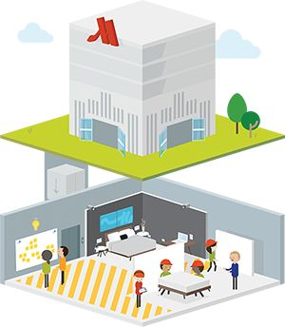

#### Prototype Spaces

These are spaces to cocreate products and service experiences with customers and/or observe their behavior to gain new insights. Invite potential customers to create their own perfect experience. Include industry experts to help build and test new concepts and ideas.

Hotel chain Marriott built a prototyping space in its headquarters’ basement called the Underground. Guests and experts are invited to create the hotel experience of the future by cocreating hotel rooms and other spaces. Guests are invited to add furniture, electricity outlets, electronic gadgets, and more, to hotel room replicas that can easily be reconfigured.

Tips

* Make sure you validate life-size prototypes and service experiences with a CTA. Customers will always be tempted to create the perfect experience in a prototype setting, whereas they might not be willing to pay for it in real life.
* Use quicker and cheaper validation methods before you draw on life-size prototypes and real-world replicas of service experiences.
* Don’t let the costs for this type of prototyping get out of hand. Stick to the principles of rapid, quick, and low-cost prototyping as much as possible, while offering a close-to-life experience to test subjects.



Landing Page

The typical landing page MVP is a single web page or simple website that describes a value proposition or some aspects of it. The website visitor is invited to perform a CTA that allows the tester to validate one or more hypotheses. The main learning instrument of a landing page MVP is the conversion rate from the number of people visiting the site to visitors performing the CTA (e.g., e-mail sign-up, simulated purchase).

“The goal of a landing page MVP is to validate one or more hypotheses, not to collect e-mails or sell, which is a nice by-product of the experiment.”

When?

Test early to learn if the jobs, pains, and gains you intend to address and/or your value proposition are sufficiently important to your customer for them to perform an action.

Variations

Combine with split testing to investigate preferences or alternatives that work better than others. Measure click activity with so-called heat maps to learn where visitors click on your page.

Use your value map to craft the headline and text that describes your value proposition on the landing page.

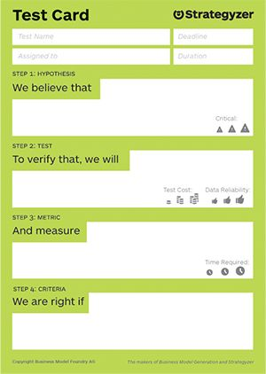

Design your landing page, traffic generation, and CTA based on your learning goals.

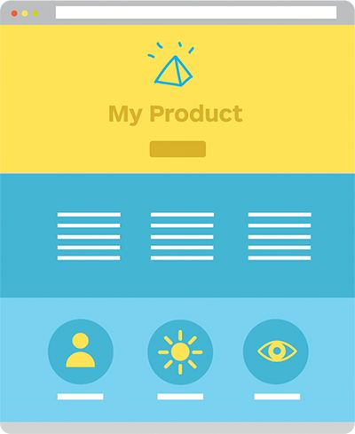

#### Traffic

Generate traffic to your landing page MVP with ads, social media, or your existing channels. Make sure you address the target customers you want to learn about, not just anybody.

#### Headline

Craft a headline that speaks to your potential customers and introduces the value proposition.

#### Value Proposition

Use the previously described techniques to make your value proposition clear and tangible to potential customers.

#### Call to Action

Get website visitors to perform an action that you can learn from (e.g., e-mail sign-up, surveys, fake purchase, prepurchase). Limit your CTAs to optimize learning.

#### Outreach

Reach out to people who performed your CTA and investigate why they were motivated enough to perform the action. Learn about their jobs, pains, and gains. Of course, this requires collecting contact information during the CTA.

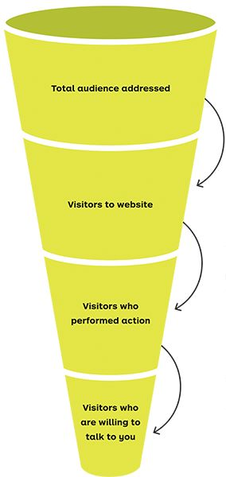



What percentage of people were interested enough to visit your page?

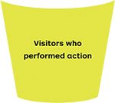

What percentage of people were interested to perform the action?



What percentage of people were willing to invest time to talk to you?

Tips

* Consider building a landing page MVP that gives the illusion that a value proposition exists even if doesn’t yet. Your insights from a CTA closer to reality (e.g., simulated sales) will provide more realistic evidence than, for example, the e-mail sign-up to a planned value proposition or a prepurchase of it.
* Be transparent with your test subjects after a concluded experiment if you, for instance, “fake” the existence of a value proposition. Consider offering them a reward for participating in the experiment.
* A landing page MVP can be set up as a standalone web page or within an existing website.



Split Testing

Split testing, also known as A/B testing, is a technique to compare the performance of two or more options. In this book we apply the technique to compare the performance of alternative value propositions with customers or to learn more about jobs, pains, and gains.



Control 8%  
Send the same amount of people to the diff erent options you want to test.



Challenge 20%  
Compare how each option performs regarding your CTA.

#### Conducting Split Tests

The most common form of split test is to test two or more variations of a web page or a purpose-built landing page (e.g., the variations may have design tweaks or outline slightly or entirely different value propositions). This technique was popularized by companies such as Google and LinkedIn, as well as the 2008 Obama campaign. Split tests can also be conducted in the physical world. The main learning instrument is to compare if conversion rates regarding a specific call to action differ between competing alternatives.

#### What to Test?

Here are some elements that you can easily test with A/B testing

* Alternative features
* Pricing
* Discounts
* Copy text
* Packaging
* Website variations
* . . .

#### Call to Action

How many of the test subjects perform the CTA?

* Purchase
* E-mail sign-up
* Click on button
* Survey
* Completion of any other task

Split testing the title of this book

For this book we performed several split tests. For example, we redirected traffic from businessmodelgeneration.com to test three different book titles. We tested the titles with more than 120,000 people over a period of 5 weeks.

There were several CTAs. The first one was to simply click on a button labeled “learn more.” Then people could sign up with their e-mail for the launch of the book. In the last CTA, we asked them to fill out a survey to learn more about their jobs, pains, and gains. As a small reward we showed people a video explaining the Value Proposition Canvas.

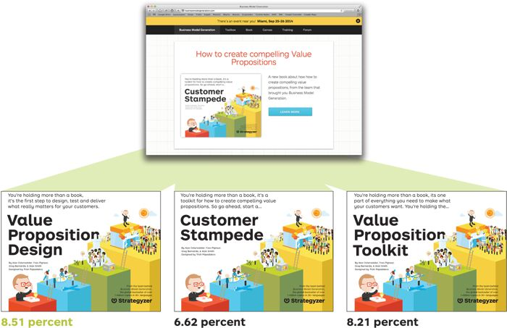

Tips

* Test a single variation in the challenging option if you want to clearly identify what leads to a better performance.
* Use so-called multivariate testing to test several combined elements to figure out which combination creates the highest impact.
* Use Google AdWords or other options to attract test subjects.
* Make sure you reach a statistical significance of greater than 95 percent
* Use tools such as Google Website Optimizer, Optimizely, or others to easily perform split tests.



Innovation Games®

Innovation Games is a methodology popularized by Luke Hohmann to help you design better value propositions by using collaborative play with your (potential) customers. The games can be played online or in person. We present three of them.

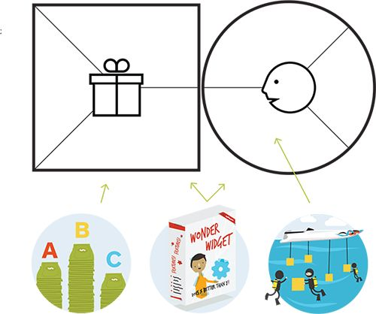

All three Innovation Games we present can be used in various ways. We outline three specific tasks they can help us with when it comes to the Value Proposition Canvas and related hypotheses.

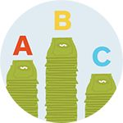

Buy a feature  
Task: Prioritize which features customers want most.

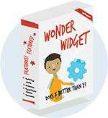

Product Box  
Task: Understand your customers’ jobs, pains, and gains and the value propositions they’d like.

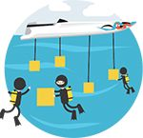

Speed Boat  
Task: Identify the most extreme pains holding customers back from completing their jobs to be done.

Hohmann, Innovation Games, 2006.



Speed Boat

This is a simple but powerful game to help you verify your understanding of customer pains. Get your customers to explicitly state the problems, obstacles, and risks that are holding them back from successfully performing their jobs to be done by using the analogy of a speed boat held back by anchors.

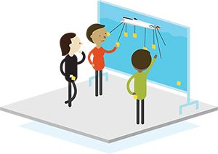

1

Set-up.

Prepare a large poster with a speedboat floating at sea.

2

Identify pains.

Invite customers to identify the problems, obstacles, and risks that are preventing them from successfully performing their jobs. Each issue should go on a large sticky note. Ask them to place each sticky as anchors to the boat—the lower the anchor, the more extreme the pain.

3

Analysis.

Compare the outcomes of this exercise with your previous understanding of what is holding customers back from performing their jobs to be done.

Tips

* This exercise can be used during the design phase to identify customer pains or during testing to verify your existing understanding.
* Use a sailing boat with anchors and sails if you want to work on pains and gains simultaneously. The sails allow you to ask, “What makes the boat faster,” in addition to using the anchors to symbolize what holds people back.



Product Box

In this game, you ask customers to design a product box that represents the value proposition they’d want to buy from you. You’ll learn what matters to customers and which features they get excited about.

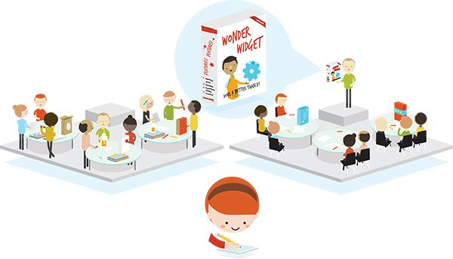

1

Design.

Invite customers to a workshop. Give them a cardboard box and ask them to literally design a product box that they would buy. The box should feature the key marketing messages, main features, and key benefits that they would expect from your value proposition.

2

Pitch.

Ask your customers to imagine they’re selling your product at a tradeshow. Pretend you’re a skeptical prospect and get your customer to pitch the box to you.

3

Capture.

Observe and note which messages, features, and benefits customers mention on the box and which particular aspects they highlight during the pitch. Identify their jobs, pains, and gains.



Buy a Feature

This is a sophisticated game to get customers to prioritize among a list of predefined (but not yet existing) value proposition features. Customers get a limited budget of play money to buy their preferred features, which you price based on real-world factors.

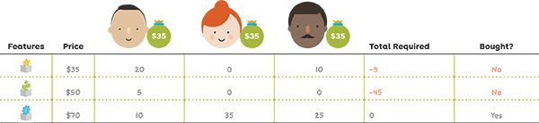

1

Select and price features.

Select the features for which you want to test customer preferences. Price each one based on development cost, market price, or other factors that are important to you.

2

Define the budget.

Participants buy features as a group, but each participant gets a personal budget that he or she can allocate individually. Make sure the personal budget forces participants to pool resources, and the overall budget forces them to make hard choices among the features they want.

3

Have the participants buy.

Invite participants to allocate their budget among the features they want. Instruct them to collaborate with others to get more features.

4

Analyze outcomes.

Analyze which features get most traction and are bought and which ones are not.



Mock Sales

A great way to test sincere customer interest is to set up a mock sale before your value proposition even exists. The goal is make your customers believe they are completing a real purchase. This is easily done in an online context but can also be done in a physical one.

Online

Test different levels of customer commitment with these three experiments:

Learn about customer interest by measuring how many people click on a simple “buy now” button.

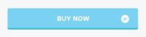

Learn how pricing influences customer interest. Combine with A/B testing (see p. 230) to learn more about demand elasticity and the optimal price point.

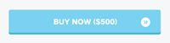

Get hard data by simulating a transaction with the customer’s credit card information. This is the strongest evidence of customer demand (see tips to manage customer perception, p. 237).

Physical World

Mock sales are not limited to online. Here’s what retailers do to test customer interest and pricing in the real world:

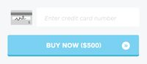



Introduce products that don’t exist yet in a limited number of (mail order) catalogs.

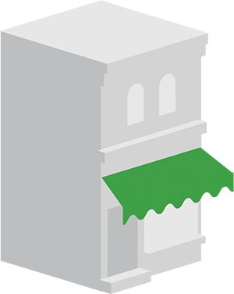

Sell a product in one retail location only for a limited amount of time (different from a pilot, which typically covers an entire market).

Tips

Don’t fear that mock sales might alienate customers and negatively affect your brand. Manage customer perception well, and mock sales can be turned into an advantage. Build on these best practices:

* Explain that you were performing a test after the customer completes the mock purchase.
* Be transparent about which information you keep or erase.
* Always erase credit card information in a fake purchase.
* Offer a reward for participating in the test (e.g. goodies, discounts).

You will turn test subjects into advocates for your brand rather than alienate them if you manage customer perception well.

#### Attention

Remember that successful presales are only an indicator. Ouya, an Android-based video game console, raised millions on Kickstarter but later failed to attract a large base of customers or design a scalable business model.



Presales

The main objective of this type of presales is to explore customer interest; it is not to sell. Customers make a purchase commitment and are aware of the fact that your value proposition does not yet fully exist. In case of a lack of interest, the sale is canceled and the customer reimbursed.

Online

Platforms such as Kickstarter made preselling popular. They allow you to advertise a project, and if customers like it, they can pledge money. Projects receive funds only if they reach their predefined funding goals. If you are up for building the required infrastructure you can also set up your own presales process.

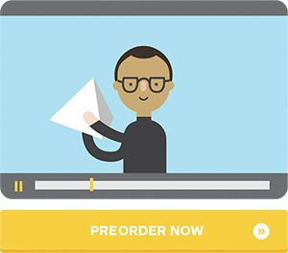

Physical World

Pledges, letters of intent, and signatures, even if not legally binding, are a powerful technique to test potential customers’ willingness to buy. This is also easier to apply in a B2B context.

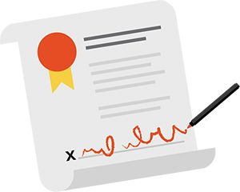

3.4  
Bringing It All Together



The Testing Process

Use all the tools you learned about to describe what you need to test and how you will do so in order to turn your idea into reality.

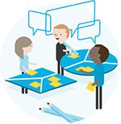

What to Test

With the Value Proposition and Business Model Canvases, you map out how you believe your idea could become a success. This foundation allows you to easily make the hypotheses explicit that need to be true for your idea to work. Start by testing the most important ones with a series of experiments.

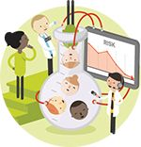

How to Test

With the testing card, you describe how exactly you will verify your most important hypotheses and what you will measure. After one or more completed experiments, you use the learning card to capture your insights and indicate whether you need to learn more, iterate, pivot, or move on to test the next important hypothesis.



What’s Next

Keep your eyes on the prize, and make sure you are progressing. Track whether you are advancing from your initial idea toward a profitable and scalable business via problem-solution fit, product-market fit, and business model fit.

1

Shape your ideas



2

Extract your hypotheses



3

Design your tests.



4

Enter the learning loop.

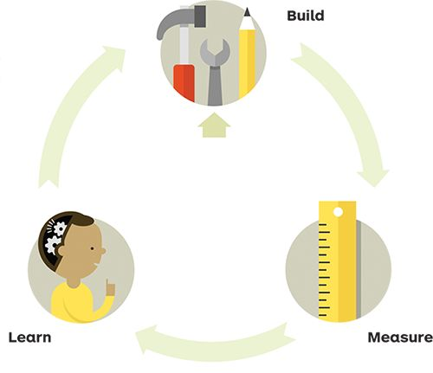

5

Capture learnings and next actions.

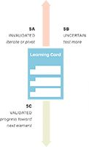

6

Measure progress.

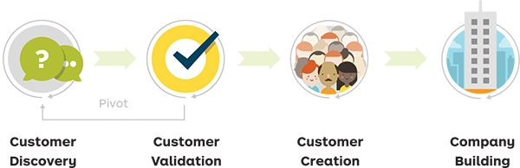



Measure Your Progress

The testing process allows you to continuously reduce uncertainty and gets you closer to turning your idea into a real business. Measure your progress toward this goal by tracking the activities you’ve done and the results you’ve achieved. We designed this spread that allows you to understand if you’re progressing based on Steve Blank’s Investment Readiness Thermometer.

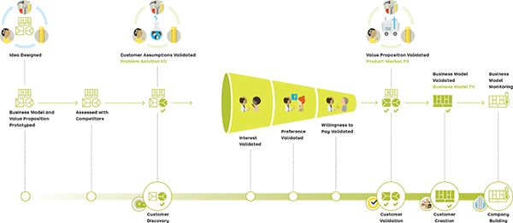

Blank, Investment Readiness Thermometer, 2013,http://steveblank.com/2013/11/25/its-time-to-play-moneyball-the-investment-readiness-level/.

 [Download Progress Indicators](http://strategyzer.com/vpd/test/3.4)



The Progress Board

Use the progress board to manage and monitor your tests and assess how much progress you are making toward success.

 [Get Progress Board poster](http://strategyzer.com/vpd/test/3.4)



What did I test already?

Use the Value Proposition and Business Model Canvases to track which elements you have tested, validated, or invalidated.



What am I testing, and what did I learn?

Track the tests you are planning, building, measuring, and digesting to learn and make your insights and follow-up actions explicit.



How much progress did I make?

Keep score of how much progress you are making.

1

(re)Shape your ideas.



2

Extract your hypotheses.



3

Design your tests.



4

Tests

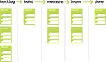

5

Insights and Actions

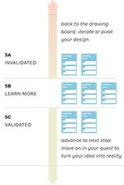

6

Measure progress.

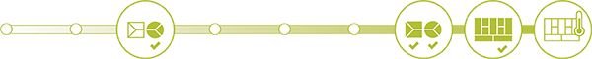



Owlet: Constant Progress with Systematic Design and Testing

Wireless monitoring of babies’ blood oxygen, heart rate, and sleep data.*

Owlet Business Model: version 0

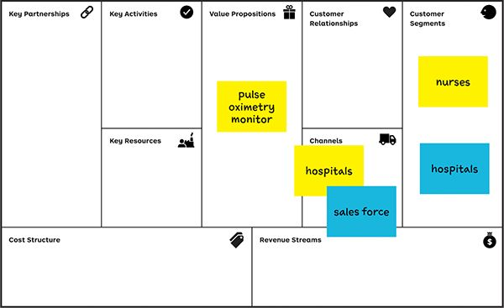

*Case adopted in accordance with Owlet. Owlet was the winner of the 2013 International Business Model Competition.

 [Watch Owlet presentation online](http://strategyzer.com/vpd/test/3.4)

1  
Initial idea

An opportunity

Monitoring pulse oximetry could be easier without the cord between the device and the monitor display.

Nurses

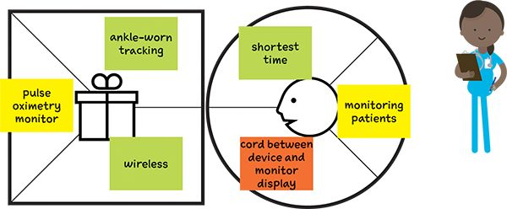

#### 00447.gif Test 1A: Nurse Interviews

HYPOTHESIS: Wireless pulse oximetry is more convenient

METRIC: Percentage of positive feedback

TEST: Interview nurses

DATA: Of 58 nurses interviewed, 93 percent prefer the wireless monitoring.

Validated: 1 week, $0

Hospital administrators

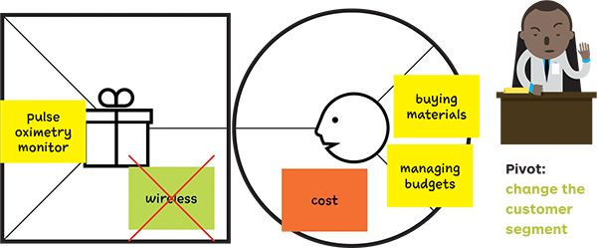

#### 00447.gif Test 1B: Hospital Administrator Interviews

HYPOTHESIS: Wireless pulse oximetry is more convenient.

METRIC: Percentage of positive feedback

TEST: Interview hospital administrators

DATA: 0 percent ready to pay more for wireless

“ease of use is not a pain, if not cost-effective.”

Unvalidated: 1 week, $0



DATA: Sudden infant death syndrome (SIDS) is the leading cause of infant deaths.

a first pivot after one week

#### Pivot:

Change the customer segment from nurses and hospitals to worried parents.

Owlet Business Model: version 2

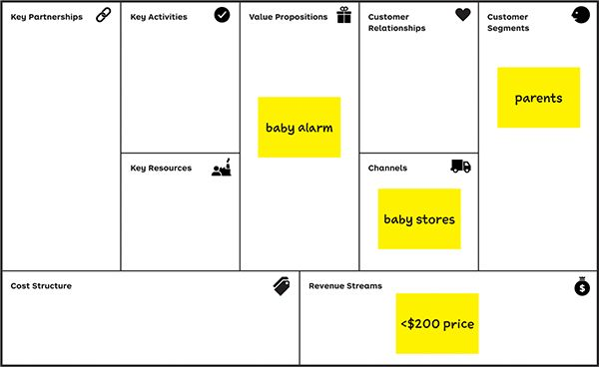

2  
 Iteration

Peace of mind for parents

A wireless monitor that collects the baby’s heart rate, oxygen level, and sleep pattern and sends them via Bluetooth to the parents’ smartphone with alerts; distributed by baby stores.

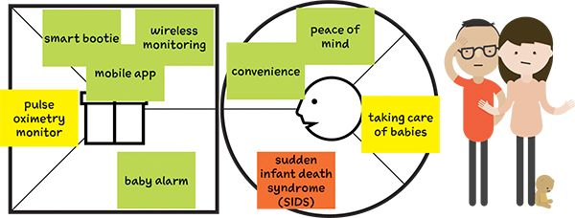

#### 00447.gif Test 2: Parent interviews

HYPOTHESIS: Parents are ready to adopt

and buy a wireless baby alarm.

METRIC: Percentage of adopting parents

TEST: Interview mothers

DATA: Of 105 mothers interviewed, 96 percent

adopt the wireless monitoring.

“Awesome. I want to buy now!”

Validated

#### 00447.gifTest 3: MVP landing page

HYPOTHESIS: A smart bootie is convenient and

easy to use for monitoring.

METRIC: Number of positive comments

TEST: An MVP, with a video on a website

DATA: 17,000 views, 5,500 shares of Facebook,

500 positive comments by parents, distributors,

and research organizations

Validated, 2 weeks, $220

#### 00447.gif Test 4: A/B Price test

HYPOTHESIS: Rental versus sale at $200+

sale price

METRIC: Percentage for a sale price

TEST: A/B testing, 3 rounds, on the website

DATA: 1,170 people tested, $299 the best price

Validated, 8 weeks, $30



Owlet Business Model: version 3

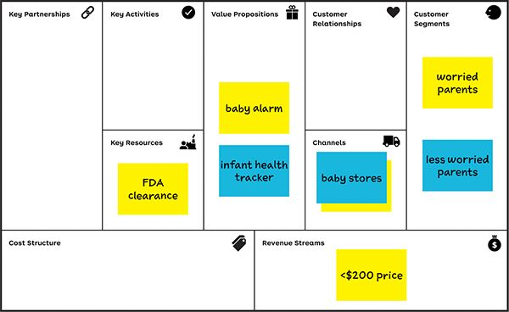

after 24 weeks, and $1,150 for the tests, including a technical proof of concept

Running lean

Based on experts, a food and Drug Administration (fDA) clearance for a baby alarm is one year, $120,000–$200,000

3   
 Iteration

Peace of mind, but for less worried parents

With a more minimal, less risky product, an infant health tracker (heart rate, oxygen levels, and sleep patterns), but without alarm, for another customer segment: the less worried parents.

#### 00447.gif Test 5: interview/Proposition:

“owlet Challenge”

HYPOTHESIS: Less worried parents are ready to

adopt and buy a wireless baby health tracker,

without alarm.

METRIC: Percentage of parents adopting the

no-alarm tracker

TEST: Interview at retail locations, having to

choose between the Owlet tracker and other

similar systems (video, sound, and movement)

DATA: Of 81 people interviewed, 20 percent

adopted the Owlet tracker.

Validated, 3 weeks, $0

Less worried parents

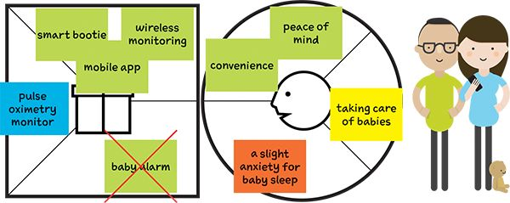



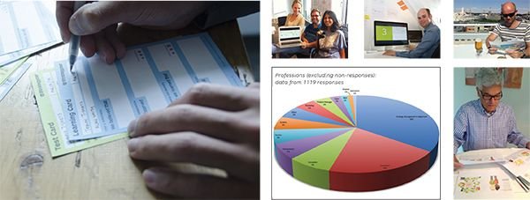

Lessons Learned

Testing Step-by-Step

Your customers are the judge, jury, and executioner of your value proposition, so get outside of the building and test your ideas with the customer development and lean start-up process. Make sure you start with quick and cheap experiments to test the assumptions underlying your ideas when uncertainty is at its maximum.

Experiment Library

What your customers say might wildly differ from what they do in reality. Go beyond talking to customers and conduct a series of experiments. Get them to perform actions that provide evidence of their interest, their preferences, and their willingness to pay.

Bringing It All Together

Launching ideas without testing is wishful thinking. Testing ideas without launching is just a pastime. Launching tested ideas can change your life as an entrepreneur. Measure your progress from idea to real business step by step.

4: Evolve

Use the Value Proposition and Business Model Canvas as a shared language to Create Alignment throughout every part of your organization while it continuously evolves. Make sure you constantly Measure and Monitor your value propositions and business models in order to Improve Relentlessly and Reinvent Yourself Constantly.

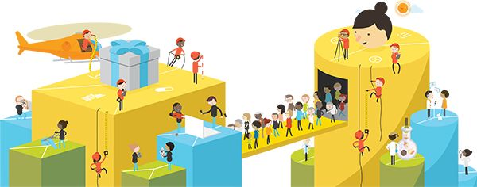

Create Alignment

The Value Proposition Canvas is an excellent alignment tool. It helps you communicate to different stakeholders which customer jobs, pains, and gains you are focusing on and explains how exactly your products and services relieve pains and create gains.

|  |  |
| --- | --- |
| 00457.jpeg Craft aligned messages. |  |
| 00458.jpeg | Advertising |
| 00459.jpeg | Slide Decks |
| 00460.jpeg | Explainer Videos |
| 00461.jpeg | Packaging |
| 00462.jpeg | Sales Scripts |

|  |  |
| --- | --- |
| Align internal and external stakeholders. |  |
| 00463.jpeg | (Channel) Partners  Bring (channel) partners on board, and explain your value proposition. Help them understand why customers will love your products and services by highlighting pain relievers and gain creators. |
| 00464.jpeg | Marketing  Craft marketing messages based on the jobs, pains, and gains your products and services are helping with. Align customer-facing messaging all the way from advertising to package design. Point out which pain relievers and gain creators to focus on. |
| 00465.jpeg | Employees  Help all employees understand which customers you are targeting and which jobs, pains, and gains you are addressing, and outline how exactly your products and services will create value for customers. Explain how the value proposition fits into the business model. |
| 00466.jpeg | Sales  Help sales understand which segments to target and what customers’ jobs, pains, and gains are. Highlight which attributes of your value proposition are most likely to sell by relieving pains and creating gains. Align sales scripts and pitch decks. |
| 00467.jpeg | Shareholders  Explain to your shareholders how exactly you intend to create value for your customers. Clarify how the (new or improved) value proposition will bolster your business model and create a competitive advantage. |



Measure and Monitor

Use the Value Proposition and Business Model Canvases to create and monitorspan performance indicators once your value proposition is operational in the market. Track the performance of your business model, your value proposition, and your customers’ satisfaction.

|  |  |  |
| --- | --- | --- |
| 00469.jpeg  Business Model Performance | 00470.jpeg  Value Proposition Performance (Quantitative Facts) | 00471.jpeg  Customer Satisfaction 262 (Perception) |

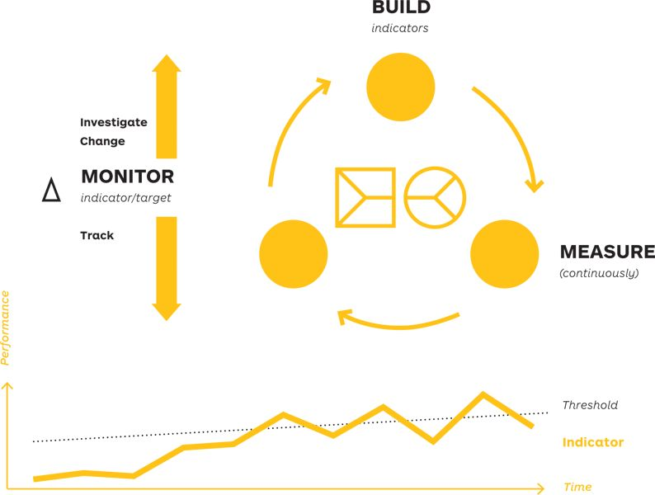

|  |  |  |  |  |
| --- | --- | --- | --- | --- |
| Target | 50% | 25% | **** | 80% satisfied with balance |
| Indicator | # workshop guide downloads by readers who signed up online | conversion rate from book to online sign-up | rating on Amazon.com | # of readers who feel theory/practice is good |
| Building Block | 00473.jpeg |  |  |  |



Improve Relentlessly

Use the same tools and processes from testing and monitoring to improve your value proposition once it’s in the market. Continuously test “what if” improvement scenarios, and measure their impact on customer satisfaction.

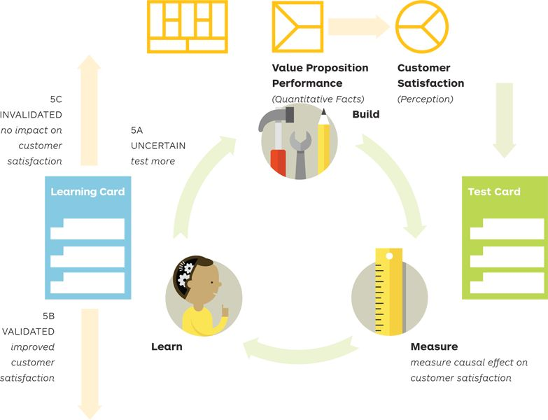

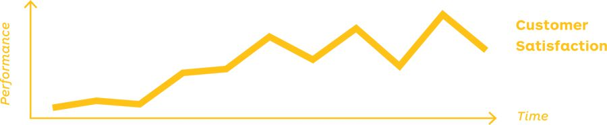

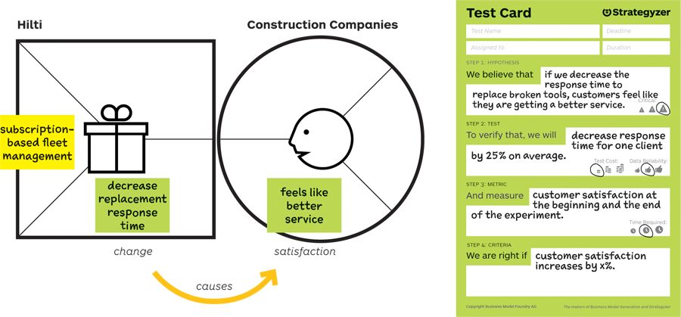

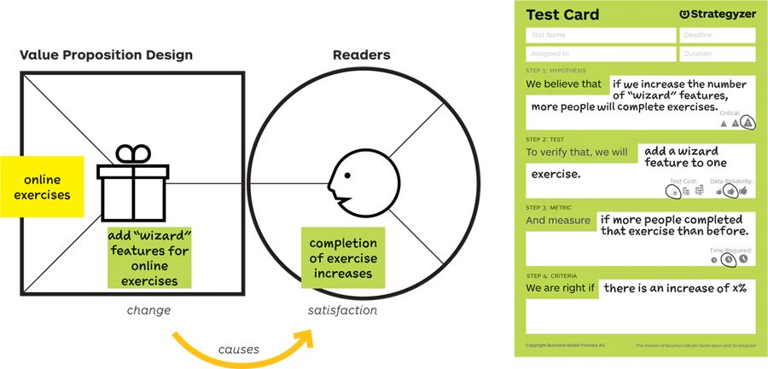



Reinvent Yourself Constantly

Successful companies create value propositions that sell embedded in business models that work. Outstanding companies do so continuously. They create new value propositions and business models while they are successful.

Today’s enterprise must be agile and develop what Columbia Business School Professor Rita McGrath calls transient advantages in her book The End of Competitive Advantage. She argues that companies must develop the ability to rapidly and continuously address new opportunities, rather than search for increasingly unsustainable long-term competitive advantages.

Use the tools and processes of Value Proposition Design to continuously reinvent yourself and create new value propositions embedded in great business models.

Five things to remember when you build transient advantages:

* Take the exploration of new value propositions and business models just as seriously as the execution of existing ones.
* Invest in continuously experimenting with new value propositions and business models rather than making big bold uncertain bets.
* Reinvent yourself while you are successful; don’t wait for a crisis to force you to.
* See new ideas and opportunities as a means to energize and mobilize employees and customers rather than a risky endeavor.
* Use customer experiments as a yardstick to judge new ideas and opportunities rather than the opinions of managers, strategists, or experts.

Continuously ask yourself…

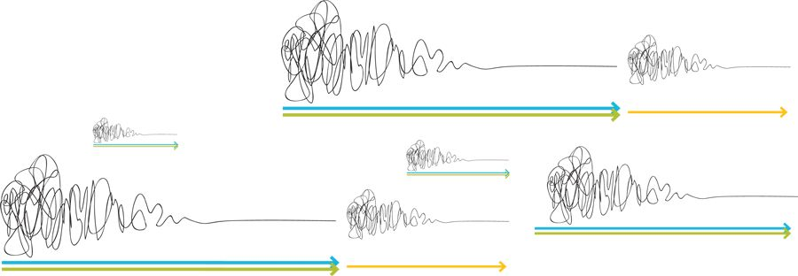



What elements in your environment are changing? What do market, technology, regulatory, macroeconomic, or competitive changes mean for your value propositions and business models? Do those changes offer an opportunity to explore new possibilities or could they be a threat that might disrupt you?



Is your business model expiring? Do you need to add new resources or activities? Do the existing ones offer an opportunity to expand your business model? Could you bolster your existing business model or should you build completely new ones? Is your business model portfolio fit for the future?



Is your value proposition still compelling to your customers? How are your customer’s jobs, pains, and gains evolving? Can you build on your existing value proposition or do you need to revisit it entirely? Is there a new potential customer or a new segmentation emerging? What is happening in your business that creates the basis for new value propositions to existing or new customers?



Taobao: Reinventing (E-)Commerce

Taobao is the Chinese e-commerce phenomenon, part of the Alibaba Group. It is credited with ushering in a new wave of commerce in China by using the Internet to create an ecosystem where trusted commercial exchanges could take place. In 10 years it evolved its business models three times. It proactively embraced the changes taking place on its platform and in the wider Chinese economy and turned them into an opportunity.

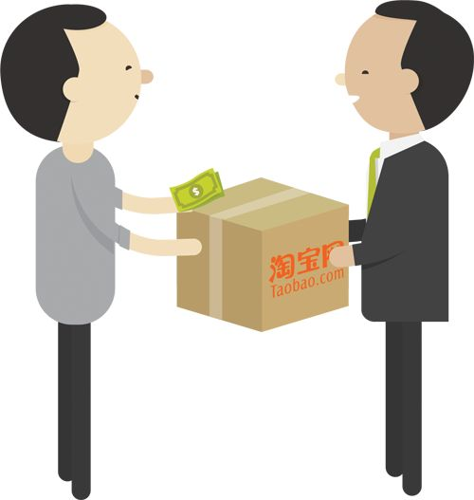

2003  
A new Consumer-to-Consumer (C2C) Platform

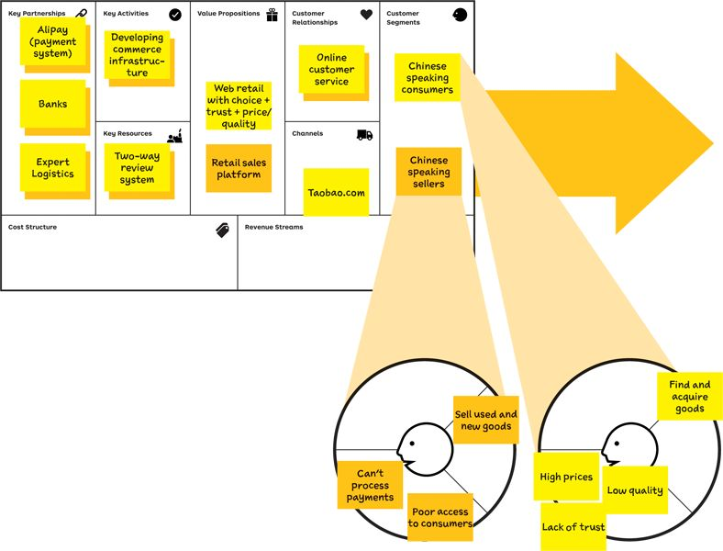

1

Obstacles to commerce in the Chinese economy

Lack of infrastructure to do business

Consumers discouraged by high prices, low quality, and lack of trust.

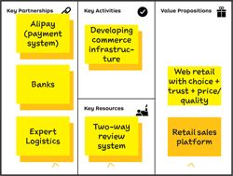

2

Creation of a trusted platform

Launch of a payment and logistics infrastructure with partners to facilitate commercial transactions and shipment of goods.

Creation of a new value proposition for buyers and sellers

Introduction of a review system creates trust among buyers and sellers that did not exist in the physical economy

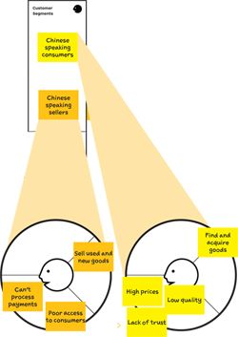

2006  
Taobao — Small Business-to-Consumer (B2C)

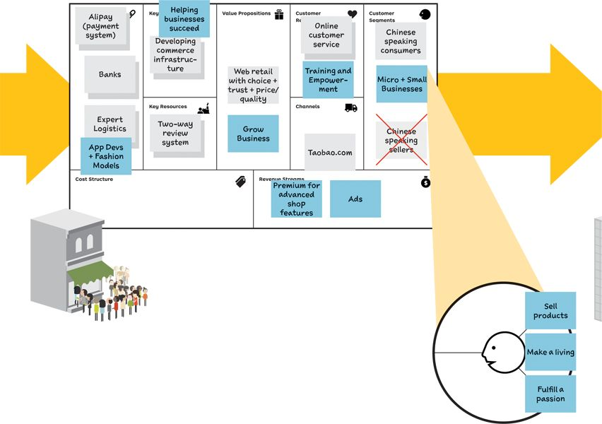

1

Birth of microentrepreneurs

The Taobao platform becomes so popular that millions of sellers see an opportunity to become micro-entrepreneurs

Creation of the “Taobao University” to help entrepreneurs navigate the platform and learn about business

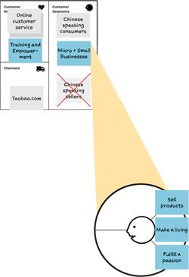

2

Pivot toward microentrepreneurs

Taobao shifts focus and builds on this trend by catering to micro-entrepreneurs

Inclusion of third-party service providers to strengthen the value proposition

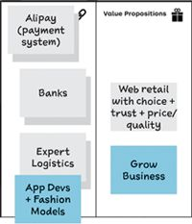

2008  
Taobao — Big Business-to-Consumer (B2C)

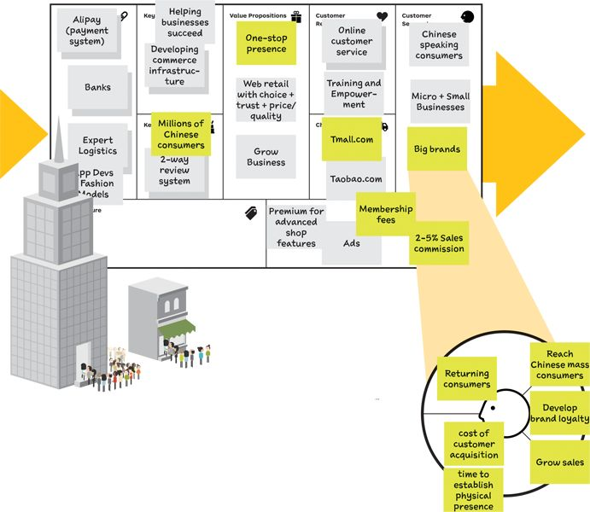

1

A new asset is revealed

Taobao realizes that its business model possesses an incredible asset: hundreds of millions of Chinese consumers.

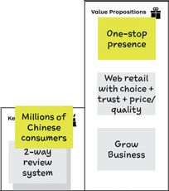

2

Launch of a new business

The “new” asset becomes the basis of a new value proposition

…for a new customer (big brands)…

…helping them reach Chinese consumers much faster than through the opening of physical stores.

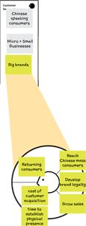

2013  
Taobao — ?



Taobao went from a simple e-commerce platform to complex ecosystem in 10 years. It achieved this by improving and reinventing its value propositions and business models on the way. With new developments in mobile, gaming, messaging, and more, however, the company can’t rest on its laurels. Taobao is constantly challenged to continue its evolution.



Lessons Learned

Create Alignment

The Value Proposition and Business Model Canvases are excellent alignment tools. Use them as a shared language to create better collaboration across the different parts of your organization. Help every stakeholder understand how exactly you intend to create value for your customers and your business.

Measure, Monitor, Improve

Track the performance of your value propositions over time to make sure you continue to create customer value while market conditions change. Use the same tools and processes to improve your value propositions, which you used to design them.

Reinvent While Successful

Don’t wait with reinventing your value propositions and business models. Do so before before market conditions force you to, because it might be too late. Create organizational structures that allow you to improve existing value propositions and business models and invent new ones at the same time.

Afterword

Glossary

(Business) Hypothesis

Something that needs to be true for your idea to work partially or fully but that hasn't been validated yet.

Business Model

Rationale of how an organization creates, delivers, and captures value.

Business Model Canvas

Strategic management tool to design, test, build, and manage (profitable and scalable) business models.

Call to Action (CTA)

Prompts a subject to perform an action; used in an experiment in order to test one or more hypotheses.

Customer Development

Four-step process invented by Steve Blank to reduce the risk and uncertainty in entrepreneurship by continuously testing the hypotheses underlying a business model with customers and stakeholders.

Customer Gains

Outcomes and benefits customers must have, expect, desire, or dream to achieve.

Customer Insight

Minor or major breakthrough in your customer understanding helping you design better value propositions and business models.

Customer Pains

Bad outcomes, risks, and obstacles that customers want to avoid, notably because they prevent them from getting a job done (well).

Customer Profile

Business tool that constitutes the right-hand side of the Value Proposition Canvas. Visualizes the jobs, pains, and gains of a customer segment (or stakeholder) you intend to create value for.

Environment Map

Strategic foresight tool to map the context in which you design and manage value propositions and business models.

Evidence

Proves or disproves a (business) hypothesis, customer insight, or belief about a value proposition, business model, or the environment.

Experiment/Test

A procedure to validate or invalidate a value proposition or business model hypothesis that produces evidence.

Fit

When the elements of your value map meet relevant jobs, pains, and gains of your customer segment and a substantial number of customers “hire” your value proposition to satisfy those jobs, pains, and gains.

Gain Creators

Describes how products and services create gains and help customers achieve the outcomes and benefits they require, expect, desire, or dream of by getting a job done (well).

Jobs to Be Done

What customers need, want, or desire to get done in their work and in their lives.

Lean Start-up

Approach by Eric Ries based on the Customer Development process to eliminate waste and uncertainty from product development by continuously building, testing, and learning in an iterative fashion.

Learning Card

Strategic learning tool to capture insights from research and experiments.

Minimum Viable Product (MVP)

A model of a value proposition designed specifically to validate or invalidate one or more hypotheses.

Pain Relievers

Describes how products and services alleviate customer pains by eliminating or reducing bad outcomes, risks, and obstacles that prevent customers from getting a job done (well).

Products and Services

The items that your value proposition is based on that your customers can see in your shop window—metaphorically speaking.

Progress Board

Strategic management tool to manage and monitor the business model and value proposition design process and track progress toward a successful value proposition and business model.

Prototyping (low/high fidelity)

The practice of building quick, inexpensive, and rough study models to learn about the desirability, feasibility, and viability of alternative value propositions and business models.

Test Card

Strategic testing tool to design and structure your research and experiments.

Value Map

Business tool that constitutes the left-hand side of the Value Proposition Canvas. Makes explicit how your products and services create value by alleviating pains and creating gains.

Value Proposition

Describes the benefits customers can expect from your products and services.

Value Proposition Canvas

Strategic management tool to design, test, build, and manage products and services. Fully integrates with the Business Model Canvas.

Value Proposition Design

The process of designing, testing, building, and managing value propositions over their entire lifecycle.

 [Get Glossary pdf](http://strategyzer.com/vpd/afterword)



Core Team

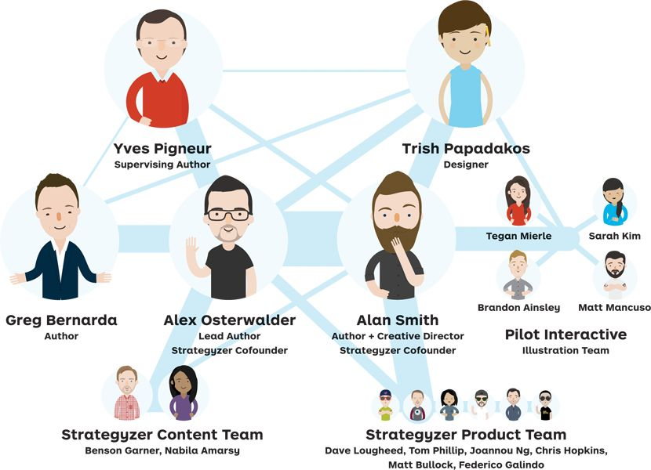



Prereaders

We practice what we preach and tested our ideas before releasing them. More than 100 selected people from around the world participated as prereaders to scrutinize our raw creations. More than 60 actively contributed by reviewing ideas, concepts, and spreads. They offered suggestions, meticulously proofread, and pointed out flaws and inconsistencies without pity. We iterated the book title several times with prereaders before testing various alternatives in the market.

Gabrielle Benefield

Phil Blake

Jasper Bouwsma

Frederic Briguet

Karl Burrow

Manuel Jose Carvajal

Pål Dahl

Christian Doll

Joseph Dougherty

Todd Dunn

Reinhard Ematinger

Sven Gakstatter

Jonas Giannini

Claus Gladyszak

Boris Golob

Dave Gray

Gaute Hagerup

Natasha Hanshaw

Chris Hill

Luke Hohmann

Jay Jayaraman

Shyam Jha

Greg Judelman

James King

Hans Kok

Ryuta Kono

Jens Korte

Jan Kyhnau

Michael Lachapelle

Ronna Lichtenberg

Justin Lokitz

Ranjan Malik

Deborah Mills-Scofield

Nathan Monk

Mario Morales

Fabio Nunes

Jan Ondrus

Aloys Osterwalder

Matty Paquay

Olivier Perez Kennedy

Johan Rapp

Christian Saclier

Andrea Schrick

Gregoire Serikoff

Aron Solomon

Peter Sonderegger

Lars Spicker Olesen

Matt Terrell

James Thomas

Paris Thomas

Patrick Van Der Pijl

Emanuela Vartolomei

Mauricio

Reiner Walter

Matt Wanat

Lu Wang

Marc Weber

Judith Wimmer

Shin Yamamoto



Bios



Alex Osterwalder

Dr. Alexander Osterwalder is the lead author of the international bestseller Business Model Generation, passionate entrepreneur, and demanded speaker. He cofounded Strategyzer, a software company specializing in tools and content for strategic management and innovation. Dr. Osterwalder invented the Business Model Canvas, the strategic management tool to design, test, build, and manage business models, which is used by companies like Coca Cola, GE, P&G, Mastercard, Ericsson, LEGO, and 3M. He is a frequent keynote speaker in leading organizations and top universities around the world, including Stanford, Berkeley, MIT, IESE, and IMD. Follow him online @alexosterwalder.



Yves Pigneur

Dr. Yves Pigneur is coauthor of Business Model Generation and a professor of management and information systems at the University of Lausanne. He has held visiting professorships in the United States, Canada, and Singapore. Yves is a frequent guest speaker on business models in universities, large corporations, entrepreneurship events, and international conferences.



Greg Bernarda

Greg Bernarda is a thinker, creator, and facilitator who supports individuals, teams, and organizations with strategy and innovation. He works with inspired leaders to (re)design a future which employees, customers, and communities can recognize as their own. His projects have been with the likes of Colgate, Volkswagen, Harvard Business School, and Capgemini. Greg is a frequent speaker; he cofounded a series of events on sustainability in Beijing; and is an advisor at Utopies in Paris. Prior to that, he was at the World Economic Forum for eight years setting up initiatives for members to address global issues. He holds an MBA (Oxford Saïd) and is a Strategyzer certified business model coach.

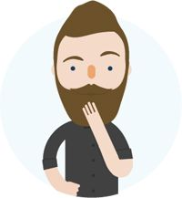

Alan Smith

Alan is obsessed with design, business, and the ways we do them. A design-trained entrepreneur, he has worked across film, television, print, mobile, and web. Previously, he cofounded The Movement, an international design agency with offices in London, Toronto, and Geneva. He helped create the Value Proposition Canvas with Alex Osterwalder and Yves Pigneur, and the breakthrough design for Business Model Generation. He cofounded Strategyzer, where he builds tools and content with an amazing team; helping businesspeople make stuff customers want. Follow him online @thinksmith.



Trish Papadakos

Trish is a designer, photographer, and entrepreneur. She holds a Masters in Design from Central St. Martins in London and Bachelor of Design from the York Sheridan Joint Program in Toronto. She teaches design at her alma mater, has worked with award-winning agencies, launched several businesses, and is collaborating for the third time with the Strategyzer team. Follow her photography on Instagram @trishpapadakos.

Index

A

A/B testing, 230–231

ad-libs, for Prototyping, 76, 82–83

Ad Tracking (Experiment Library), 220

AirBnB, 91

Alibaba Group, 268–271

alignment, creating, 260–261

Anthropologist, 106, 114–115, 217

Apple, 156, 157

App Store (Apple), 157

assessment

Business Model and, 156–157

of competitors, 128–129, 130–131

of skills for Value Proposition Design, xxii–xxiii

of Value Proposition, 122–123

Azuri, 146–151

B

best practices

for mapping customers’ jobs, pains, and gains, 24–25 (See also Customer Gains; Customer Pains; Jobs to be Done)

for mapping value creation, 30

Blank, Steve, 118, 182–183

Blue Ocean Strategy, 130

books, as Starting Points, 92–93

brainstorming

defining criteria with, 140

possibilities for, 92–93

See also Starting Points

Bransfield-Garth, Simon, 146

brochures, creating, 222

Build, Measure, Learn Circle, 94, 95

Business Hypothesis

defined, 201

extracting, 200–201

Lean Startup and, 185, 186–187

prioritizing, 202–203

Business Model, 142–157

assessing, 156–157

Azuri example, 146–151

compressed air energy storage example, 152–153

creating value for customers and, 144–145

Fit and, 48–49, 52–53

platform Business Models, 52–53

stress testing, 154–155

testing, 194–195

Business Model Canvas

defined, xv

illustrated, xvii

Business Model Generation (Osterwalder), xiv, xvi

business plans, experimentation processes versus, 179

business-to-business (B2B) transactions, 50–51

Buy a Feature (Experiment Library), 235

Buyer of Value (customer role), 12

C

Call to Action (CTA), 218–219

Canvas

Customer Profile and, 3–5, 9, 10–25

Fit and, 3–5, 40–59

identifying stakeholders with, 50–51

moviegoing example, 54–55

observing customers, 7

summarized, 60

Value Map and, 3–5, 8, 26–39

Value Proposition, defined, 6

See also Business Model Canvas; Customer Profile; Fit; Value Map; Value Proposition; Value Proposition Canvas

change. See Evolve

channels, defined, xvi

characteristics, of customers, 14–15

Choices, 120–141

competitors and, 128–129, 130–131

context and, 126–127

defining criteria and selecting prototypes, 140–141

feedback and, 132–133, 134–135, 136–137

role-playing and, 107, 124–125

tips for, 124, 131, 137

Value Proposition assessment, 122–123

visualization and, 138–139

Circle, Testing the, 190–191

Cocreator (for Customer Insight), 107

Cocreator of Value (customer role), 12

colleagues, Value Proposition Design for, xxiv–xxv

Company Building (Customer Development process), 183

competitors, assessing, 128–129, 130–131

compressed air energy storage example

Business Model, 152–153

Prototyping, 96–97

context

Jobs to be Done, 13

understanding, 126–127

cost structure, defined, xvi

Creation (Customer Development process), 183

criteria, defining, 140–141

Customer Development process, 182–183

Customer Gains

best practices for mapping, 24–25

checking Fit and, 46–47

defined, 16–17

psychodemographic profile approach versus, 54–55

ranking, 20–21

as Starting Point, 88–89

Testing the Circle objective, 190–191

See also Gain Creators

Customer Insight, 104–119

Anthropologist, 106, 114–115, 217

choosing mix of experiments for, 216–217 (See also Experiment Library)

Cocreator, 107

creating value for, 144–145 (See also Business Model)

customer relationship management (CRM), xvi, 109

Data Detective, 106, 108–109, 217

gaining, 106–107

identifying patterns in, 111, 116–119

Impersonator, 107, 124–125

Journalist, 106, 110–113, 217, 225

Scientist, 107

shaping ideas and, 70–71

tips for, 113, 115, 117

Customer Pains

best practices for mapping, 24–25

checking Fit and, 46–47

defined, 14–15

psychodemographic profile approach versus, 54–55

ranking, 20–21

as Starting Point, 88–89

Testing the Circle objective, 190–191

See also Pain Relievers

Customer Profile, 10–25

best practices for mapping jobs, pains, and gains, 24–25

business-to-business (B2B) transactions, 50–51

Customer Gains, defined, 16–17

Customer Pains, defined, 14–15

customer’s context and, 56–57

customer segments, xvi, 116

defined, 9

different solutions for same customers, 58–59

identifying high-value jobs, 100–101

innovating from, 102–103

jobs, pains, and gains as new approach, 54–55

Jobs to be Done, defined, 12–13

ranking jobs, pains, and gains, 20–21

sketching, 18–19

understanding customer perspective for, 22–23

use of, 60–61

See also Jobs to be Done; Starting Points

D

Data Detective, 106, 108–109, 217

data mining, 109

data sheets, creating, 222

data traps, avoiding, 210–211

Day in the Life, A (worksheet), 115–116

de Bono, Edward, 136–137

decision makers, 50–51

Dell, 157

Design, 64–170

characteristics of great Value Propositions, 72–73

constraints, 90–91

design/build (Lean Startup), 185, 186–187

in established organizations, 158–187 (See also established organizations)

finding the right Business Model, 142–157 (See also business model)

making choices for, 120–141 (See also Choices)

overview, 67

Prototyping possibilities, 70–71, 74–85 (See also Prototyping)

shaping ideas with, 70–71

Starting Points, 70–71, 86–103 (See also Starting Points)

summarized, 170

understanding customers, 70–71, 104–119 (See also Customer Insight)

discovery (Customer Development process), 182

Dotmocracy, 138–139

Dropbox, 210

E

Earlyvangelists, 118

economic buyers, 50–51

Eight19 (Azuri), 146–151

emotional jobs, of customers, 12

end users, 50–51. See also Customer Insight

Environment Map, v, xv

EPFL, 96–97

established organizations, 158–169

inventing and improving, 160–161, 162–163

reinventing, 164–165

Value Proposition Design for, xix

workshops for, 166–167, 168–169

Evidence

Call to Action (CTA) and, 218–219

need for, 190–195

producing, 97, 216

See also Test

Evolve, 254–272

creating alignment and, 260–261

improvement and, 264–265

measuring and monitoring, 262–263

overview, 257

reinventing and, 266–267, 268–271

summarized, 272

“exhausted maximum” trap, 211

experience, as feedback, 134

Experiment Library, 214–237

Ad Tracking, 220

Buy a Feature, 235

Call to Action (CTA), 218–219

choosing mix of experiments, 216–217

experiment, defined, 216

experiment design and, 204–205

experimenting to reduce risk, 178–179

Illustrations, Storyboards, and Scenarios, 222, 224–225

Innovation Games, 232

Landing Page MVP, 228–229

Life-Size Experiments, 226–227

Minimum Viable Product (MVP), 222–223, 228–229

Mock Sales, 236–237

Pre Sales, 237

Product Box, 234

Speed Boat, 233

Split Testing, 230–231

tips for, 217, 222, 224, 227, 229, 231, 233, 237

Unique Link Tracking, 221

See also Test

F

Facebook, 157

facts, as feedback, 134

false-negative/false-positive traps, 210

Federal Institute of Technology (Switzerland), 96–97

feedback, 132–133, 134–135, 136–137

financial issues

cost structure, defined, xvi

generating revenue, 144–145

profit, defined, xvi

revenue streams, defined, xvi

stress testing, 154–155

testing customers’ willingness to pay, 219 (See also Experiment Library)

See also Business Model

Fit, 40–59

addressing customers’ jobs, pains, and gains with, 44–45

checking for, 46–47

Customer Profile and customer context, 56–57

Customer Profile and Value Map as two sides of, 3–5

Customer Profile versus psychodemographic profile approach, 54–55

different solutions for same customers, 58–59

multiple Fit, 52–53

stages of, 48–49

striving for, 42–43

use of, 60–61

functional jobs, of customers, 12

G

Gain Creators

Fit and, 9, 47

Pain Relievers versus, 38

Products and Services as, 33

Value Map and, 33–34

gains. See Customer Gains

Google

AdWords, 220

searches, 108

government census data, 108

H

Hilti, 90

Hohmann, Luke, 232

hypothesis. See Business Hypothesis

I

Ikea, 157

Illustrations, Storyboards, and Scenarios (Experiment Library), 222, 224–225

Impersonator, 107

improvement

for established organizations, 160–161, 162–163

as relentless, 264–265

See also Evolve

Indigo, 150–151

influencers, 50–51

Innovation Games, 232

intermediary Fit, 52–53

interviewing, of customers, 106, 110–113, 217, 225

iPod (Apple), 156

J

Jobs to be Done

best practices for mapping, 24–25

defined, 12–13

identifying high-value jobs, 98–99, 100–101

psychodemographic profile approach versus, 54–55

ranking, 20–21

as Starting Point, 88–89

Testing the Circle objective, 190–191

Journalist, 106, 110–113, 217, 225

K

Key activities, defined, xvi

key partnerships, defined, xvi

key resources, defined, xvi

L

Landing Page MVP (Experiment Library), 228–229

Lean Startup, 184–185, 186–187

Learning Cards, 206–207, 213

learning (Lean Startup), 185, 186–187

Life-Size Experiments (Experiment Library), 226–227

listening, 112

Lit Motors, 226

“local maximum” trap, 211

M

magazines, as Starting Points, 92–93

market pull, 95

Marriott, 227

measurement

Evolve and, 262–263

Lean Startup feature, 185, 186–187

See also Test

MedTech, 154–155

Minimum Viable Product (MVP)

Lean Start-up with, 184

Prototyping and, 77

testing with, 222–223, 228–229

Mock Sales (Experiment Library), 236–237

N

napkin sketch, for Prototyping, 76, 80–81

Nespresso, 90, 156

new ventures, Value Proposition Design for, xviii

O

observation, of customers, 106, 114–115, 216–217. See also Experiment Library

obstacles, of customers, 14–15. See also Customer Pains

opinion, as feedback, 134

Osterwalder, Alexander, xiv, xvi

outcomes

Customer Gains as, 16–17

undesired, by customers, 14–15

Owlet, 246–251

P

Pain Relievers

Fit and, 9, 47

Gain Creators versus, 38

Products and Services as, 31–32

Value Map and, 33–34

“participatory tv,” for understanding context, 126, 127

patterns, identifying, 111, 116–119

personal jobs, of customers, 12

perspective, of customers, 22–23. See also Customer Insight

platform Business Models, 52–53

Pre Sales (Experiment Library), 237

prioritization, 202–203, 219.

See also Experiment Library

problems, of customers, 14–15.

See also Customer Pains

Problem-Solution Fit, 48–49

Product Box (Experiment Library), 234

Product-Market Fit, 48–49

Products and Services

meeting customer expectations with, 31–32

multiple Fit for, 52–53

Testing the Square objective, 192–193

types of, 29–30

value of, to customers, 31–32

profit, defined, xvi

Progress Board, 242–243, 244–245

Prototyping, 74–85

ad-libs for, 76, 82–83

defined, 76

napkin sketch for, 76, 80–81

packaging and, 223, 234

principles of, 78–79

selecting prototypes, 140–141

shaping ideas with, 70–71

spaces for, 227

tips for, 77

Value Proposition Canvas for, 77, 84–85

See also Experiment Library

psychodemographic profiles, as traditional approach, 54–55

push versus pull debate, 94–95, 96–97, 98–99, 100–101

R

ranking, for customer jobs/pains/gains, 20–21

recommenders, 50–51

Rectangle, Testing the, 194–195

reinventing, to Evolve, 266–267, 268–271

required gains, of customers, 16

research, about customers. See Customer Insight

revenue streams, defined, xvi

Ries, Eric, 184–185

risks, customers and, 14–15

role-playing, 107, 124–125

S

saboteurs, 50–51

Scientist, 107

segmentation, xvi, 116

services. See Products and Services

Skype, 157

social jobs, of customers, 12

social media analytics, 109

Southwest, 91

Speed Boat (Experiment Library), 233

Split Testing (Experiment Library), 230–231

Square, Testing the, 192–193

stakeholders

identifying, 50–51

role-playing and, 107, 124–125

Starting Points, 86–103

addressing customer concerns with, 88–89

books and magazines for, 92–93

design constraints and, 90–91

innovation with Customer Profile, 102–103

push versus pull debate, 94–95, 96–97, 98–99, 100–101

shaping ideas with, 70–71

tips for, 93, 97

start-ups, Value Proposition Design for, xviii

Step-by-Step Testing, 196–213

avoiding data traps, 210–211

extracting hypothesis, 200–201

Learning Cards for insight, 206–207, 213

learning speed and, 208–209

overview, 198–199

prioritizing hypothesis, 202–203

Test Cards for experiment design, 204–205, 212

tips for, 210

Strategy Canvas, 129, 130

Strategyzer logo, explained, x

stress testing, 154–155

supporting jobs, of customers, 12

Swatch, 90

synthesis, 116, 117

T

Taobao, 268–271

technology push, 94, 96–97

Test, 172–252

Customer Development process, 182–183

experimenting to reduce risk, 178–179

Experiment Library for, 214–237 (See also Experiment Library)

Lean Startup, applying, 186–187

Lean Startup movement, 184–185

principles, 180–181

Progress Board, 242–243, 244–245

step-by-step, 196–213 (See also Step-by-Step Testing)

systematic design and testing example, 246–251

testing process, summarized, 240–241, 252

Testing the Circle objective, 190–191

Testing the Rectangle objective, 194–195

Testing the Square objective, 192–193

tips for, 183

Test Cards, 204–205, 212

thinking hats (de Bono), 136–137

third-party research reports, 108

Transferrer of Value (customer role), 12

U

unique link tracking (Experiment Library), 221

V

validation (Customer Development process), 182

Value Map, 26–39

best practices for mapping value creation, 30

Gain Creators and, 33–34

mapping how products and services create value, 36–38

mapping value propositions, 34–35

Pain Relievers, 31–32

Products and Services, 29–30

use of, 60–61

Value Proposition

assessing competitors and, 128–129, 130–131

assessment, 122–123

Business Model connection to, 152–153

defined, vi, xvi, 6

See also Value Proposition Canvas; Value Proposition Design

Value Proposition Canvas

characteristics of great value propositions, 72–73 (See also Design)

for Prototyping, 77, 84–85

Value Proposition Design

book organization and online companion, x

Business Model Canvas, defined, xv (See also Business Model Canvas)

competitors versus, 128–129

Environment Map and, v, xv

for established organizations, xix

to overcome problems, vi–vii

selling colleagues on, xxiv–xxv

skills needed for, xxii–xxiii

for start-ups, xviii

successful use of, viii, xi

tools and process of, xii–xiii (See also Canvas; Design; Evolve; Test)

uses of, xx–xxi

Value Proposition Canvas, defined, xiv, xv (See also Value Proposition Canvas)

visualization, 138–139

W

website

tracking customers on, 109

Value Proposition Design Online Companion, explained, x

websites

landing pages of, 223, 228–229

WhatsApp, 157

workshops, for established organizations, 166–167, 168–169